GAY, Horace Edward
VX90103

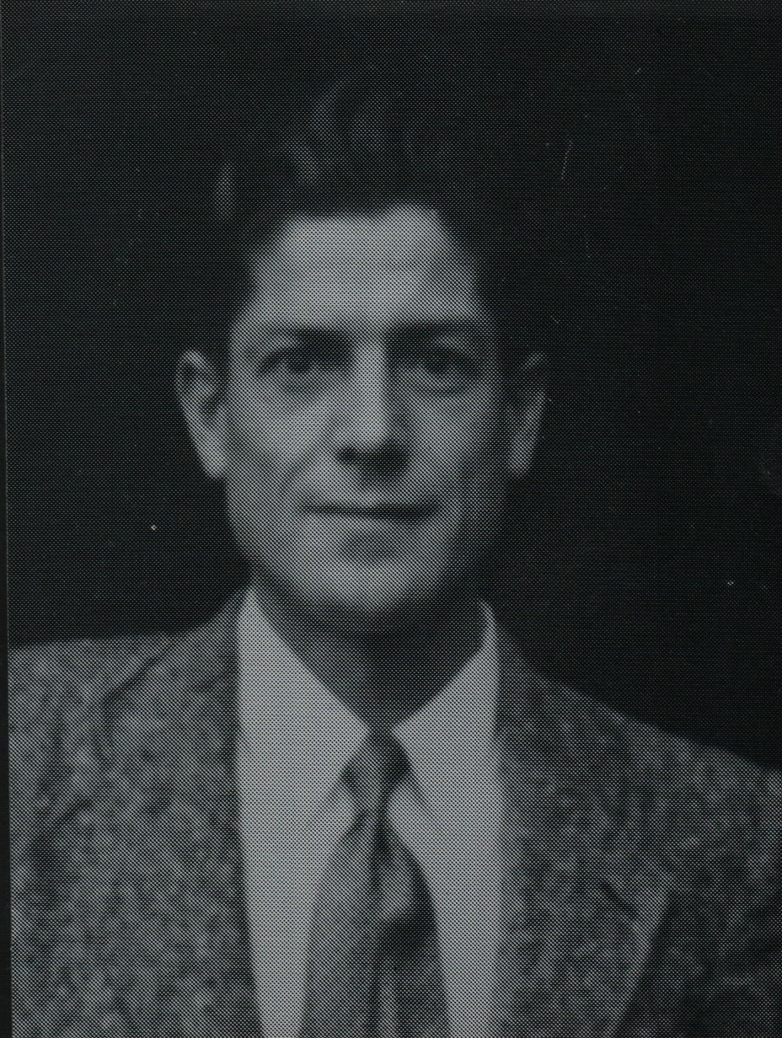

Horace embarked with the unit for New Guinea aboard S.S. “DUNTROON” on 17 Jun 1943 as a Trooper.
He was discharged on 15 Jun 1945.

