BRIGGS, Robert Ian Francis
VX88711

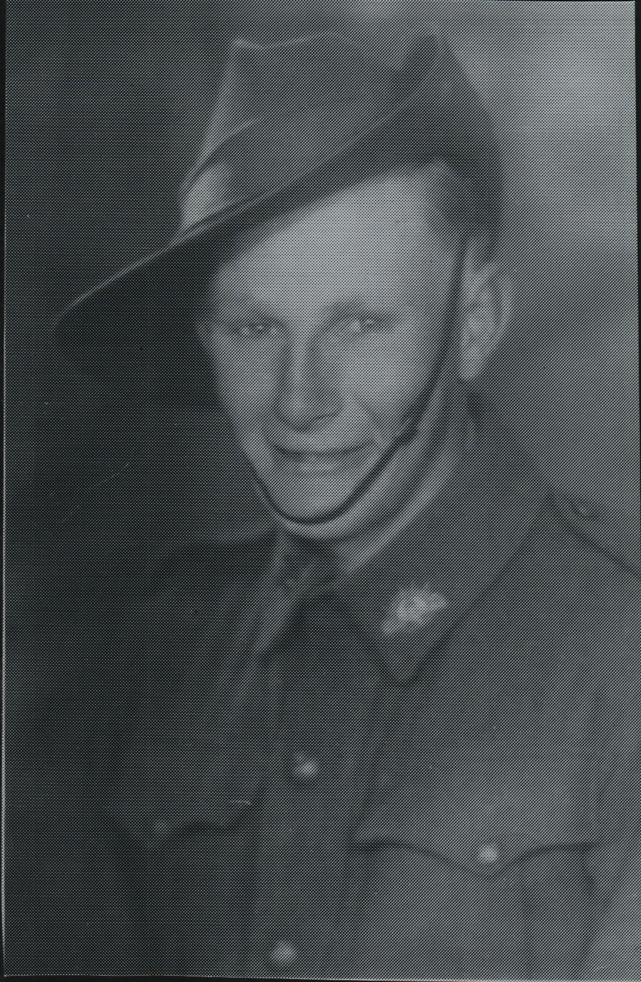

Robert joined the Aust Military Forces (Militia) 15 Dec 1941 to 20 Jul 1942, when he enlisted into the AIF 21 Jul 1942.
Robert embarked with the unit for New Guinea aboard S.S. “DUNTROON” on 17 Jun 1943 as a Trooper in No 9 Sect, “C” Troop and returned to Australia with them aboard “TAROONA” on 3 Sept 1944.
After leave and reorganization, he embarked for New Britain aboard “TAROONA” on 9 Apr 1945 with the unit as a Trooper in No 9 Sect, “C” Troop.
He was discharged 19 Jun 1946.

