BEER, Keith Raymond
VX84164

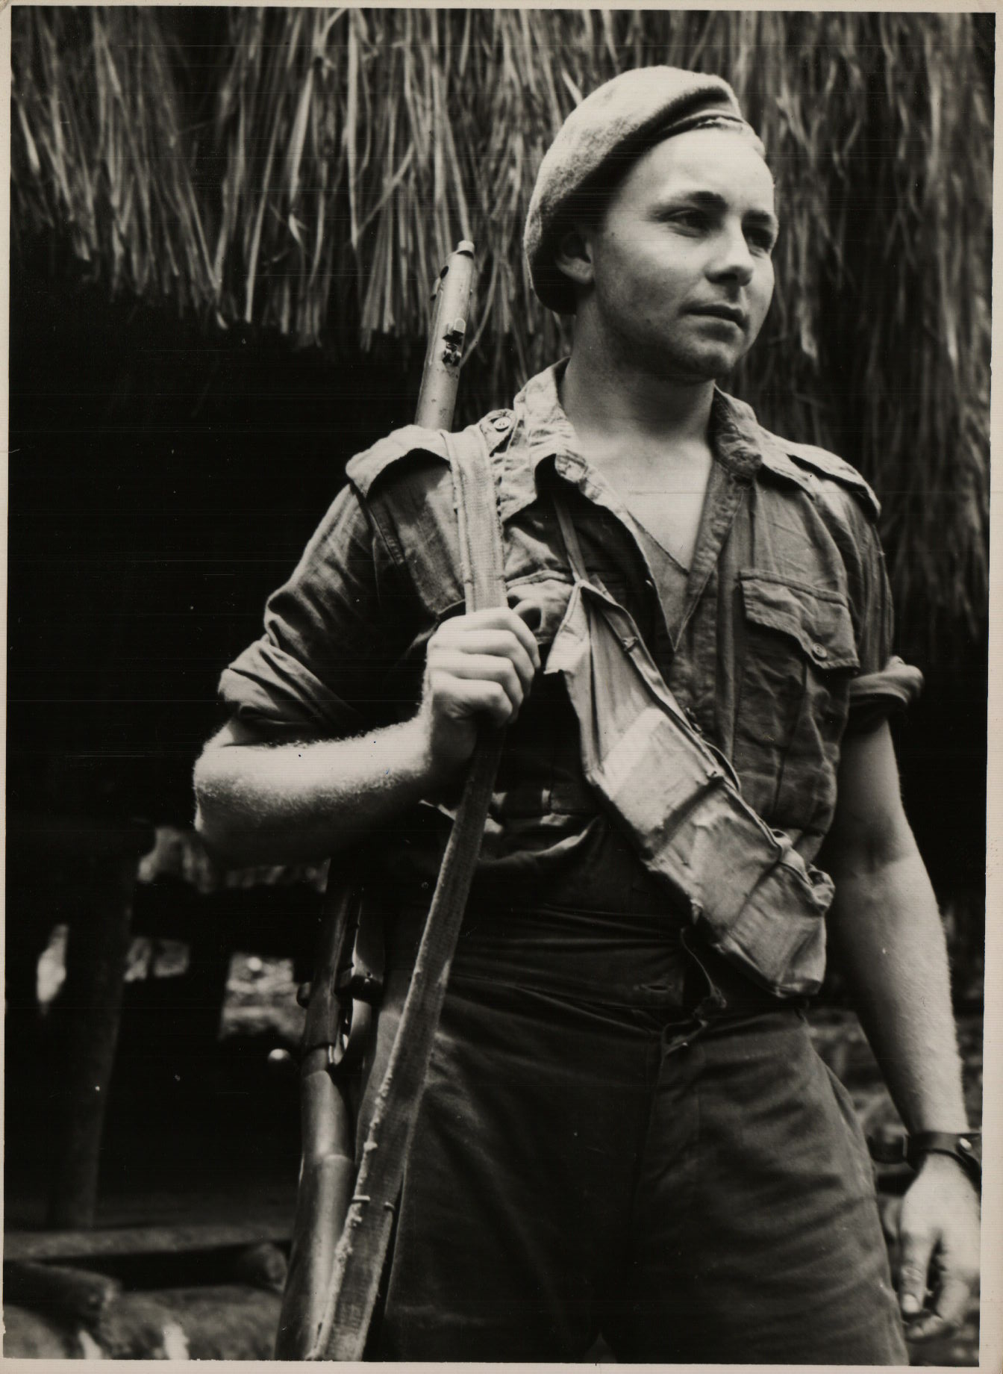

Keith embarked with the unit for New Guinea aboard SS “DUNTROON” on 17 Jun 1943 as a Trooper in No 8 Sect, “C” Troop and returned to Australia with them aboard “TAROONA” on 3 Sept 1944.
He was discharged on 18 Dec 1944.

