EASTICK, Herbert Ronald
VX71522

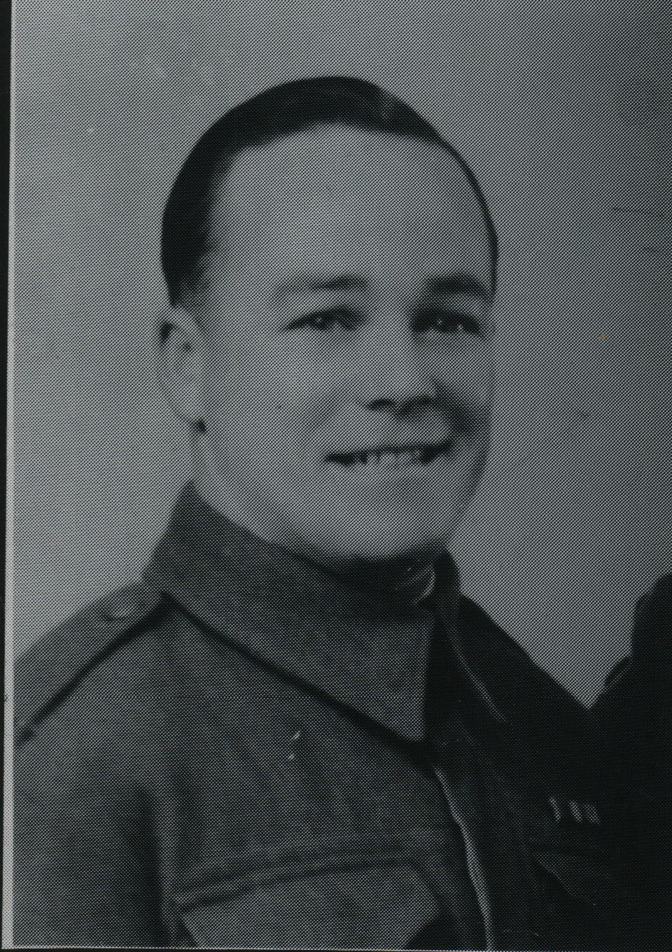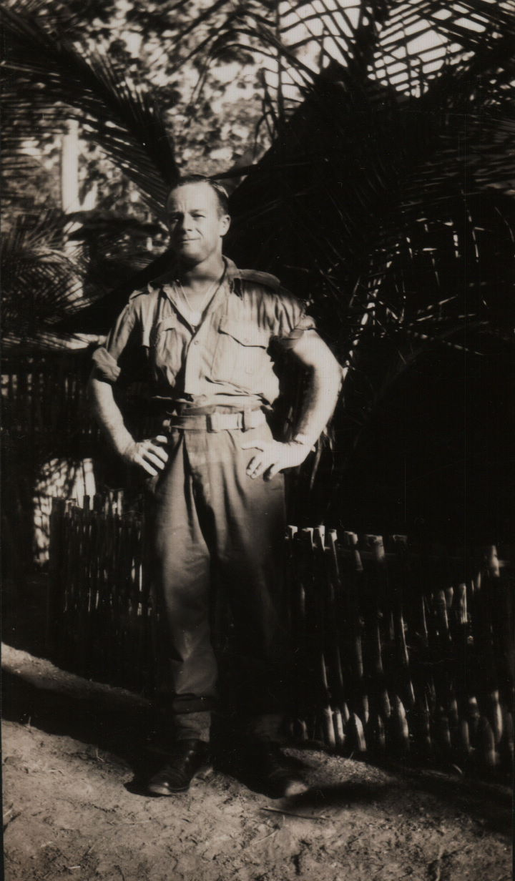

Herbert embarked with the unit for New Guinea as a Trooper aboard S.S. “DUNTROON” on 17 Jun 1943 and returned to Australia with them aboard “TAROONA” on 3 Sept 1944.
After leave and reorganization, he embarked for New Britain aboard “TAROONA” on 9 Apr 1945 with the unit as a Trooper.
He was discharged on 13 Jun 1946.

