GRACHAN, Alfred Bernard
VX60758

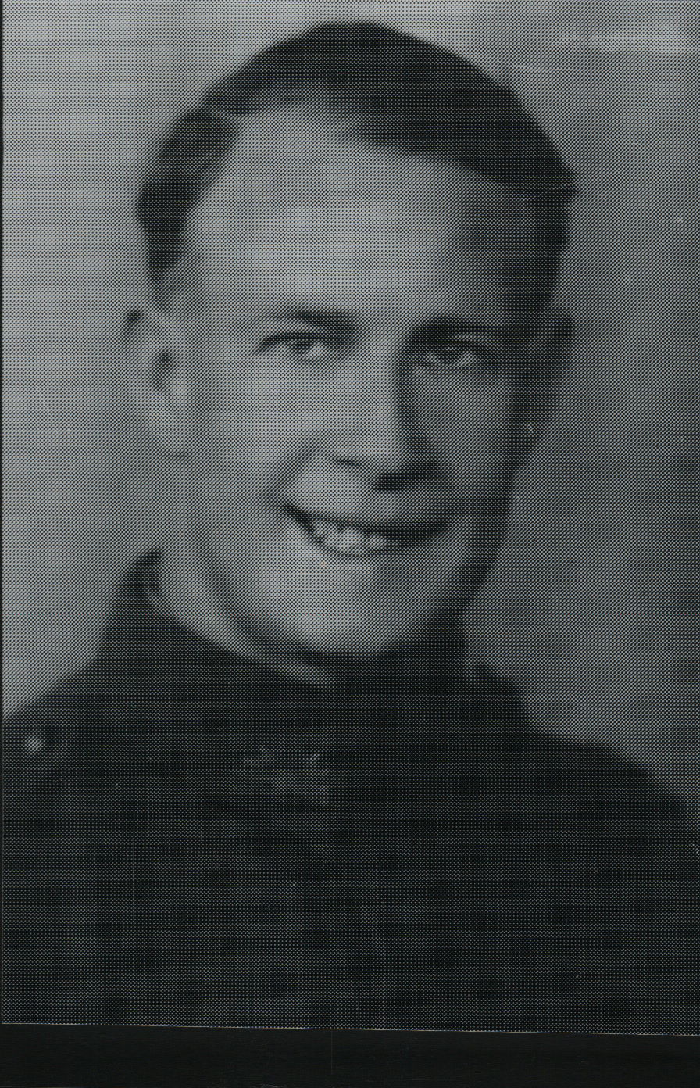

Alfred was an original member of the unit, embarking aboard “S.S. ZEALANDIA” on 8 Dec 1941 for Timor as a Sapper in the Engineers Sect, Headquarters Group. After the campaign on Timor, he embarked with the unit, for Australia aboard the Royal Dutch destroyer “Tjerk Hiddes” on either 11 Dec 1942 or 16 Dec 1942, as the embarkation rolls do not differentiate.
After leave and reorganization he embarked with the unit for New Guinea as a Sapper in the Engineers Sect, Headquarters Group aboard S.S. “DUNTROON” on 17 Jun 1943 and returned to Australia with them aboard “TAROONA” on 3 Sept 1944. After leave and reorganization, he embarked for New Britain aboard “TAROONA” on 9 Apr 1945 with the unit as a Trooper.
After New Guinea the Engineers Sect was disbanded and the members were dispersed throughout the unit.
He was discharged on 3 Jan 1946.

