COYLE, John Thomas
VX59614

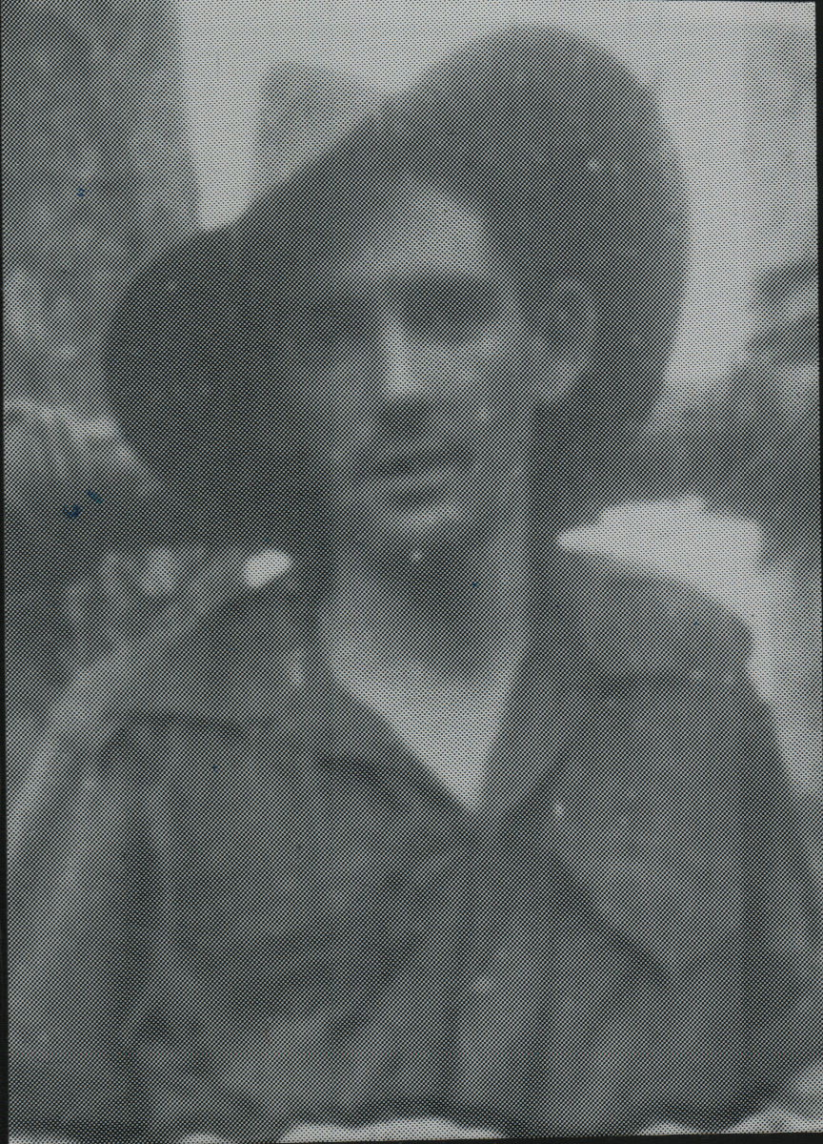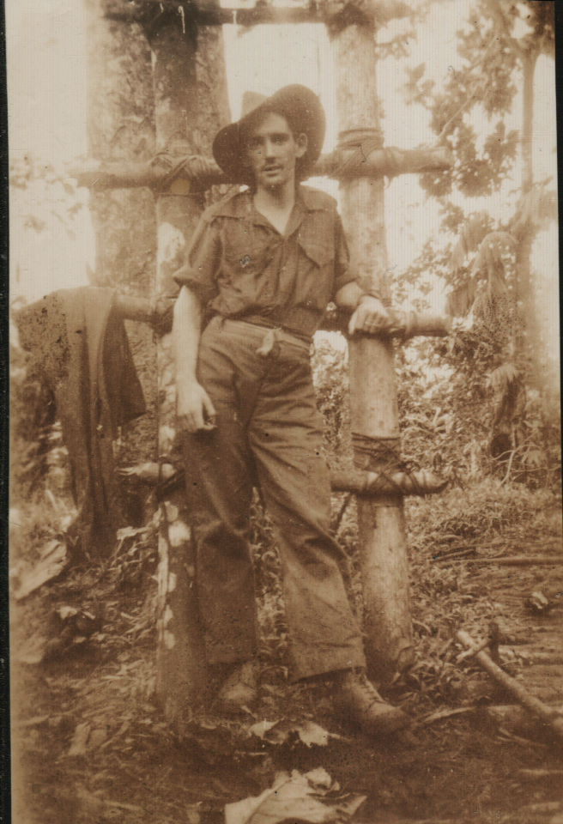

John was a member of the First Reinforcements that arrive at Dili, Timor, aboard M.V. “Kalama”, on 22 Jan 1942, prior to the Japanese landing. He joined the unit as a Private in No 9 Sect, “C” Platoon. After the campaign on Timor, he embarked with the unit, for Australia aboard the Royal Dutch destroyer “Tjerk Hiddes” on either 11 Dec 1942 or 16 Dec 1942, as the embarkation rolls do not differentiate.
After leave and reorganization he embarked with the unit for New Guinea as a Trooper aboard S.S. “DUNTROON” on 17 Jun 1943 and returned to Australia with them aboard “TAROONA” on 3 Sept 1944.
He was discharged on 22 Dec 1944.

