GREENHALGH, George Frederick
VX55437

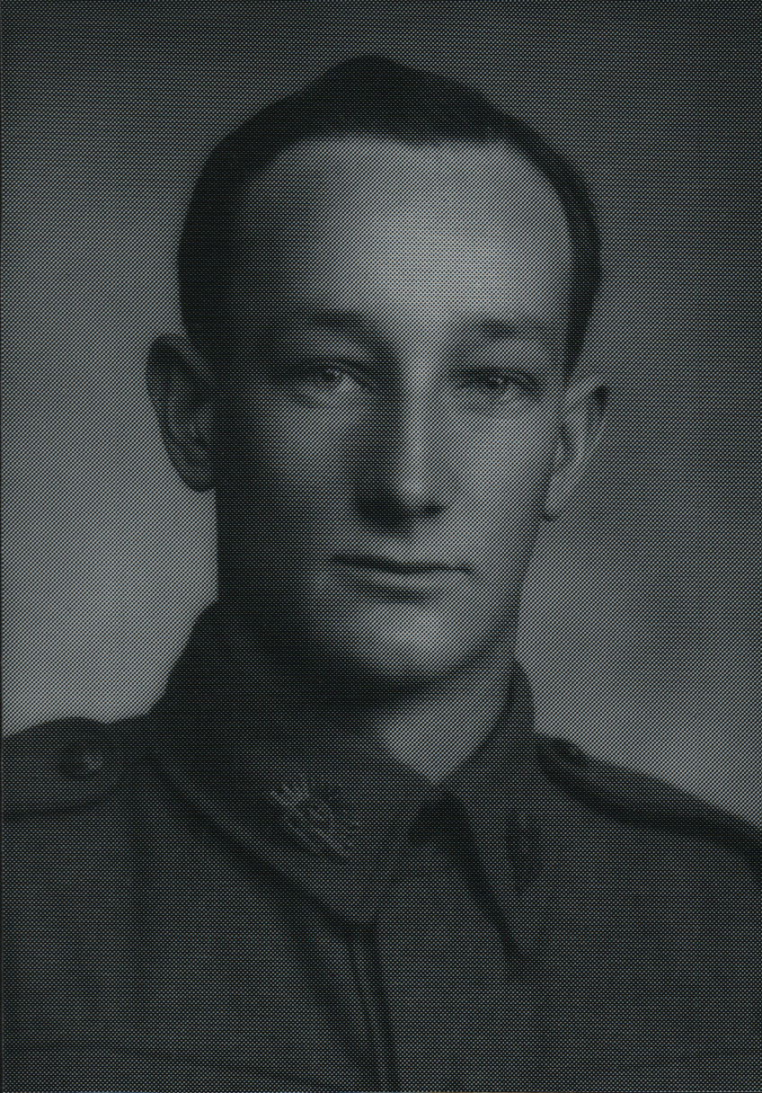

George was an original member of the unit, embarking aboard “S.S. ZEALANDIA” on 8 Dec 1941 for Timor as a Signalman, Signals Sect, Headquarters Group. After the campaign on Timor, he embarked with the unit, for Australia aboard the Royal Dutch destroyer “Tjerk Hiddes” on either 11 Dec 1942 or 16 Dec 1942, as the embarkation rolls do not differentiate.
After leave and reorganization he embarked with the unit for New Guinea as a Corporal Signals Sect, Headquarters Group aboard S.S. “DUNTROON” on 17 Jun 1943 and returned to Australia with them aboard “TAROONA” on 3 Sept 1944.
After further leave and reorganization, he embarked for New Britain aboard “TAROONA” on 9 Apr 1945 with the unit as a Corporal attached to “A” Troop.
He was discharges on 7 Jan 1946.
(Happy)

