BOTTERILL, Harold
VX55118

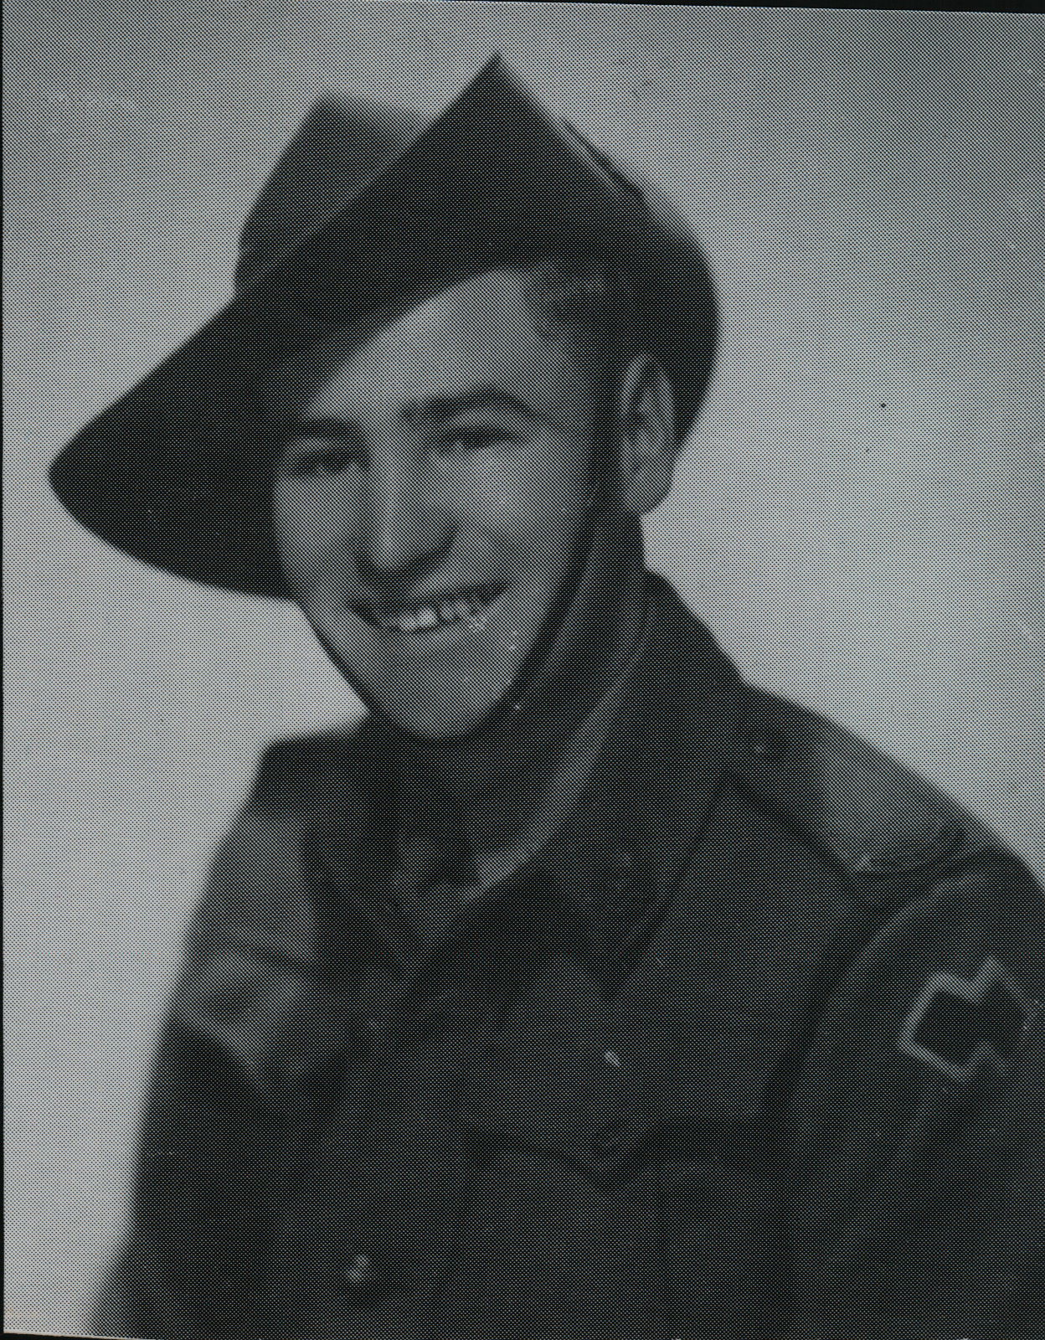

Harry was an original member of the unit, aboard “S.S. ZEALANDIA” on 8 Dec 1941 for Timor as a Signalman in the Signals Sect of Headquarters. After the campaign on Timor, he embarked with the unit, for Australia aboard the Royal Dutch destroyer “Tjerk Hiddes” on either 11 Dec 1942 or 16 Dec 1942, as the embarkation rolls do not differentiate.
Harry embarked with the unit for New Guinea aboard S.S. “DUNTROON” on 17 Jun 1943 as a Corporal in the Signals Sect, Headquarters and returned to Australia with them aboard “TAROONA” on 3 Sept 1944.
After leave and reorganization, he embarked for New Britain aboard “TAROONA” on 9 Apr 1945 with the unit as a Corporal attached to “B” Troop.
He was discharged on 8 Jan 1946.

