CALLINAN, Bernard James
VX50081

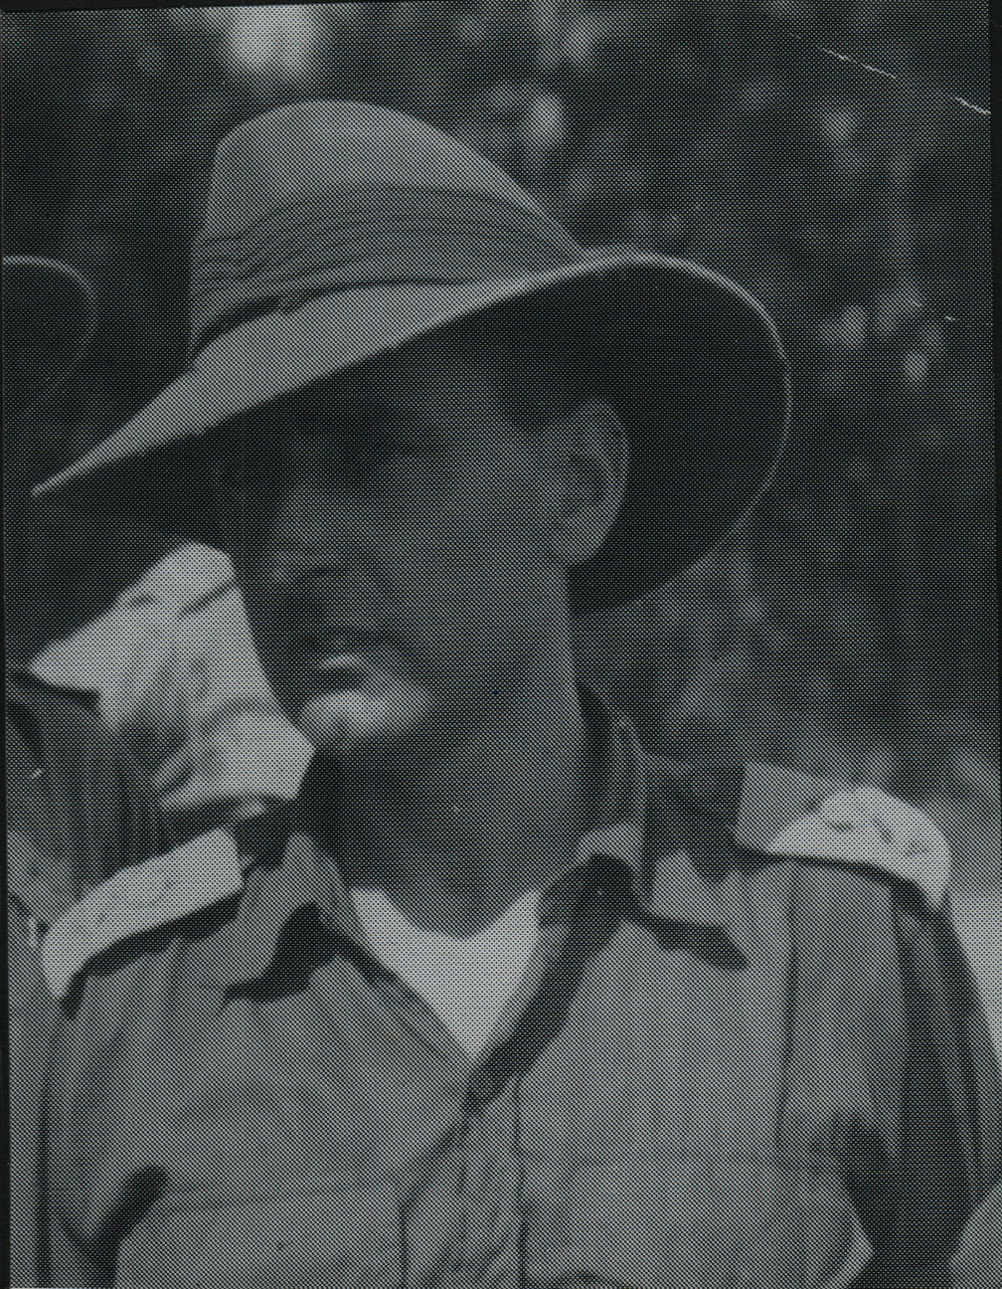

Bernard was an instructor at Demolitions Wing, 101st British Military Mission, 7th Infantry Training Centre, from 3 Mar 1941. He transferred to No 2 Independent Company as a Captain, 5 Jul 1941.
He was an original member of the unit, embarking aboard “S.S. ZEALANDIA” on 8 Dec 1941 for Timor as a Captain, the Units Second In Command, Headquarters Group. He was promoted to Major, Commanding Officer of the unit, 24 May 1942.
On the 4 Jul 1942 was Commanding Officer, Australian Troops Sparrow Force.
Nov 1942 he took command of the entire force on Timor, now known as “Lancer Force”
He embarked for Australia from Timor, arriving Darwin, 10 Jan 1943.
He was promoted to Major, 2 Feb 1943 and was Mentioned in Despatches, London Gazette, 25 May 1943 and in the Commonwealth of Australia Gazette, No 119-3 Jun 1943. These are the two Gazettes for the Timor Campaign.
He attended a Junior Staff Officers course, 2 May 1943 to 9 Jul 1943.
Arrive, Merauke, New Guinea, 3 Aug 1943.
Was appointed Second in Command, 31/51st Battalion, 5 Nov 1943.
He was awarded a Military Cross, London Gazette, 23 Dec 1943.
Returned to Australia, 20 Apr 1944 and attended, Land Headquarters Tactical School for Senior Officers, until 3 Jun 1944.
Arrive, Merauke, New Guinea, 5 Jul 1944.
Returned to Australia, 8 Aug 1944.
Arrived Bougainville, 8 Dec 1944 and was attached to 26th Battalion, 30 Jan 1945 to 8 Feb 1945 when as a Temporary Lieutenant Colonel, he took command of 26th Battalion.
He returned to Australia from Bougainville on 8 Jul 1945 and then returned to Bougainville on 4 Sept 1945, he administered Command of 11th Brigade, Sept 1945.
Promoted Lieutenant Colonel, 3 Jan 1946 and retuned to Australia, 18 Jan 1946.
He was discharged on 5 Feb 1946.
Awarded a Distinguished Service Order, London Gazette, 14 Feb 1946.
In later life Bernard was awarded the following,
Order of the British Empire, Commander, Civil, London Gazette, 1 Jan 1971.
Knight Bachelor, London Gazette, 7 Oct 1977.
Companion of the Order Of Australia, 26 Jan 1986.

