GRIFFIN, James
VX48366

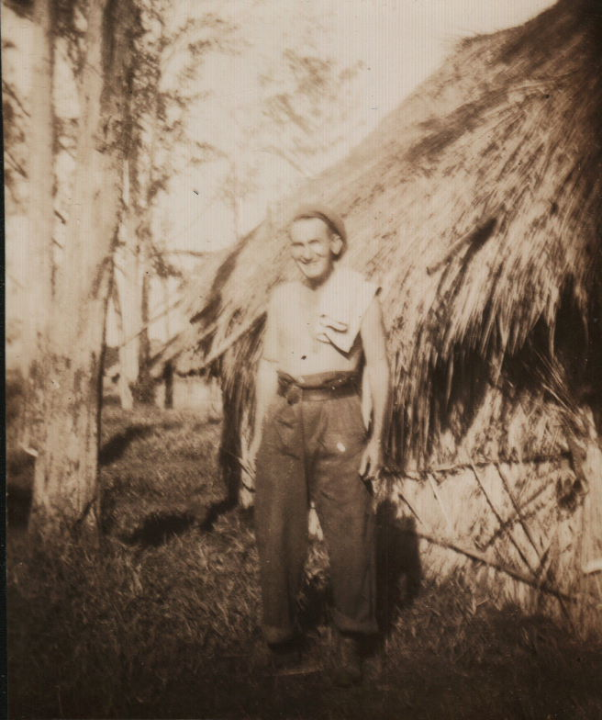

James joined the unit on Timor as a Private from 2/40 Battalion, after the fall of Koepang, approx March 1942. He was one of the former Koepang men, who moved to the village of Mape for intensive commando training and on 8 May 1942, they were formed into a new Platoon, “D” Platoon under the command of Lieutenant Turton and later under Lt Doig.
After the campaign on Timor, he embarked with the unit, for Australia aboard the Royal Dutch destroyer “Tjerk Hiddes” on either 11 Dec 1942 or 16 Dec 1942, as the embarkation rolls do not differentiate.
He was transferred to the unit from the 2/40th Bn on arrival back in Australia.
After leave and reorganization he embarked with the unit for New Guinea as a Trooper in the Headquarters group of “A” Troop aboard S.S. “DUNTROON” on 17 Jun 1943 and returned to Australia with them aboard “TAROONA” on 3 Sept 1944. After leave and reorganization, he embarked for New Britain aboard “TAROONA” on 9 Apr 1945 with the unit as a Trooper in the Headquarters group of “A” Troop.
He was discharged on 3 Oct 1945.

