CURRAN, Kevin Stanley
VX47342

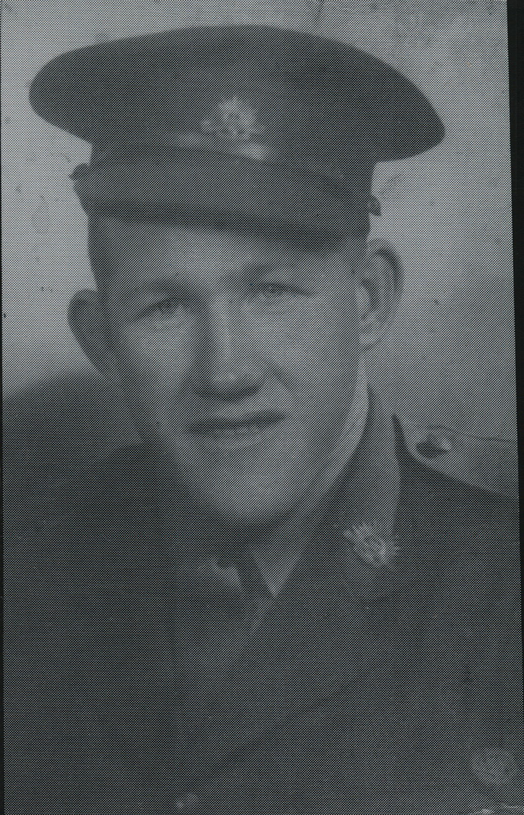

Kevin was an original member of the unit, embarking aboard “S.S. ZEALANDIA” on 8 Dec 1941 for Timor as a Corporal in No 2 Sect, “A” Platoon.
Nov 1942 he was Commissioned in the field and took command of No 2 Sect.
After the campaign on Timor, he embarked with the unit, for Australia aboard the Royal Dutch destroyer “Tjerk Hiddes” on either 11 Dec 1942 or 16 Dec 1942, as the embarkation rolls do not differentiate.
Promoted to Lieutenant on 24 Dec 1943.
He was Mentioned in Despatches, London Gazette, 25 May 1943 and in the Commonwealth of Australia Gazette, No 119-3 Jun 1943.
Attended Officer Training and rejoined the unit on New Guinea as the Transport Officer. As the unit had no transport, the Transport Sect was used as another Troop.
At the end of the New Guinea campaign, Kevin returned to Australia with the unit aboard “TAROONA” on 3 Sept 1944.
After leave and reorganization, he embarked for New Britain aboard “TAROONA” on 9 Apr 1945 with the unit as a Lieutenant, Officer Commanding, No 7 Sect, “C” Troop.
He was discharged on 22 Oct 1945.

