DEXTER, David St Alban
VX38890

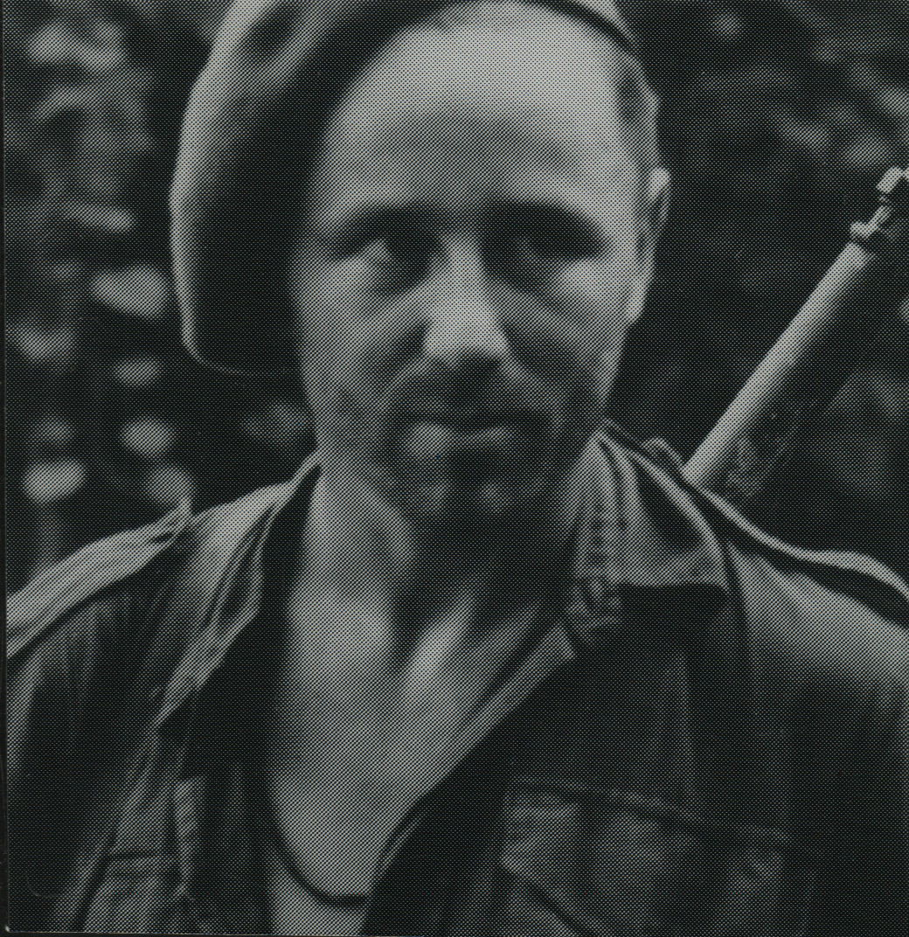

David served with 2/21st Battalion, 1940-41. Promoted to Lieutenant, 11 Jul 1941.
He was an original member of the unit, embarking aboard “S.S. ZEALANDIA” on 8 Dec 1941 for Timor as a Lieutenant, Officer Commanding, No 1 Sect, “A” Platoon.
He was promoted to Captain, 1 Sept 1942.
After the campaign on Timor, he embarked with the unit, for Australia aboard the Royal Dutch destroyer “Tjerk Hiddes” on either 11 Dec 1942 or 16 Dec 1942, as the embarkation rolls do not differentiate.
He was Mentioned in Despatches, London Gazette, 25 May 1943 and in the Commonwealth of Australia Gazette, No 119-3 Jun 1943. These are the two Gazettes for the Timor Campaign.
After leave and reorganization he embarked with the unit as a Captain, Officer Commanding, “A” Troop, for New Guinea aboard S.S. “DUNTROON” on 17 Jun 1943 and returned to Australia with them aboard “TAROONA” on 3 Sept 1944.
David served a short period with “Z” Force during 1944.
He was Mentioned in Despatches, London Gazette, 8 Mar 1945 and in the Commonwealth of Australia Gazette, No 54-15 Mar 1945.
After leave and further reorganization, he embarked for New Britain aboard “TAROONA” on 9 Apr 1945 with the unit as a Captain, Officer Commanding, “B” Troop.
Promoted to Major, 12 Jun 1945 and was made Second in Command of the unit.
Transferred to 2/4th Cdo Sqn at Tarakan as a Major.
He was discharged on 16 Jan 1946.
Photo below

