CHISWELL, Gordon Albert
VX38419

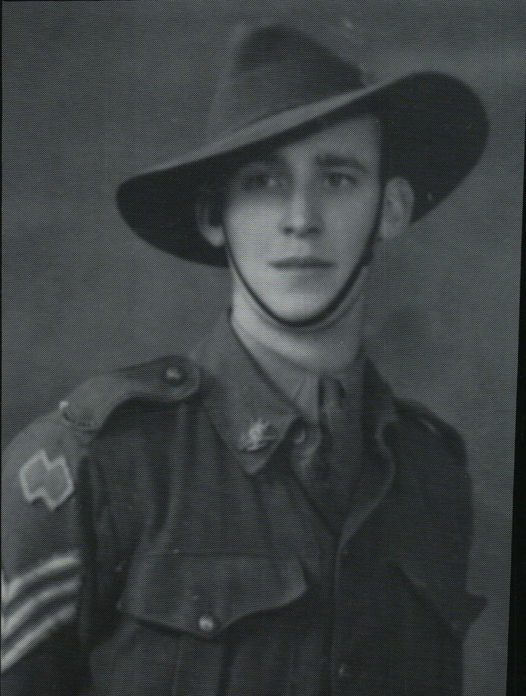

Gordon was an original member of the unit, embarking aboard “S.S. ZEALANDIA” on 8 Dec 1941 for Timor as a Sergeant in No 7 Sect, “A” Platoon.
Gordon was killed in Action, 20 Feb 1942, when the Sect was caught in an ambush, during the first landing of the Japanese on Timor. He is commemorated on the Northern Territory Memorial.

