BOURKE, Edmund Meskill
VX134084

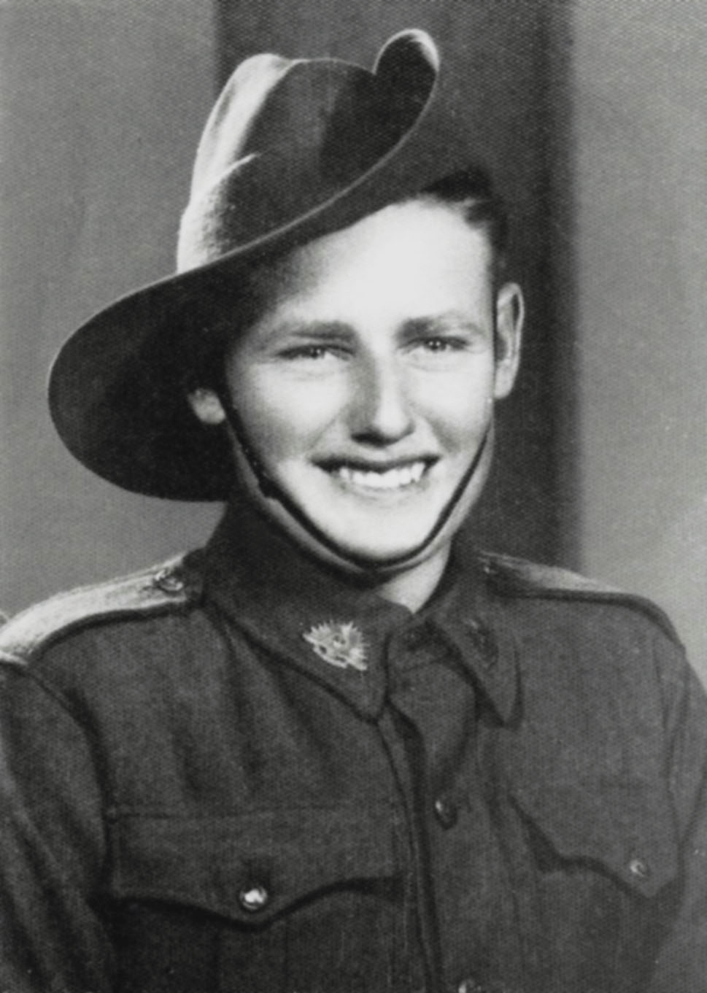

Edmund served in various Signals units prior to joining the unit at Jacquinot Bay, New Britain, in May 1945.
He served with the unit as a Trooper in No 7 section, “C” Troop.
Edmund was a member of the ‘Long Patrol’ of July 1945. A 10 day patrol which became 24 days of physical exhaustion.
He was discharged on 15 May 1946.

