BACHE, Hubert Edwin
VX115800

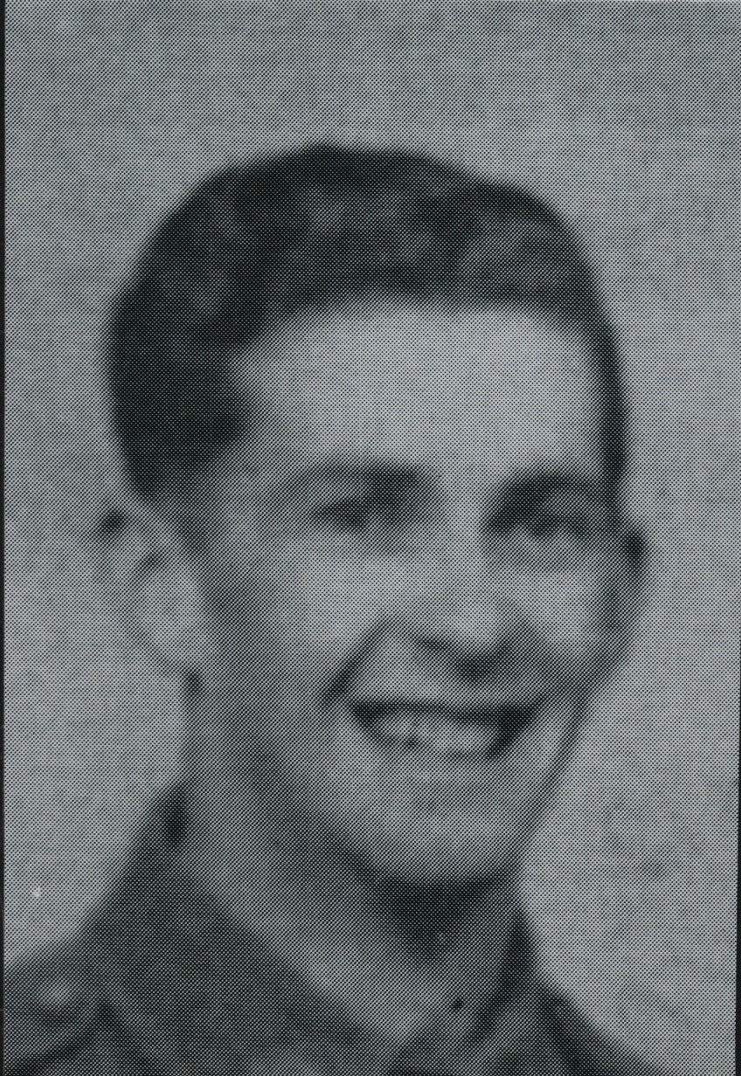

Hubert enlisted into the Aust Military Forces, (Militia) 16th Field Ambulance and was attached to 2nd Cavalry Division, Jan 1939.
He enlisted into the AIF, Jan 1941, attached to the following
- 8th Light Horse – 2nd Cav Div.
- 26th Motor Regiment – 1st Armoured Div.
Hubert was Aust Army Medical Corps instructor for 1st Armoured Division at Moora, W.A.
He had special training at Geelong and Heidelberg Hospitals in both the Casualty and Theatre Sections. He attended Sydney University’s Army Tropical Medical School.
He was then attached 503rd USA Para Infantry at Canungra, Qld.
He joined the unit on their return from New Guinea and embarked with them for New Britain aboard “TAROONA” on 9 Apr 1945 as the Medical Sergeant in the Headquarters Group.
When the unit was disbanded, he returned to Australia and was discharged on 2 Jul 1946.

