COOPER, Leith Norman Roy
VX103924

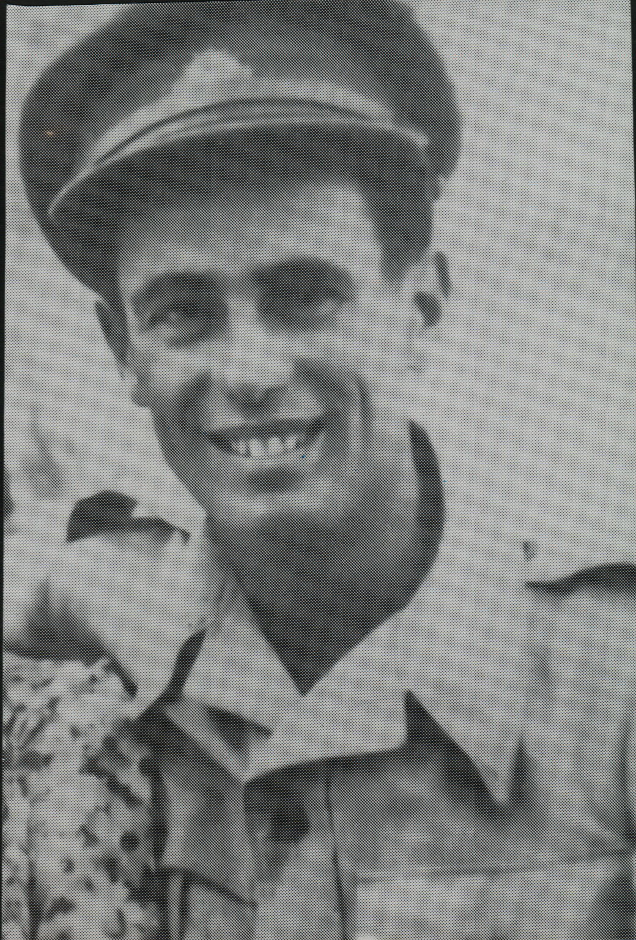

Leith embarked with the unit for New Guinea as a Trooper in No 8 Sect, “C” Troop aboard S.S. “DUNTROON” on 17 Jun 1943 and returned to Australia with them aboard “TAROONA” on 3 Sept 1944.
After leave and reorganization, he embarked for New Britain aboard “TAROONA” on 9 Apr 1945 with the unit as a Lance Corporal in No 8 Sect, “C” Troop.
Transferred to Intelligence and Promoted to Warrant Officer Class 11.
Served last 6 months of the war with Military History Section of the Army

