DIGNUM, Oscar Keith
SX881

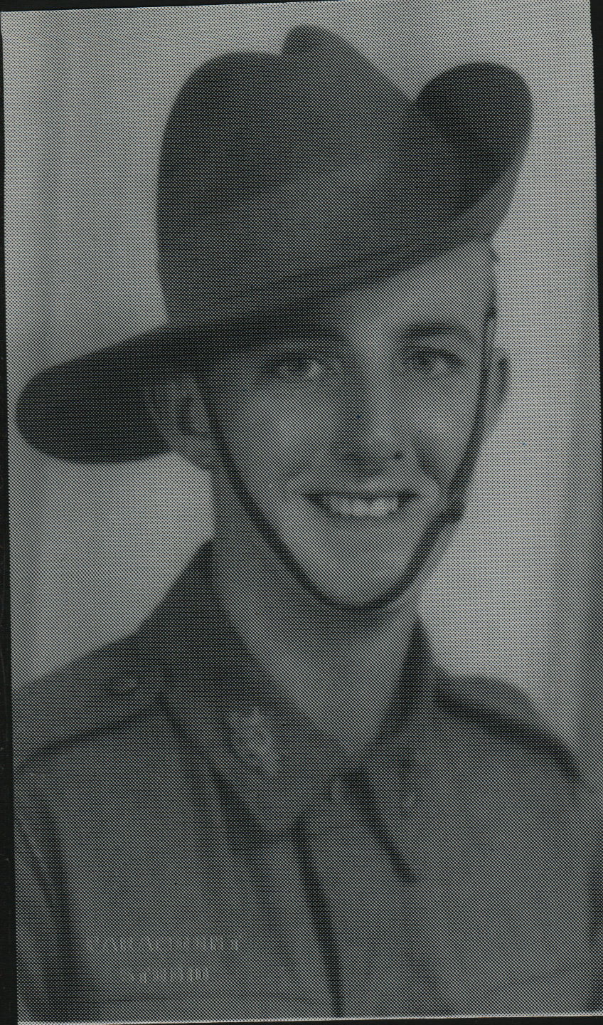

Oscar enlisted in South Australia on 20 Oct 1939 and served with 2/3rd Field Artillery Regiment in England, Lybia, Greece and Crete. He was wounded and hospitalized 28 Apr 1941 to Mar 1942.
He returned to Australia and joined the unit Apr 1943 and embarked with the unit for New Guinea as a Trooper in No 4 Sect, “B” Troop aboard S.S. “DUNTROON” on 17 Jun 1943 and returned to Australia with them aboard “TAROONA” on 3 Sept 1944.
After leave and reorganization, he embarked for New Britain aboard “TAROONA” on 9 Apr 1945 with the unit as a lance Corporal in No 4 Sect, “B” Troop.
He was discharged on 6 Oct 1945.

