FOX, Jack
SX25427

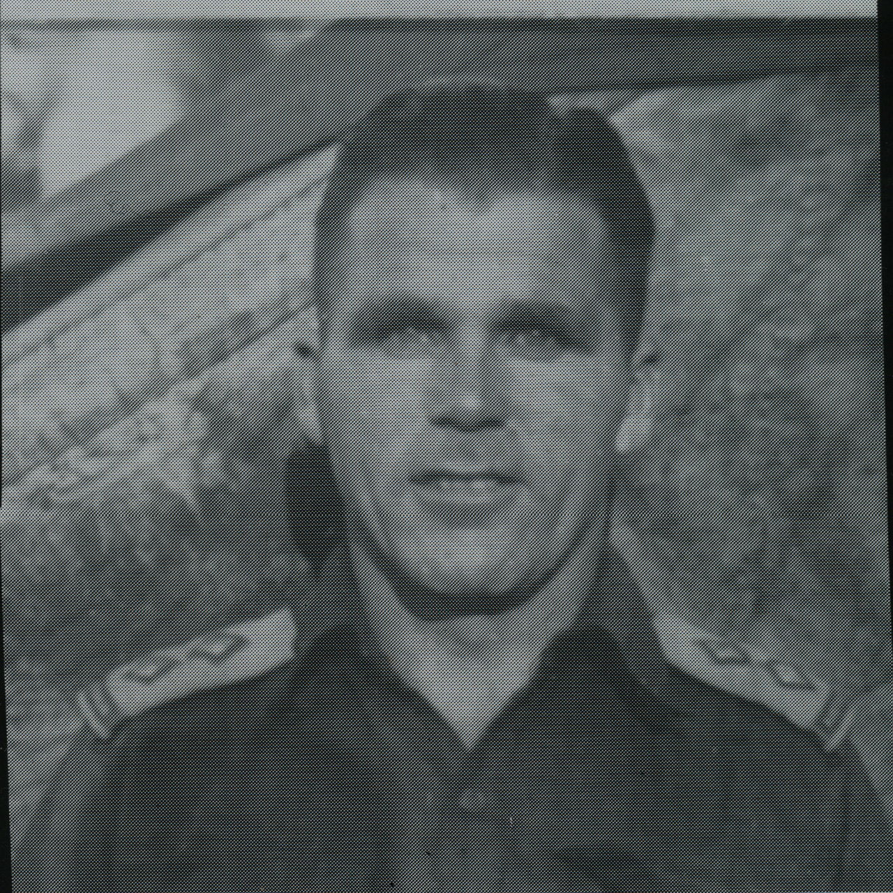

Jack was commissioned on 30 Jun 1942 and served with 10th Aust Infantry Battalion until transferred to the unit and setup a staging section in the Northern Territory on 25 Nov 1942.
After the unit reorganized, he embarked with the unit for New Guinea as a Lieutenant, the Unit Adjutant, Headquarters Group aboard S.S. “DUNTROON” on 17 Jun 1943 and returned to Australia with them aboard “TAROONA” on 3 Sept 1944.
After leave and further reorganization, he embarked for New Britain aboard “TAROONA” on 9 Apr 1945 with the unit as a Captain, Officer Commanding, No 6 Sect, “B” Troop.
He was the units Demobilisation Officer and continued serving with the Aust Army, with service No 456, until discharged on 20 Nov 1972.

