CARTHEW, Kelvin Glen
SX20206

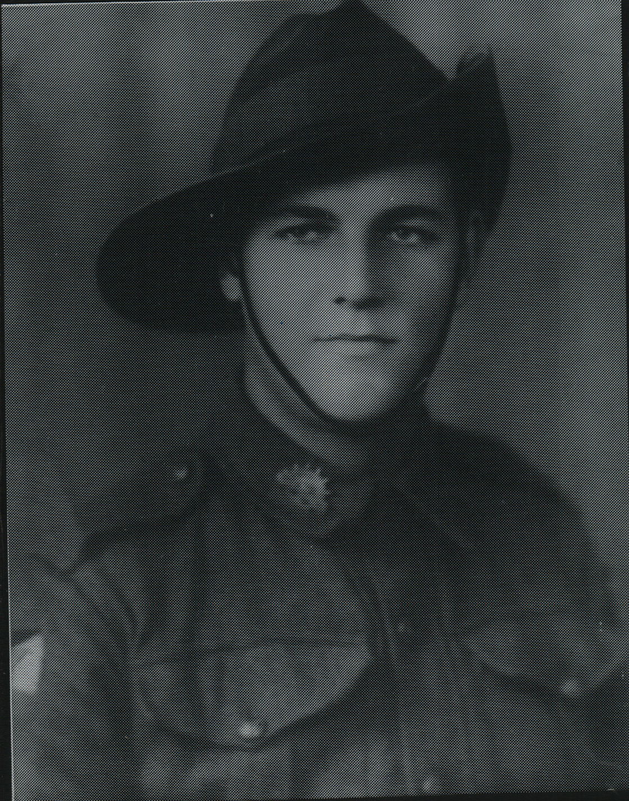

Kelvin joined the Australian Military Forces (Militia) & served Dec1942 to Jan 1943.
He joined the unit in Qld & he embarked with the unit as a Trooper in No 6 Sect, “B” Troop for New Guinea aboard S.S. “DUNTROON” on 17 Jun 1943 and returned to Australia with them aboard “TAROONA” on 3 Sept 1944.
After leave and reorganization, he embarked for New Britain aboard “TAROONA” on 9 Apr 1945 with the unit as a trooper in No 6 Sect, “B” Troop.
He was discharged on 1 Jul 1946.

