GOODHEW, Jack Ronald
QX33384

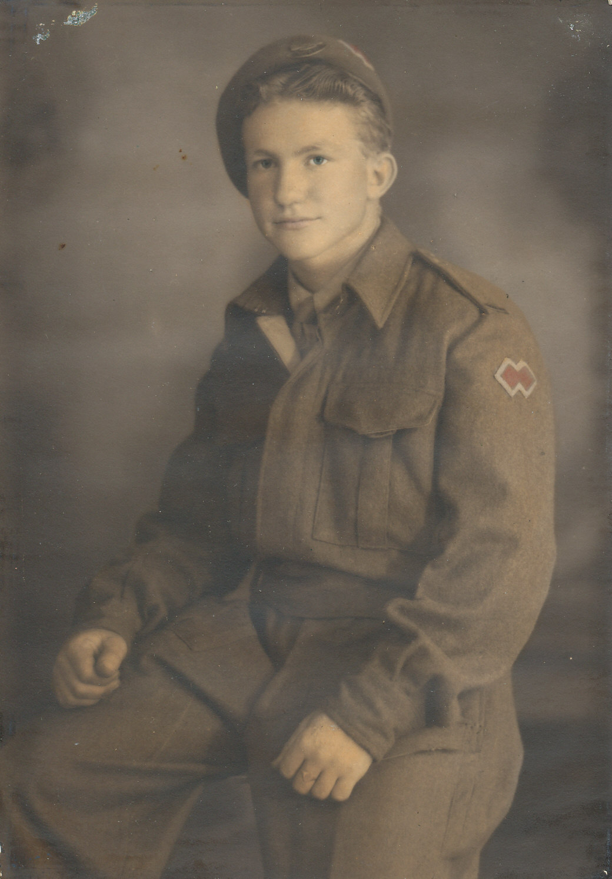

Jack joined the unit at Canungra, QLD and embarked with the unit as a Trooper in No 4 Sect, “B” Troop for New Guinea aboard S.S. “DUNTROON” on 17 Jun 1943 and returned to Australia with them aboard “TAROONA” on 3 Sept 1944. Jack was wounded while serving on New Guinea.
After leave and reorganization, he embarked for New Britain aboard “TAROONA” on 9 Apr 1945 with the unit as a Trooper in No 4 Sect, “B” Troop.
He was discharged on 15 Nov 1945.

