ANDREW, Colin Stephen
QX21923

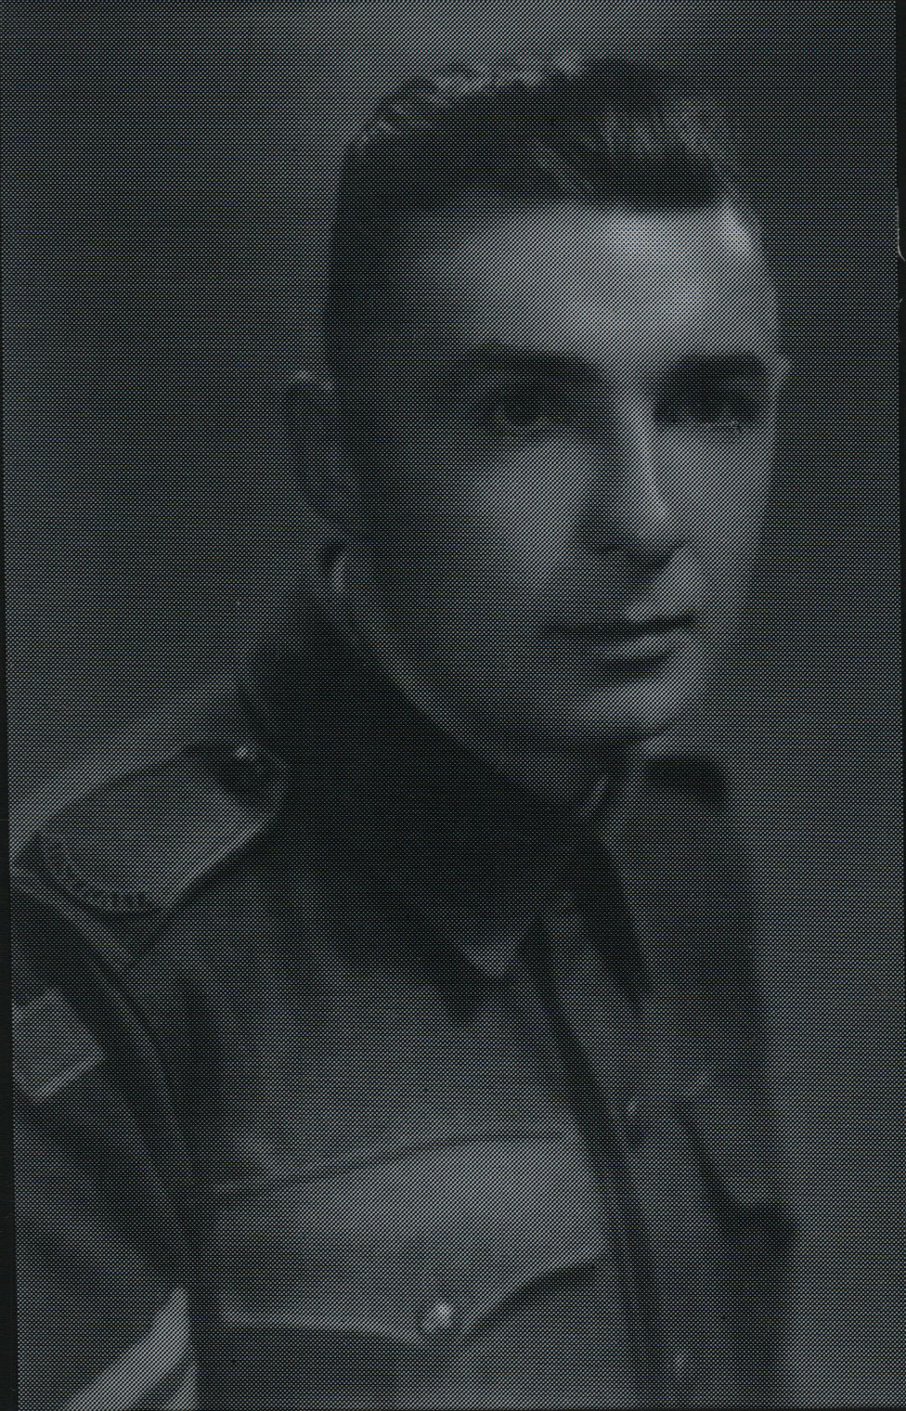

Colin joined the unit at Canungra, Qld, as a Corporal in the Regimental Aid Post. He embarked with the unit for New Guinea aboard S.S. “DUNTROON” on 17 Jun 1943 and returned to Australia with them aboard “TAROONA” on 3 Sept 1944.
After leave and reorganization, he embarked for New Britain with the unit aboard “TAROONA” on 9 Apr 1945 as a Corporal.
He was discharged on 25 Mar 1946.

