ADAMS, Tony Bradfield
QX1011

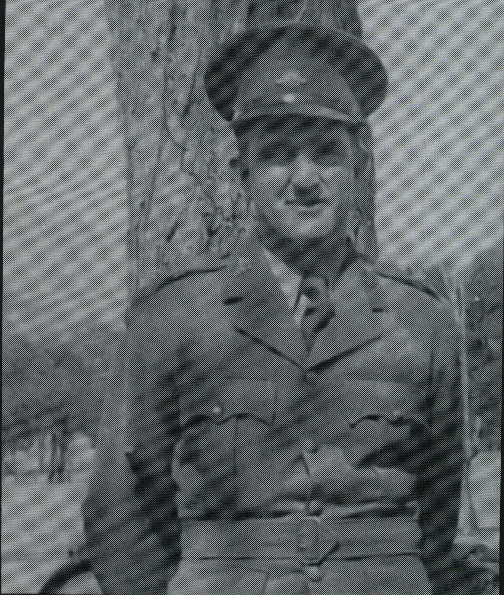

Prior to joining the unit Tony served as a Lieutenant in 2 / 11 Field Regt, Royal Australian Artillery, in the Middle East. Then as an instructor at 1st Aust Commando Training Squadron, 16 Oct 1942 to 14 May 1943. He transferred to the unit at Canungra, Qld
As a Lieutenant, Officer Commanding No 7 Sect, “C” Troop, he embarked with the unit for New Guinea aboard S.S. “DUNTROON” on 17 Jun 1943 and returned to Australia with them aboard “TAROONA” on 3 Sept 1944. After leave and further reorganization, he embarked for New Britain aboard “TAROONA” on 9 Apr 1945 with the unit as a Captain, Officer Commanding “C” Troop.
Tony was discharged in 10 Oct 1945.

