BLANCH, Russell Francis
NX83989

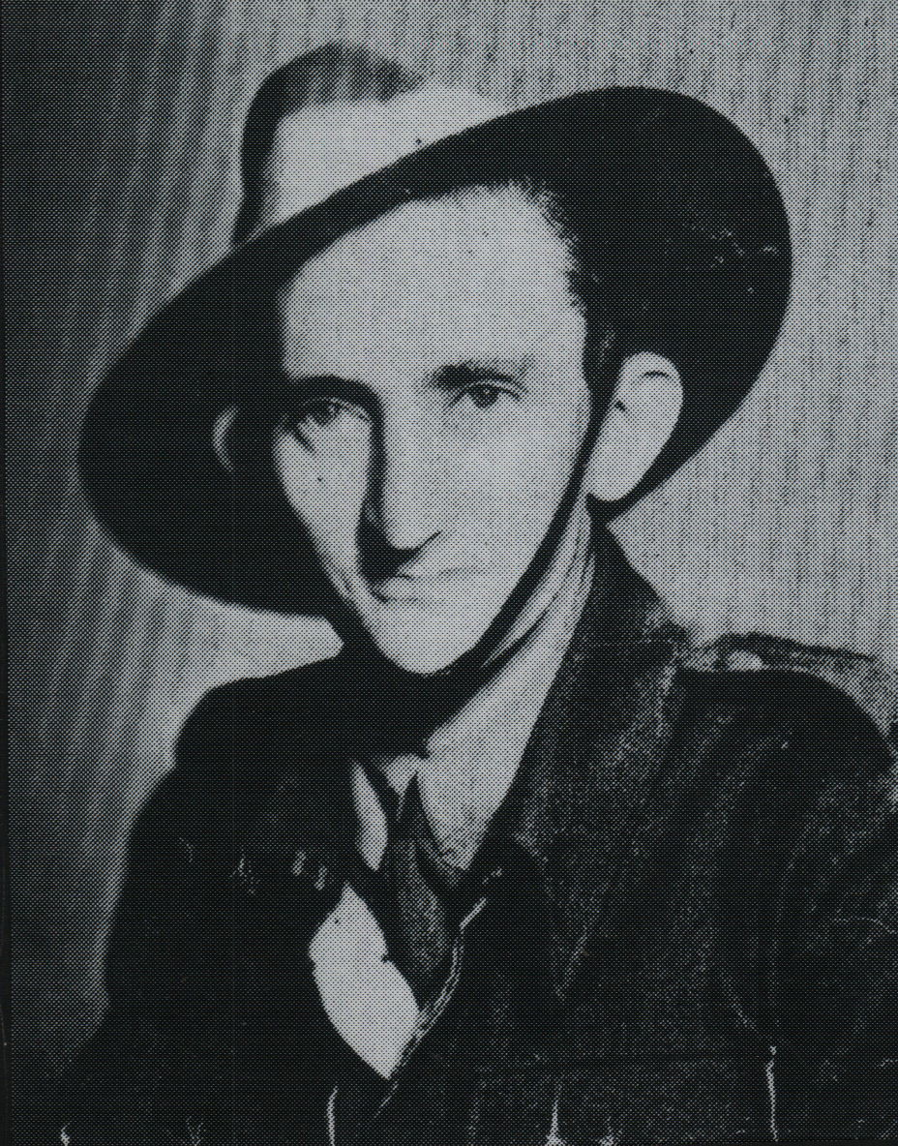

Russell embarked with the unit for New Guinea aboard S.S. “DUNTROON” on 17 Jun 1943 as a Signalman in Headquarters and returned to Australia with them aboard “TAROONA” on 3 Sept 1944.
After leave and reorganization, he embarked for New Britain aboard “TAROONA” on 9 Apr 1945 with the unit as a Signalman in “A” Troop.
He was discharged on 6 Jun 1946.

