BRAY, Neal
NX80051

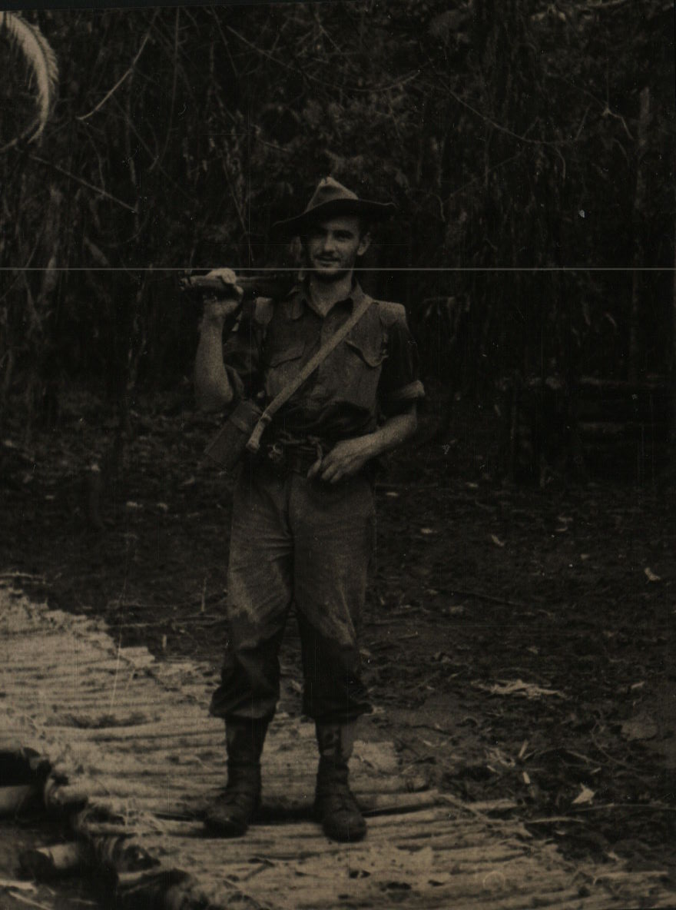

Neal embarked with the unit for New Guinea aboard SS “DUNTROON” on 17 Jun 1943 as a Trooper in No 8 Sect, “C” Troop and returned to Australia with them aboard “TAROONA” on 3 Sept 1944.
He was discharged 12 May 1946.

