CARDY, John Allan
NX76534

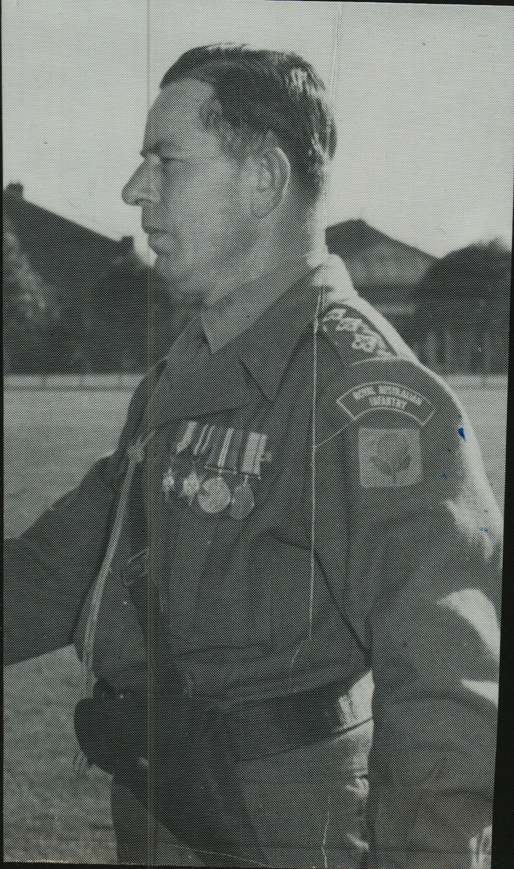

John enlisted into the British Regular Army on 5 Feb 1930 and was posted to the Kings Royal Rifle Corps.
In 1931, he was posted with his unit to India. Promoted to Sergeant during his time in India and in 1938 transferred to the Australian Army and then qualified as a Warrant Officer Class 11 Instructor as a prerequisite to instruct at No 1 Officer Training School, Liverpool, NSW.
Posted to No 7 Infantry Training Centre at Foster.
John was a member of the First Reinforcements that arrive at Dili, Timor, aboard M.V. “Kalama”, on 22 Jan 1942, prior to the Japanese landing. He joined the unit as a Lieutenant and in May he was in command of No 5 Sect, “B” Platoon. After the campaign on Timor, he embarked with the unit, for Australia aboard the Royal Dutch destroyer “Tjerk Hiddes” on either 11 Dec 1942 or 16 Dec 1942, as the embarkation rolls do not differentiate.
After leave and reorganization he embarked with the unit for New Guinea aboard S.S. “DUNTROON” on 17 Jun 1943 as a Lieutenant.
He was invalided out of New Guinea to Australia.
On recovery he was transferred out of the unit to numerous postings.

- 1945 Promoted to Captain.
- Given Service No 2338.
- 1946 Staff Captain, Headquarters, Eastern Command.
- 1949 Area Staff Officer, Riverina, NSW.
- 1951 Commanding Officer of 15th Cadet Battalion, Young, NSW.
- 1953 Commanding Officer of 10th Cadet Battalion.
- 1955 First Adjutant / Quarter Master, Australian Regular Army Commando
Unit (No1 Company)
- 1957 First Officer in Australia issued with Green Beret.
- 1958 Transferred to Royal NSW Lancers.
- 1961 Posted to Company Command Battle Group.
- 1962 Posted to Headquarters, Eastern Command as Staff Captain “Q”.
- 1964 Promoted to Major.
- 1972 Retired form Army as a Major and Promoted to Lieutenant Colonel.

