CHOLERTON, Thomas Edward
NX69311

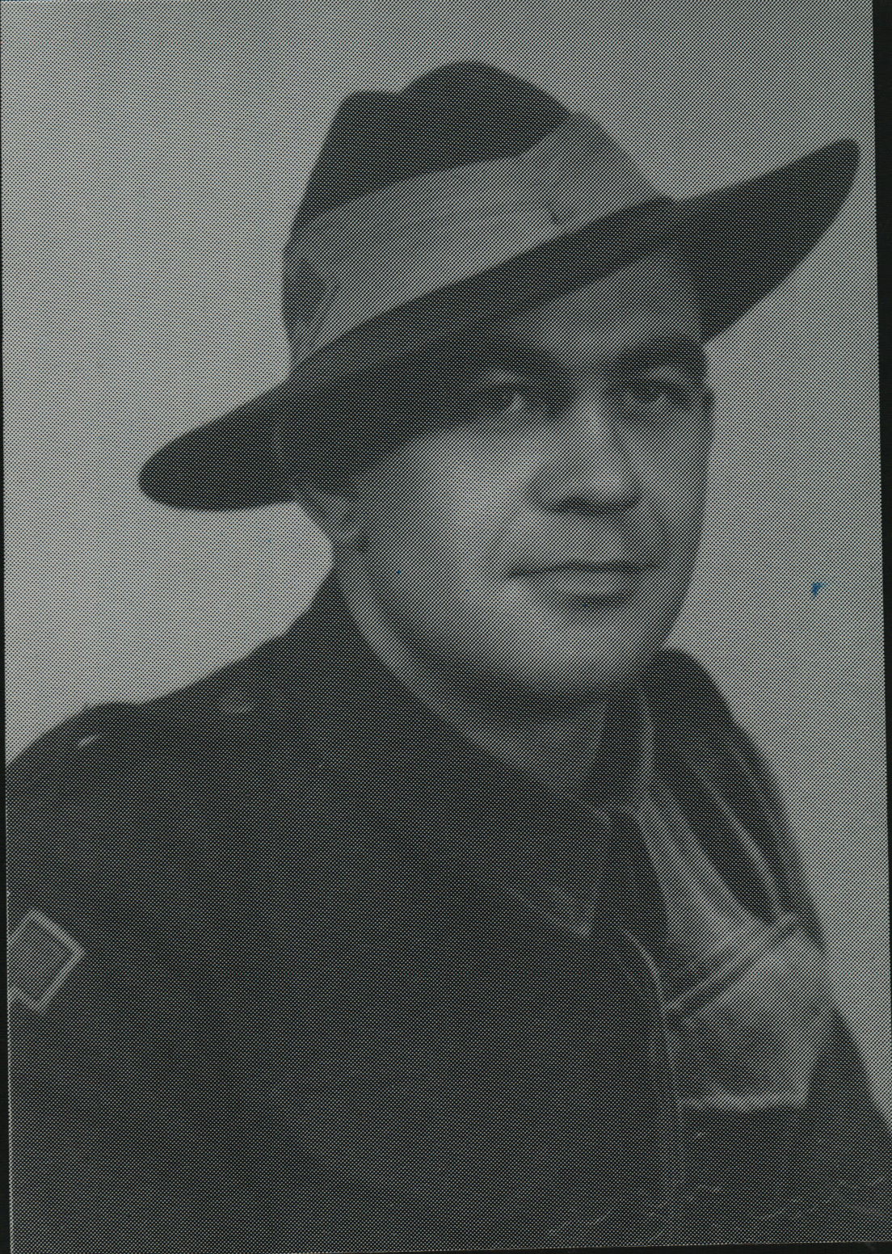

Prior to joining the unit at Canungra, Qld, Thomas, served
- Dec1940 – Mar 1941, 9th Field Regiment, Royal Aust Artillery
- Mar 1941 – Jan 1943, 2/13th Aust Field Regiment & 2/1st Aust Medium Regiment, Royal Aust Artillery, in Darwin & Middle East
Thomas embarked with the unit for New Guinea as a Trooper in No 5 sect, “B” Troop aboard S.S. “DUNTROON” on 17 Jun 1943 and returned to Australia with them aboard “TAROONA” on 3 Sept 1944.
After leave and reorganization, he embarked for New Britain aboard “TAROONA” on 9 Apr 1945 with the unit as a Trooper in No 5 sect, “B” Troop.
Discharged on 29 Jan 1946

