DIXON, Alan
NX59991

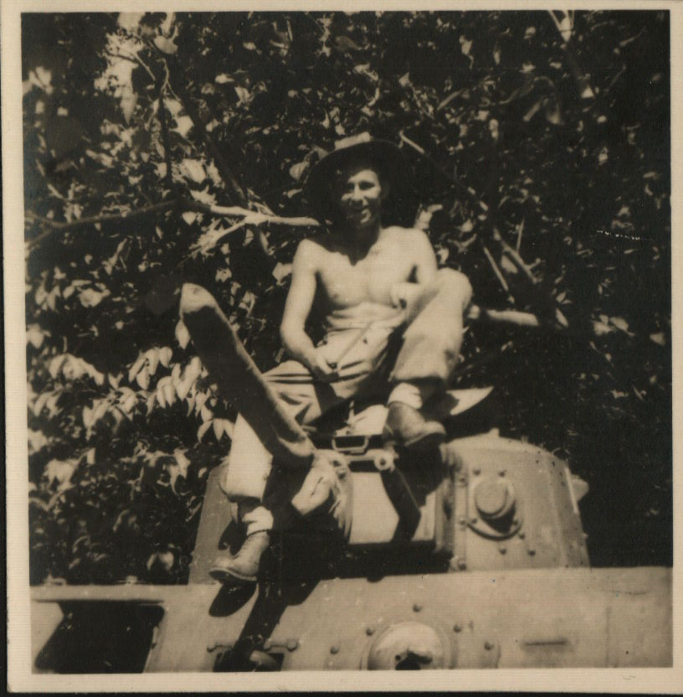

Alan embarked with the unit for New Guinea as a Sergeant in Headquarters Group aboard S.S. “DUNTROON” on 17 Jun 1943. After leave and reorganization, he embarked for New Britain aboard “TAROONA” on 9 Apr 1945 with the unit as a Sergeant.
He was discharged on 24 Jan 1946.

