BUCKMAN, Noel
NX49207

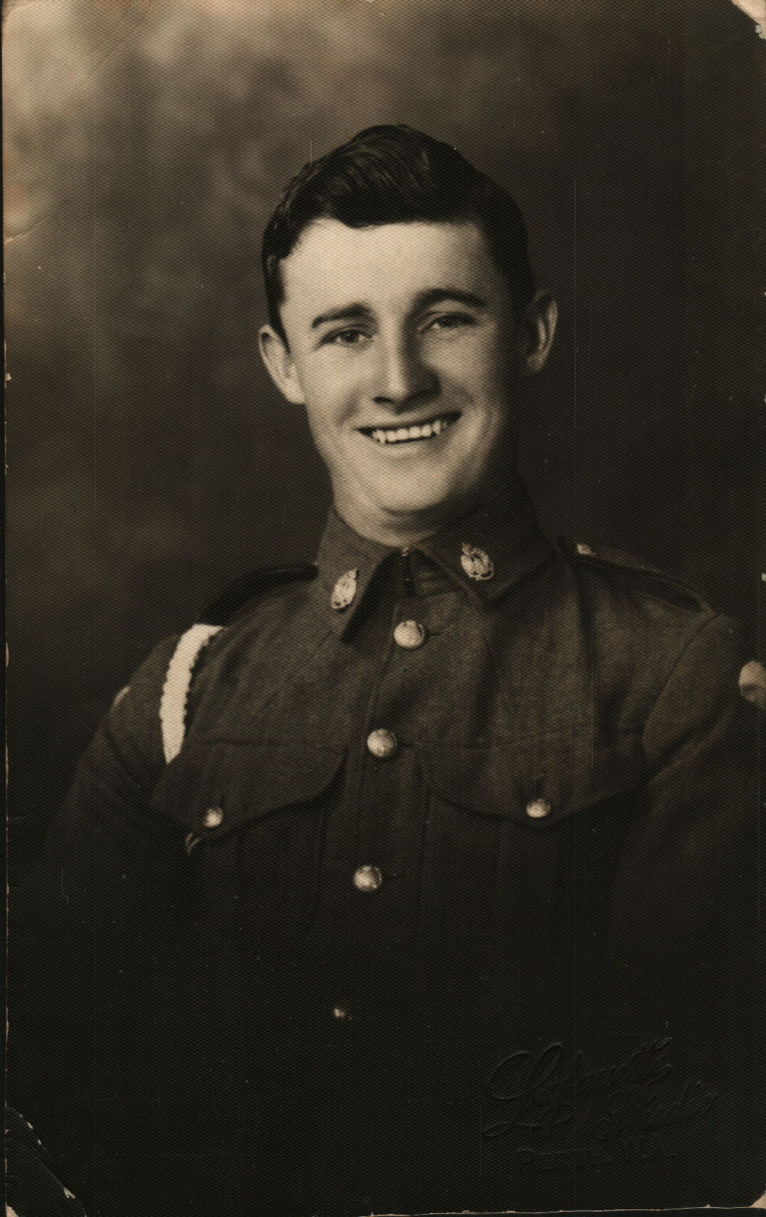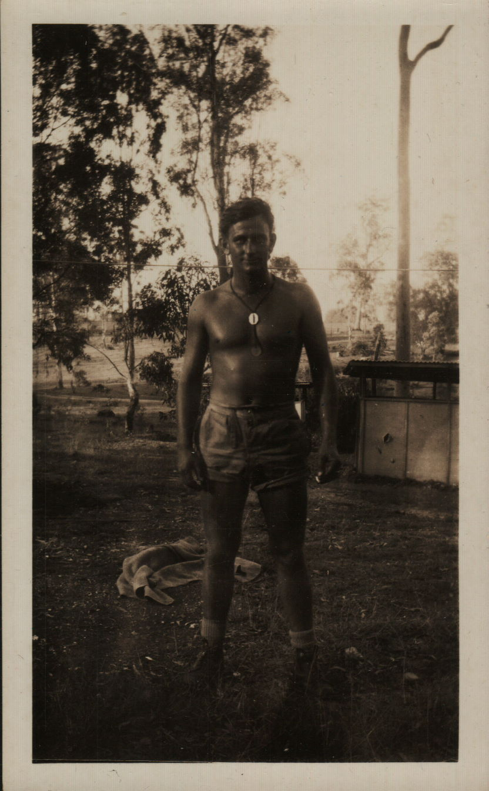

Noel was a member of the First Reinforcements that arrive at Dili, Timor, aboard M.V. “Kalama”, on 22 Jan 1942, prior to the Japanese landing. He joined the unit as a Private. After the campaign on Timor, he embarked with the unit, for Australia aboard the Royal Dutch destroyer “Tjerk Hiddes” on either 11 Dec 1942 or 16 Dec 1942, as the embarkation rolls do not differentiate.
After leave and reorganization he embarked with the unit for New Guinea aboard S.S. “DUNTROON” on 17 Jun 1943 as a Trooper, possibly in No 4 Sect, “B” Troop and returned to Australia with them aboard “TAROONA” on 3 Sept 1944.
After leave and reorganization, he embarked for New Britain aboard “TAROONA” on 9 Apr 1945 with the unit as a Trooper.
He was discharged on 25 Jan 1946.

