CONLEY, Ralph Gordon
NX38656

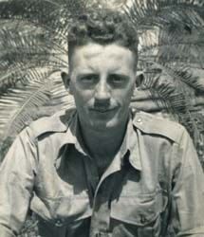

Ralph joined the unit on Timor as a Staff Sergeant from 2/1 Aust Fortress Company, after the fall of Koepang, approx March 1942.
After the campaign on Timor, he embarked with the unit, for Australia aboard the Royal Dutch destroyer “Tjerk Hiddes” on either 11 Dec 1942 or 16 Dec 1942, as the embarkation rolls do not differentiate.
On return to Australia, it is believed that he stayed with 2/1 Aust Fortress Company and finished the war as a Lieutenant.
He was discharged on 6 Nov 1945.

