GREIG, John
NX30636

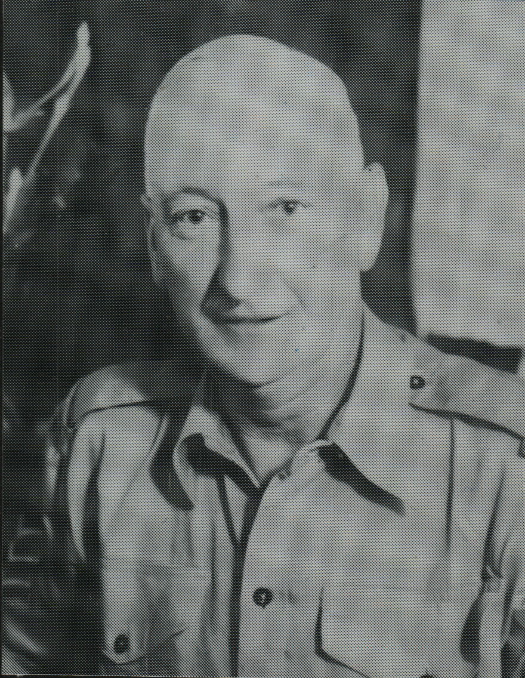

John joined the unit on Timor as a Staff Sergeant from Aust Army Service Corps, after the fall of Koepang, approx March 1942.
He was one of the former Koepang men, who moved to the village of Mape for intensive commando training and on 8 May 1942, they were formed into a new Platoon, “D” Platoon under the command of Lieutenant Turton and later under Lt Doig.
He embarked for Darwin on 29 Jul 1942.
His discharged date from the A.I.F. is unknown.
He served until 3 Mar 1955 with service No 245066 which included British Occupation Forces in Japan.

