GOODACRE, Ronald Rolf
NX131753

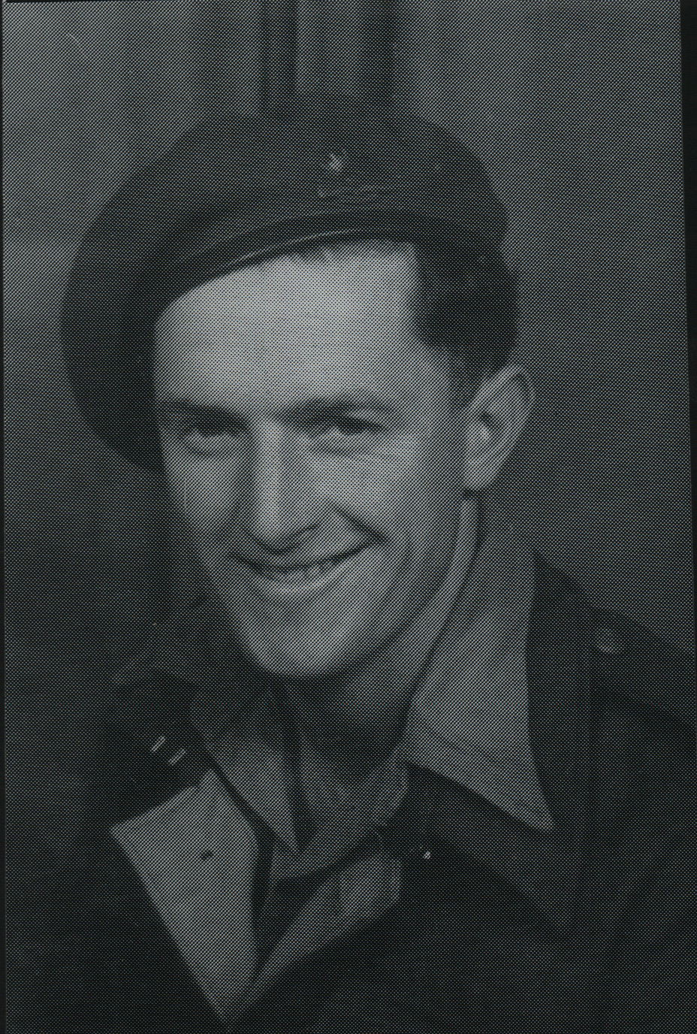

Prior to joining the unit, Ronald served in the Militia with Service No N4237 from Dec 1941 to 21 Sept 1942, with 6th Light Horse Regiment and 6th Motor Regiment.
He joined the unit at Canungra, Qld and embarked with the unit as a Trooper in No 1 Sect, “A” Troop for New Guinea aboard S.S. “DUNTROON” on 17 Jun 1943 and returned to Australia with them aboard “TAROONA” on 3 Sept 1944. After leave and reorganization, he embarked for New Britain aboard “TAROONA” on 9 Apr 1945 with the unit as a Trooper in No 1 Sect, “A” Troop.
He was discharged on 5 Jun 1946.

