CRAIG, Keith
NX130057

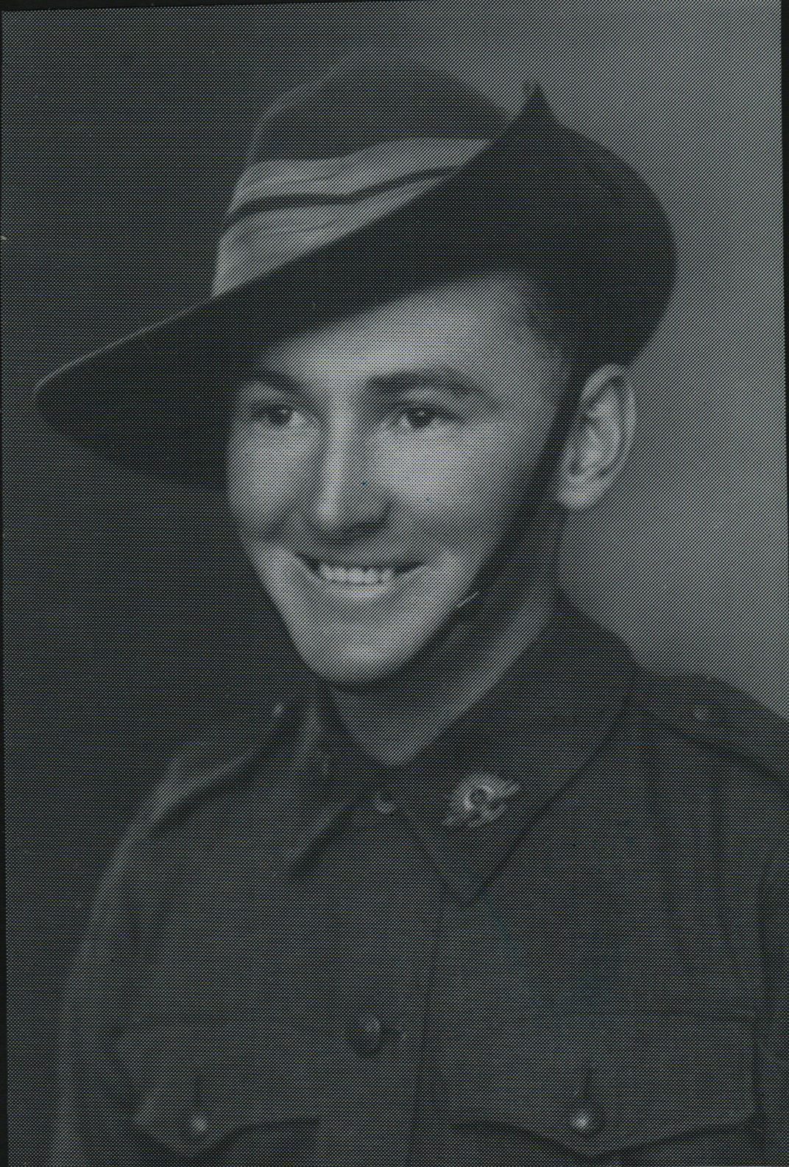

Keith joined the Militia 2 Dec 1941 and served to 21 Sept 1942, then joined the unit at Canungra, Qld and he embarked with the unit for New Guinea as a Trooper in No 5 Sect, “B” Troop aboard S.S. “DUNTROON” on 17 Jun 1943 and returned to Australia with them aboard “TAROONA” on 3 Sept 1944.
After leave and reorganization, he embarked for New Britain aboard “TAROONA” on 9 Apr 1945 with the unit as a Trooper in No 5 Sect, “B” Troop.
He was discharged on 6 Jun 1946.

