DEVLIN, Francis Micheal
NX119981

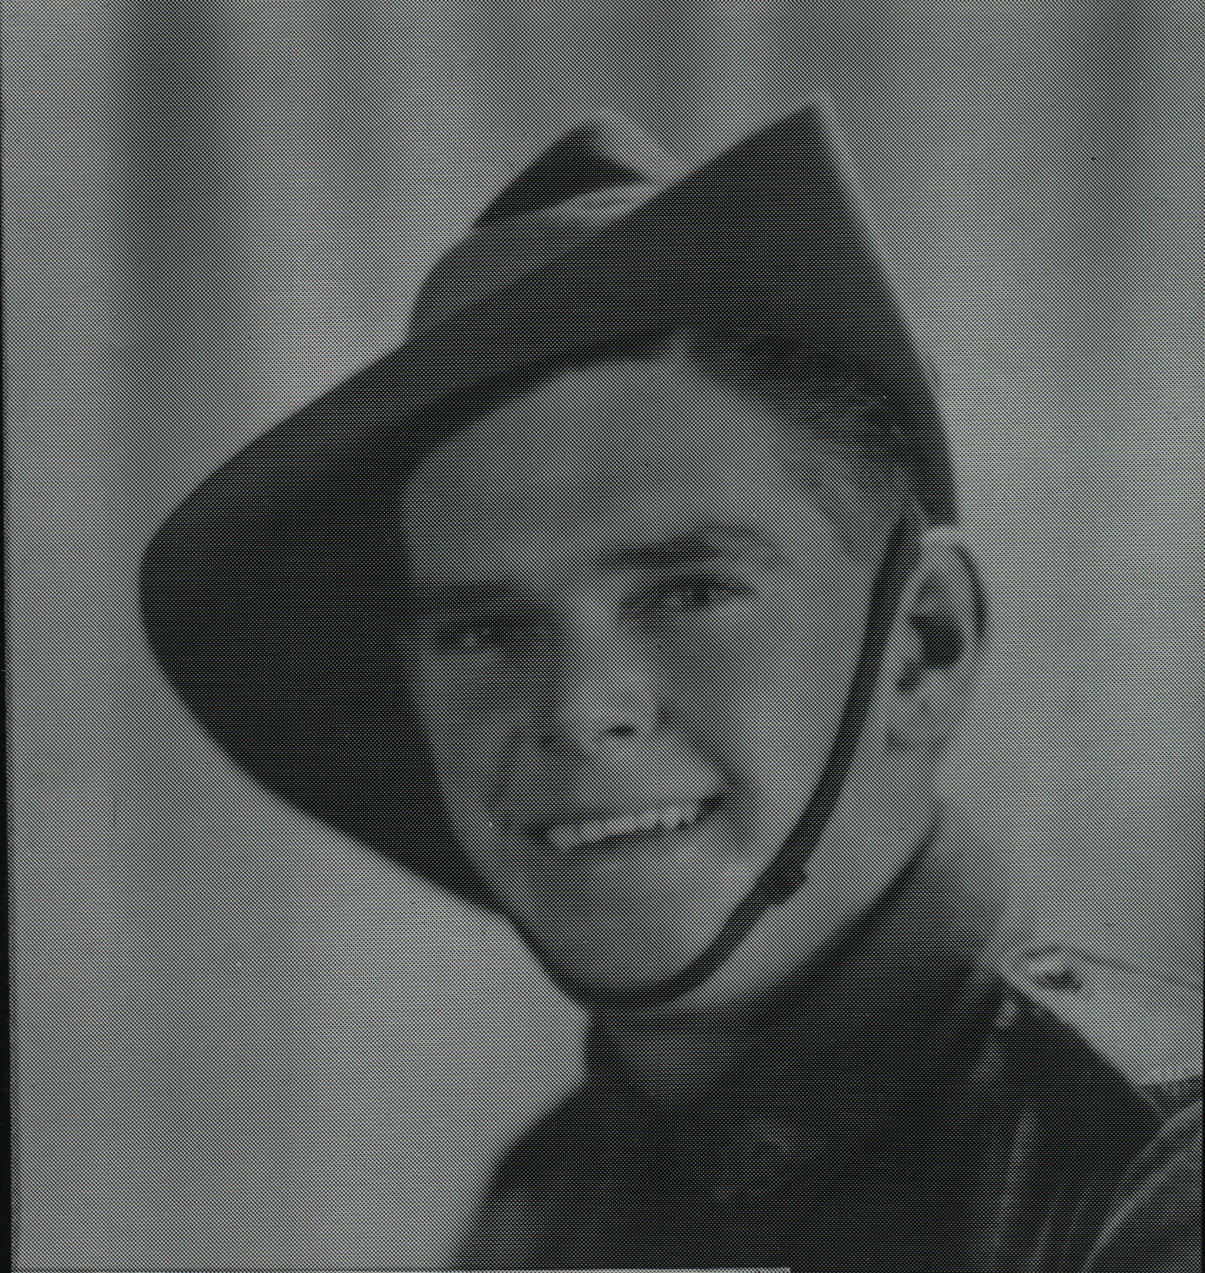

Francis joined the unit in Jun 1943 at Shrapnel Valley, New Guinea, as a Trooper in N0 9 Sect, “C” Troop and returned to Australia with them aboard “TAROONA” on 3 Sept 1944.
After leave and reorganization, he embarked for New Britain aboard “TAROONA” on 9 Apr 1945 with the unit as a Trooper in no 7 Sect, “C” Troop. He was promoted to lance Corporal while serving with the unit.
He was discharged on19 Jun 1946.

