BOWDEN, Maxwell John
NX108912

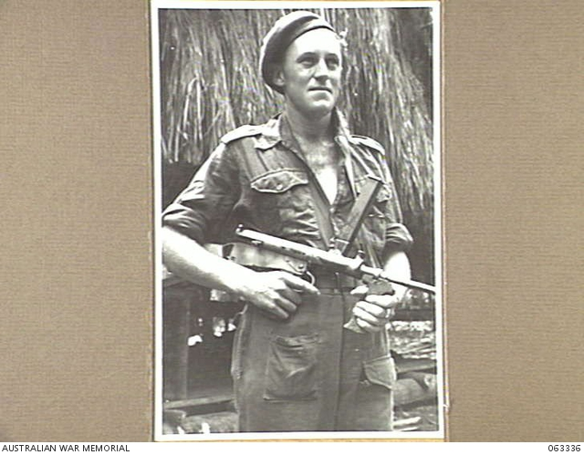

Maxwell embarked with the unit for New Guinea aboard SS “DUNTROON” on 17 Jun 1943 as a Private in No 1 Sect, “A” Troop and returned to Australia with them aboard “TAROONA” on 3 Sept 1944.
He was discharged on 4 Feb 1946.

