LANCE CORPORAL RAYMOND ALEXANDER AITKEN (WX10542) – 1915-2005
NO 4 SECT, B PLATOON
https://doublereds.org.au/history/men-of-the-22/vx/vincent-patrick-wilby-r737/
BIOGRAPHICAL SOURCES
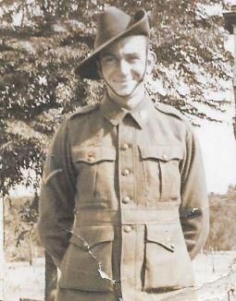

Source: Pau Cleary. - The men who came out of the ground : a gripping account of Australia's first commando campaign : Timor 1942. - Sydney : Hachette Australia, 2010.
……
Manning the forward post overlooking the town that day was a handful of the 2/2 Company’s roughest and toughest men. In command was Corporal Ray Aitken, 26, a schoolteacher from the Western Australian wheat-belt town of Mindebooka, who as a boy had camped and roamed with the Pindjarup Aboriginal people when they passed by his family’s farm on the outskirts of Perth. Despite having attended the prestigious Perth Modern School, the lanky and lean Aitken was at home in the bush.
……
When the Japanese convoy arrived in the [Bazar Tete] posto just after 10 a.m., the 2/2 men saw a senior officer begin to interrogate the administrator. The Japanese were at a range of around 400 metres, and despite presenting good targets to the Australians with rifles and Bren guns, Nisbet told his men to hold their fire. The Japanese troops soon began their trademark flanking action, moving through a chest-high maize field in a bid to encircle the 14-man Australian section, while another group of Japanese went straight up the slope. The enemy came within a stone’s throw of the forward post when the Australians opened up with a Bren gun, Tommy gun and rifles at close range. In the melee, nearly all of the Japanese— as many as 40—were killed or wounded by the intense fire, but the Australians were in a precarious position as more Japanese were pressed to attack.
The Japanese opened up with mortars and heavy machine guns, prompting Nisbet to give the order to withdraw. As the men were poised to do so, a lone enemy soldier who had survived the encounter with Aitken’s men fired at the Australians and wounded three men. Private Henry Mitchell, 34, was hit in the back as he moved off, Private Paddy Knight was hit in the stomach and Private Allan Hollow had his lower jaw blown away.
……
The remaining Japanese failed to pursue the Australians, indicating that Aitken’s men had indeed wiped out the assault troops sent up the slope, while the officers who remained at the posto were unwilling to risk more lives by pressing the attack. The remaining soldiers soon retreated as well, leaving Mitchell’s body and the wounded Knight, who told Charlie King that he was ‘finished’. King left Knight with a couple of grenades to use on the Japanese should they approach his position. A considerable time later, the distinct sound of Knight’s grenades exploding were heard by those making their way up the mountain.
……
In the second week of May, Laidlaw and Nisbet conducted a reconnaissance patrol that learned there was very little enemy activity outside the barbed wire surrounding the central part of the town.3 Laidlaw and Nisbet made contact with the village of Cacussa, about 3 km east of the town near the Fatacama headland (now Cristu Rei), which they planned to use as a staging post for assembling troops. Laidlaw and Nisbet were joined by another 18, and upon their arrival he outlined a plan that involved an assault party and a second smaller group to cover their retreat. The raid party moved off towards Dili, reaching the village of Cameia, just 1 km from the eastern edge of the town. Upon arriving at the village, the first casualty emerged—Charlie Pickering had an attack of malaria and now had a very high temperature. There was now only 13 in the raiding party, plus a further six who would cover the retreat. Among the 13 were two veterans of the bloody ambush at Bazar-Tete, Corporal Ray Aitken and Private Charlie King, whose quick reflexes and accurate aim had saved many lives that day. The other 11 men were yet to encounter the enemy.
It was a dark night with only a half-moon in the sky, but this was no hindrance to the Australians who, after months of living without any electric light or lamps, had developed excellent night vision. Before moving out of Cameia, the men blackened their faces with charcoal and grease from the cooking pots and fires of the village. The party moved into Dili following a dry river bed that ran in a north–south direction along the eastern perimeter of the town. Laidlaw established the all-important rendezvous point—a large tree in the river bed—where they left surplus gear with Timorese offsiders. They included men known as Battista, Man Lare, Rufino Alves Correia, and Juli Madeira.
Laidlaw sent corporals Aitken and Norman Thornton, a wheat farmer from Denmark, WA, into the town to probe the barbed wire. The two walked slowly down a road located one street back from the beachfront, running parallel to the coast. After an agonising wait, the pair returned to report that the barbed wire could be passed simply by pushing it down with a rifle butt, but they warned that there was a lighted hut about 200 metres from the barbed wire. Laidlaw then asked Aitken to go back down the street right to the position of the hut to see if it was clear. Aitken was about to leave with Thornton, but Nisbet, realising that Thornton was also suffering from malaria, volunteered to go in his place. Nisbet and Aitken moved down the road, following a knee-deep drain until they came right opposite the hut, where they saw a machine gun mounted on sand bags, but the post was unmanned. They reported back to Laidlaw, who then decided to mount the assault.
……
The Darlau OP had picked up useful intelligence from its network in the area. Vieira was especially helpful, and he would pay regular visits to the post, bringing information each time. After the Dili raid, one piece of intelligence concerned the arrival of a certain senior Japanese officer who was reputed to have played a leading role in the conquest of Malaya and Singapore. The officer had been brought into Timor with a special brief to clear out the ‘bandits’ in the hills. The officer was known as the ‘Singapore Tiger’. On the afternoon of 21 May, a party of six men led by Corporal Aitken set up camp above the village, about 400 metres from the OP. The Timorese partisans had bought a goat so that the men would eat well while being based there over the next four days. After five months in Timor, Aitken had become one of the more accomplished men of the company. He not only spoke Tetum, the main indigenous language in the western region of the territory, but he had also acquired some fluency in the Mombai dialect spoken by people in the hills immediately south of Dili. At the time, Mombai was the most widely spoken language in the colony, but the Australians had begun learning Tetum while they were based in Dili. The time Aitken had spent as a boy with the Pindjarup Aboriginal people gave him an affinity with the locals of Timor.
……
The firing gave Aitken’s men an early warning of a much bigger Japanese presence in the area. At first light, Aitken and Private Paddy Kenneally went down to the OP to observe the Japanese. As he swept the coastal plane and then the ridge lines leading up to the village with binoculars, Aitken spotted a column of more than 100 Japanese soldiers moving towards his position at a rapid rate. Aitken immediately packed up all their gear in the hut and moved back to the subsection’s camp, leaving no trace of their presence at Darlau. Aitken told the Timorese partisans to take all the surplus gear back to B Platoon’s camp further up the mountain and to pass on information about the Japanese movement. Aitken had instantly realised that he may well have to engage the Japanese, and by sending the Timorese away with their gear he had made his sub-section as mobile as possible.
Aitken’s men had hiked up the hill for about 1.5 km and had lost sight of the column when a small, barefoot Timorese boy came running towards them. The breathless boy spluttered the words ‘Nippon barak mai, Nippon barak mai!’ (Many Japanese are coming). Aitken was initially amused by the breathless boy’s utterances, and he challenged and joked with him. But when the boy caught his breath he explained that the enemy had taken another track which would put them above Aitken’s party. Such was the crazy network of mountains and tracks that Aitken’s men had lost contact with the large force. Aitken was ‘mighty grateful’ for this information, and quickly ordered his men to set off up the steep hill to reach a track leading east–west along a ridge heading into the village of Remexio, putting the Australians well above the Japanese column.
Aitken decided to set an ambush with the party of just six men, five of whom had seen action the week before on the Dili raid. They were Corporal Norman Thornton with the Tommy gun, and privates Kenneally, Don Lacey, and George Smith armed with ordinary .303 rifles. The only member of this group not to have seen action was Private Charlie Pickering, who carried the sniper’s rifle. Pickering had recovered from the bout of malaria which sidelined him in the Dili raid. The experience gained from the Dili raid could not make up for a profound lack of fire power. To properly engage the large force, Aitken’s men needed a Bren gun so that they could fire from a safe distance. They also lacked criados, which meant they had no way of sending back information to the platoon headquarters about the imminent engagement. One option might have been to send a soldier, but Aitken could ill-afford to lose one more rifle.
In a hastily arranged deployment, Aitken’s group clambered up a steep slope into a coffee plantation above the track. Aitken put his men adjacent to the stream that crossed the road where the track turned to the north, allowing them to look straight down the track for a distance of more than 500 metres. Kenneally thought Aitken had chosen the best location for an ambush that he saw during his time in Timor.10 But the position afforded the men very little cover in the likely event of return fire. Aitken put Corporal Thornton with the Tommy gun on the far left, closest to the enemy’s approach, while the riflemen were located further back towards a waterfall. Minutes after the six men settled into their positions, the column of Japanese soldiers appeared at the end of the track. First came four forward scouts, then another four 20 metres behind them, followed by the main body of troops led by a solidly built officer wearing a decorative military uniform and a sword. The Australians opened up on the forward scouts and the officer, while the rest of the column hit the ground or dived into a culvert for cover. Many of the Japanese fell off the track and plunged down the side of the mountain after being hit. As the Japanese retreated they carried the wounded officer with them. One group attempted to mount a heavy gun, but this attempt was probably foiled by Private George Smith and his .303 rifle. All of the riflemen were into or through their second magazine when Aitken signalled the retreat. Smith, 27, from Jarrahdale, WA, seemed to fire more than anyone else. Aitken said Smith had fired his .303 rifle like a machine gun, while Kenneally believed that it was Smith who ‘probably’ hit the senior officer.11 The Australians were well up the hill and over a crest before the Japanese brought their machine guns and mortars into action.
……
Source: Edward Willis – WWII in East Timor: an Australian Army site and travel guide. – Perth, W.A.: 2/2 Commando Association of Australia, 2004.
Exploring Around Dili - December 1941 – February 1942
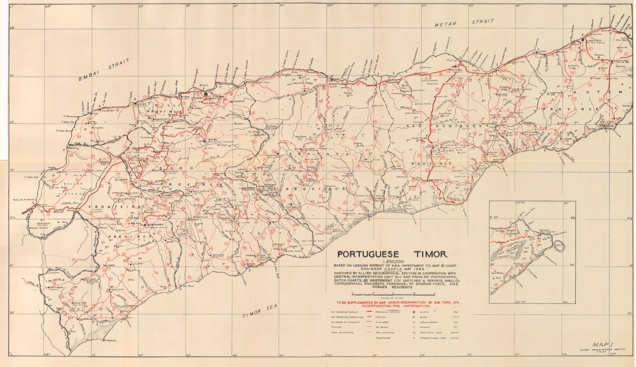
Road and track map of Portuguese Timor prepared for the Area Study and based on this early and later surveying activity [9]
Stan Aitken described how the mapping work was done:
“We removed ourselves now to the country. A Platoon went to the hills along the Dili – Aileu Road at a place called by the Australians Three Spurs. C Platoon were at Tibar, a cactus walled village near the junction of that road and the coast highway. B Platoon drew Cactus Flat, a hot salt encrusted area on the coast road, but to the west.
When it was realised that despite triangulation and despite the cost of their production, the maps of Porto National Geographic Society were hopelessly inaccurate, particularly as to distance, an attempt was made to right the matter. A series of compass traverses were put into hand and it was discovered that one “Dusty” had a skill in cartography.
…
The Timorese themselves are distinctly conditioned by their mountains. They describe heavy-going simply as “Sai Tune”, which means only “up down”. On the other hand, their concept of “flat” is a strange one. Ask a Timorese to describe a piece of land which only requires, say, a thousand climbs and descents each of say, four or five hundred feet per day’s march and he will invariably say, “raitecic” which means level ground. We found this clash of training and concepts vastly nerve-wracking.
The compass traverses gave one sub-section of the unit a solid lesson in the dangers inherent in unfamiliarity with terrain. The traverse was being made up a river which on the coast was a broad dry stream with a single viable creek amongst the sand. As the Section climbed, the stream became a fast running half-leg deep affair between rocky walls. The traverse was made in a practical if primitive manner. A single soldier with a bayoneted rifle slung across his shoulder would march ahead until an obvious turn in the stream would mean that further progress would render him invisible to his fellows. The soldier with the compass would take a reading on the bayonet and one of his fellows would ‘book’ it. The members of the Section would then pace the leg silently and on reaching the first soldier would compare notes. One of their numbers would remain at the beginning of the leg. This provided a sight for sight for ‘back bearing’. It may sound a very rough measure but these soldiers were highly skilled in ‘yard stepping’ and variations were slight and differences of opinion rare. A continuous bearing taking on all recognizable features right and left of the legs from both its extremities permitted a triangulation insurance policy against major error”. [10]
References
[1] Allied Geographical Section, South West Pacific Area. - Area study of Portuguese Timor. - [Brisbane] : The Section, 1943. Hereafter referred to as ASPT.
[2] Bowd “The Allied Geographical Section, 1942–46: forgotten by history”: 36.
[3] Cleary, The men who came out of the ground: 11-12.
[4] Barker, One man’s jungle: 108.
[5] AWM52 25/3/2/3 - 2AIC war diary July and August 1941.
[6] AWM52 25/3/2/3 - 2AIC war diary July and August 1941.
[7] Keighley, Map reading and field sketching, 1942.
[8] Cleary, The men who came out of the ground: 33.
[9] ASPT: Map 1.
[10] Extract from Aitken, Tales of the 2/2.
………..
5. Darlau (Daralau)
8°35’33.204”S, 125°37’51.624”E
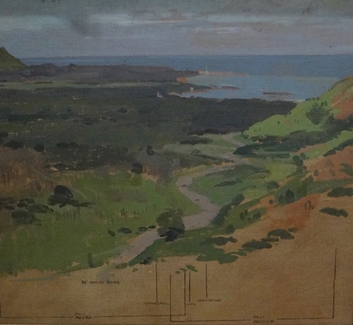 | Charles Bush ‘Panorama of Dili area’ 1945  The scene of many of the operations of 2/2nd Australian Independent Company in their guerilla warfare against the Japanese in Timor during the Japanese occupation of the island. [1]
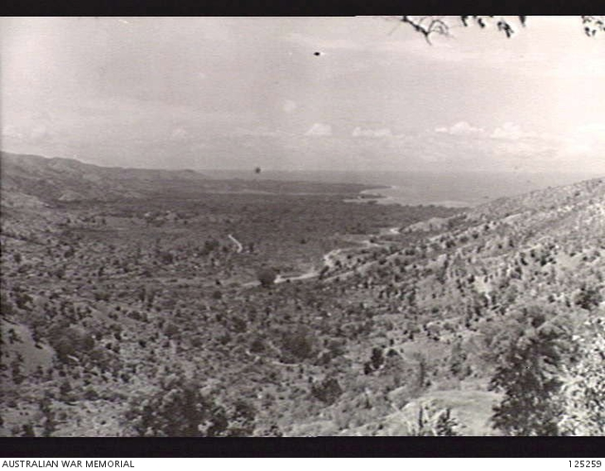 | Fatuai [Darlau], Portuguese Timor. 1946-01-09. The Baiwro China Valley showing the districts of Taibessi and Dili. (Photographer Sgt K.B. Davis) [2]
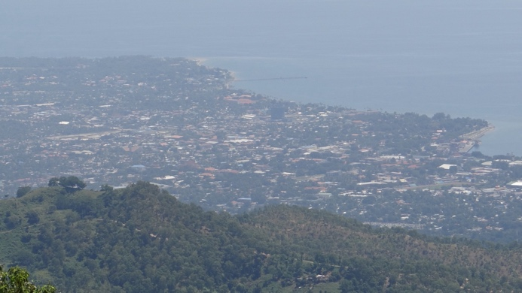 | Dili from the Darlau OP - 26 April 2014
Ray Aitken:
… No. 4 Section established an OP in the village of Daralau – a very good OP according to Ray Aitken who wrote:
“A hole had been made in the rear wall of a hut which overlooked all the clear portions of the coastal plain. Two operators, one with binoculars and one with a notebook, could sit in the dark interior with a bird’s eye view of our Nipponese neighbours ...... The view of Dili was excellent, commanding the aerodrome, the anchorage, long stretches of the main road east and west, and the Comoro River bridge.
The OP may have been a good position for spying on the enemy but it was one of the most uncomfortable and dangerous in the company’s observation network. At least five tracks led to it, making it difficult to guard. The main river track from Dili disappeared behind a ridge, only to reappear in Daralau’s village square. A second track from the capital did the same. Any Japanese patrols which were not seen leaving Dili, and which used either of these tracks, would be almost onto the OP before the Australians knew of them. Another problem was that the local Timorese, though very loyal, were few in number and too poor to provide the Australians with food. Adding to the difficulties was that the section was nearly always under-manned, so that the OP was often worked at less than sub-section strength. The living conditions were so bad, the operators never stayed there more than three or four days at a time. Because the position was so dangerous it was never manned at night – the men pulled out in the evening, camped in the bush alongside one of the tracks, and returned at daybreak”. [?]Darla
Ray Parry:
“Ray Parry (No. 5 Section) tells an interesting story concerning the aforementioned Indian Joe, whose temperamental truck had been used by the 2/2nd soon after their landing in Dili. Nothing had been heard of the white-suited gentleman since the arrival of the Japanese so that when he was seen walking towards the rear of the section’s OP at Daralau seven months later, he was greeted with some suspicion. When he was asked what he was doing in the area and where he was going, he said merely that he had come to visit them and to say “Hello”.
When Cpl Loud asked him how he knew where they were, he said some friends had told him.
“Maybe the Japanese told you?” suggested Loud.
“No, no, they do not know,” said Indian Joe.
Parry, who had been the first to see him, said he wanted to take him prisoner.
“I implored Ted Loud and the boys not to allow him to return to Dili,” said Parry. “I told him we’d been trying for months to take a prisoner with absolutely no success and here we had a chap right on our doorstep who would know more about what was going on in Dili than the average Jap soldier. And he would certainly have had a pretty fair knowledge of the disposition of Japanese units in and around the town. Indian Joe understood much of what I was saying and was showing signs of considerable unease. I told Ted: ‘As soon as that bastard gets back to Dili everybody in the city will know where we are.’ However my request fell on deaf ears; I had to watch him walk away. A few paces before he disappeared round a bend in the track he looked back. I called out: ‘You can count your blessings, fella.’”
Next morning Parry left the camp intending to walk to a fairly distant OP overlooking Dili.
“There were two of these OPs and it was no easy task to reach them,” he said. “We had to cross the Dili-Manatuto road, avoiding being seen by some pro-Japanese Timor youths who were manning a field telephone in a grass and bamboo hut, a few metres from the road. At that point the road passed through a cutting. Beyond it lay Dili. The lushness of the flora had turned the area into a jungle but across the road were just trees and sparse undergrowth.
“We had occupied the OP for an hour or so when we heard Japanese artillery fire. I could tell from the smoke and dust that they were firing on Daralau.”
The bombardment caused no serious casualties – just a few cuts and bruises – but Parry was under no doubt that Indian Joe had tipped off the Japanese about their position. “He never extended us the courtesy of another visit,” he said. [4]
References
[1] AWM Collection item ART26319. https://www.awm.gov.au/collection/C174948. Accessed 3 May 2024.
[2] AWM Collection item 125259. https://www.awm.gov.au/collection/C221097. Accessed 3 May 2024.
[3] Ayris, All the Bull’s men: 260.
[4] Ayris, All the Bull’s men: 302-304.
6. Singapore Tiger Ambush Site
8°37'18"S, 125°38'36"E [1]
2AIC war diary:
22 May | During the night 21-22 May Japanese moved out and camped on the REMEXIO track. They intended to move on to that place the day following. At approx. 0400 hrs L/Sjt TOMASETTI and L/Cpl KIRKWOOD with several Portuguese were returning from COMHER along the track to REMEXIO when the patrol encountered the Japanese patrol. They killed 4 or 5 and then went bush.  The shooting warned the sub-Section under Cpl AITKEN at DARALAU who ambushed the Japanese at approx. 1000 hrs. The Japanese lost 25 in the ambush, and as they fled without firing a shot; there were no casualties to our troops. Our troops retired to LILTAI. The Japanese retired to DILI. [2]
Cleary:
The Arrival of the Singapore Tiger in Dili
The Darlau OP had picked up useful intelligence from its network in the area. Vieira was especially helpful, and he would pay regular visits to the post, bringing information each time. After the Dili raid, one piece of intelligence concerned the arrival of a certain senior Japanese officer who was reputed to have played a leading role in the conquest of Malaya and Singapore. The officer had been brought into Timor with a special brief to clear out the ‘bandits’ in the hills. The officer was known as the ‘Singapore Tiger’.
Corporal Ray Aitken
On the afternoon of 21 May, a party of six men led by Corporal Aitken set up camp above the village, about 400 metres from the OP. The Timorese partisans had bought a goat so that the men would eat well while being based there over the next four days. After five months in Timor, Aitken had become one of the more accomplished men of the company. He not only spoke Tetum, the main indigenous language in the western region of the territory, but he had also acquired some fluency in the Mombai dialect spoken by people in the hills immediately south of Dili. At the time, Mombai was the most widely spoken language in the colony, but the Australians had begun learning Tetum while they were based in Dili. The time Aitken had spent as a boy with the Pindjarup Aboriginal people gave him an affinity with the locals of Timor.
Tomasetti and the International Brigade Ambushed
Early on the morning of the 22 May, at about 4 a.m., the Darlau post was wakened by the sound of gunfire in the hills around them. A party of Australian and Portuguese volunteers led by Corporal Bill Tomasetti had been surprised by a Japanese patrol. Tomasetti had been put in charge of a so-called ‘International Brigade’ of serving and former Portuguese army NCOs, and deportados (political deportees). The brigade had a number of capable soldiers, including Juli Madeira, José ‘Zeca’ Rebelo, Alfredo dos Santos, and Fernando Martins. Tomasetti’s men killed about five Japanese before heading for the hills, but they left behind Martins, who was captured. The Japanese dealt brutally with their prisoner. They tied Martins to his pony and dragged him along rocky mountain tracks all the way back to Dili. He was almost unrecognisable upon reaching Dili and died along the way.
Aitken Prepares for a Japanese Attack
The firing gave Aitken’s men an early warning of a much bigger Japanese presence in the area. At first light, Aitken and Private Paddy Kenneally went down to the OP to observe the Japanese. As he swept the coastal plane and then the ridge lines leading up to the village with binoculars, Aitken spotted a column of more than 100 Japanese soldiers moving towards his position at a rapid rate. Aitken immediately packed up all their gear in the hut and moved back to the subsection’s camp, leaving no trace of their presence at Darlau. Aitken told the Timorese partisans to take all the surplus gear back to B Platoon’s camp further up the mountain and to pass on information about the Japanese movement. Aitken had instantly realised that he may well have to engage the Japanese, and by sending the Timorese away with their gear he had made his sub-section as mobile as possible.
A Small Boy’s Warning
Aitken’s men had hiked up the hill for about 1.5 km and had lost sight of the column when a small, barefoot Timorese boy came running towards them. The breathless boy spluttered the words ‘Nippon barak mai, Nippon barak mai!’ (Many Japanese are coming). Aitken was initially amused by the breathless boy’s utterances, and he challenged and joked with him. But when the boy caught his breath he explained that the enemy had taken another track which would put them above Aitken’s party. Such was the crazy network of mountains and tracks that Aitken’s men had lost contact with the large force. Aitken was ‘mighty grateful’ for this information, and quickly ordered his men to set off up the steep hill to reach a track leading east–west along a ridge heading into the village of Remexio, putting the Australians well above the Japanese column.
Aitken Sets an Ambush
Aitken decided to set an ambush with the party of just six men, five of whom had seen action the week before on the Dili raid. They were Corporal Norman Thornton with the Tommy gun, and privates Kenneally, Don Lacey, and George Smith armed with ordinary .303 rifles. The only member of this group not to have seen action was Private Charlie Pickering, who carried the sniper’s rifle. Pickering had recovered from the bout of malaria which sidelined him in the Dili raid. The experience gained from the Dili raid could not make up for a profound lack of fire power. To properly engage the large force, Aitken’s men needed a Bren gun so that they could fire from a safe distance. They also lacked creados, which meant they had no way of sending back information to the platoon headquarters about the imminent engagement. One option might have been to send a soldier, but Aitken could ill-afford to lose one more rifle.
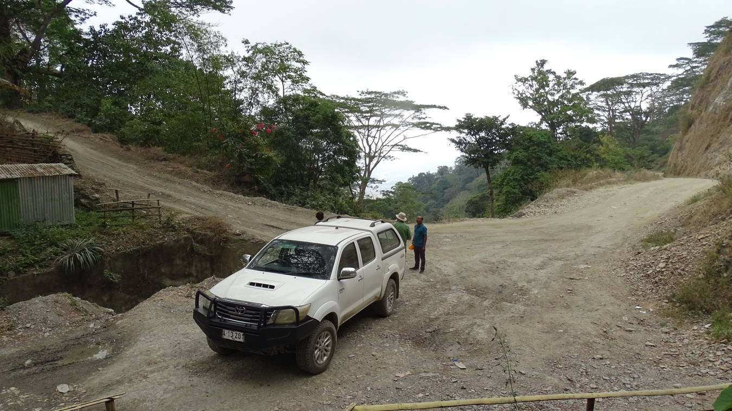
Singapore Tiger ambush site – 5 August 2022
The Ambush Site
In a hastily arranged deployment, Aitken’s group clambered up a steep slope into a coffee plantation above the track. Aitken put his men adjacent to the stream that crossed the road where the track turned to the north, allowing them to look straight down the track for a distance of more than 500 metres. Kenneally thought Aitken had chosen the best location for an ambush that he saw during his time in Timor.
But the position afforded the men very little cover in the likely event of return fire.
The Japanese Arrive
Aitken put Corporal Thornton with the Tommy gun on the far left, closest to the enemy’s approach, while the riflemen were located further back towards a waterfall. Minutes after the six men settled into their positions, the column of Japanese soldiers appeared at the end of the track. First came four forward scouts, then another four 20 metres behind them, followed by the main body of troops led by a solidly built officer wearing a decorative military uniform and a sword.
The Ambush
The Australians opened up on the forward scouts and the officer, while the rest of the column hit the ground or dived into a culvert for cover. Many of the Japanese fell off the track and plunged down the side of the mountain after being hit. As the Japanese retreated they carried the wounded officer with them. One group attempted to mount a heavy gun, but this attempt was probably foiled by Private George Smith and his .303 rifle. All of the riflemen were into or through their second magazine when Aitken signalled the retreat. Smith, 27, from Jarrahdale, WA, seemed to fire more than anyone else. Aitken said Smith had fired his .303 rifle like a machine gun, while Kenneally believed that it was Smith who ‘probably’ hit the senior officer. The Australians were well up the hill and over a crest before the Japanese brought their machine guns and mortars into action.
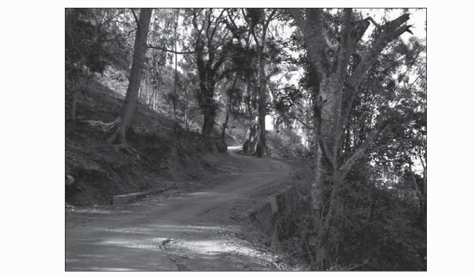
Recent photo of the location of Remexio ambush, May 1942, from the vantage point of the six Australiana (Paul Cleary) [3]
The Singapore Tiger Killed
The party came into contact with Laidlaw just a few hundred metres above their position. Had they waited for the main platoon to join them they would have been much more heavily armed. João Vieira later told the Australians that the casualties were around 30 that day, including the officer with the sword, who was believed to have died of wounds on his way back to Dili. For the six Australians who took part in this ambush, the person who loomed largest after the event, and for many years to come, was the small boy who came racing uphill crying ‘Nippon barak mai!’. [4]
References
[1] The site described is that researched and located by Paul Cleary. It is nearby the Jardim Remexio [Leroliça], a picnic spot on the road into Remexio.
[2] 2AIC war diary.
[3] Cleary, The men who came out of the ground: photos between 145-146.
[4] Cleary, The men who came out of the ground: 133-137.
…………………
3. Boibau (
8°40'58.1"S, 125°19'03.4"E
Boibau (-8.6828,125.3176, 644m, accuracy: 100m): Located at a military defence outpost held by the Portuguese on a high spur with extensive views for good defence. [1]
Fazenda Algarve (-8.6708,125.3298, 916m, accuracy: 20m): Located at the house of Carrascalão near Darulete. The caretaker showed the site of the old weather station in Portuguese times and a wind run gauge was also found installed during Indonesian times. Fazenda Algarve was originally known as Granja Eduardo Marques, founded in 1908 employing 5,000 indigenous labourers. [2]
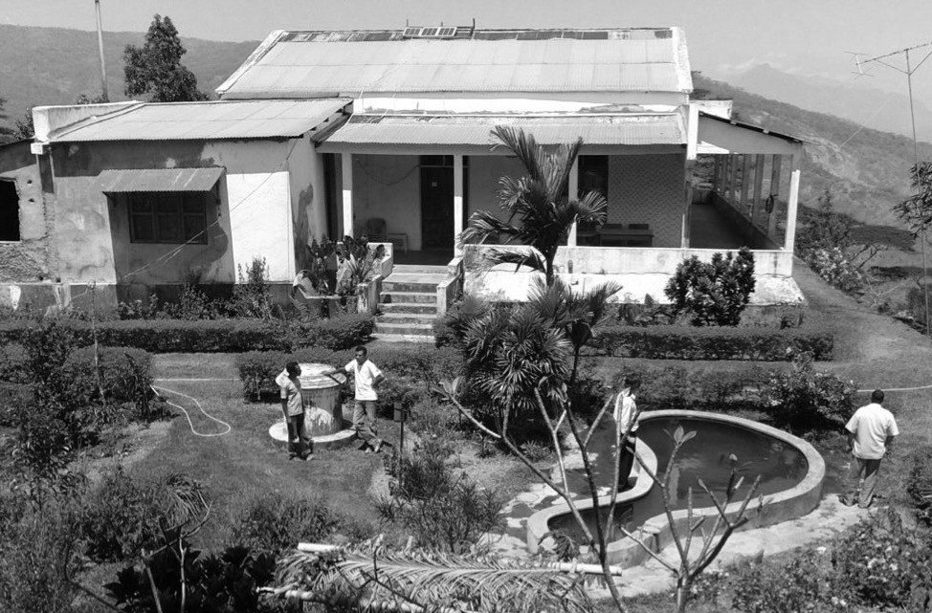
The house and gardens of the historical farm of Fazenda Algarve … [3]
24c. Hatu-Lia to Fatu-Bessi to Boibau to Liquissa (Liquiça):
Distance, 20 miles (32 km.). Time taken, 13 hours.
The track heads northwest from Hatu-Lia and crosses the Batuto River and the Lalimilau Range at its western end. It then swings east into the Sociedade's coffee plantations at Fatu-Bessi. The track then heads north and then crosses the Lauela River and passes through the large native market centres of Boibau and Banturo. The track then climbs north past Mt. Cutu-Lau (Fatu Masin on map) and descends a spur towards a watercourse which leads to Liquissa. Cover throughout the journey is good, but portions of the track are very steep. [4]
Located at the top of the cliffs of the Lois River, on a small plateau, opposite the famous Fátu-Béssi plantation, Boibau confronts, in the direction of Liquiçá, the Eduardo Marques farm, agricultural experiment station where some Europeans lived. Once the seat of an administrative post, it enjoys an excellent climate and, at the time, had a large and comfortable house. [5]
Ray Aitken’s Recollections of Boibau [6]
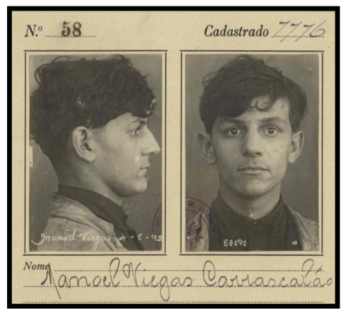
Manuel Viegas Carrascalão [7]
Reconnaissance to Boibau
Out went the Sections to ‘traverse’ routes into Dutch Timor so that the Company might withdraw by land. As far as Four Section was concerned, Lieutenant Tom left for the great Nanura Plains to the southwest to examine the crossings of the mighty Lois River. Mick continued to garrison Nun Turi Pu, while Ray left with Big Pat and Bill to map the route from Bazaar Tete to Boibau over which it was likely that B Platoon would withdraw.
The lack of rations in a peaceful Timor was not a very serious matter as Command had managed to organise co-operation with the Portuguese on promise of eventual payment. The Portos in turn had undertaken to honour any legitimate ‘surat’ (receipt) presented by a native. In any case, particularly as regards small patrols, the unfailing hospitality of a simple people and the Portos equal if somewhat more flamboyant goodwill always ensured a well-planned patrol of at least ‘one good feed per day’. To this end, Ray decided to go on a forced march to Boibau in one day and after camping the night there to ‘traverse’ on the slower uphill return journey over two days, for it was known that at Boibau was a Governmental Experimental Station with a rehabilitated communist exile as its chief. The ‘Granza’ [Granja Eduardo Marques] was designed to experiment in possible new crops for the island but, in fact, had degenerated into a plantation growing those crops already established.
The ‘Granza’ [Granja Eduardo Marques]
Morrera Ratua had given Ray an expressive picture of Manuelo Caviscalou [Manuel Viegas Carrascalão] the manager of the Granza. He was a ‘deportado’, that is to say he was exiled to Timor for life as a result of taking part in one of the several communist revolutions which had occurred in Lisbon. There were a number of Deportados on Timor. Some were independent farmers but for the most part they had some form of semi-governmental job and though looked upon as lower in status than the official Portos, were still very important people.
The trip to Boibau was without incident and the Granza residence proved to be a great white building with a flight of broad white steps before the main door. On the top stood a man so thin and tall in his white tropical suit as to give the impression of making a third pillar. His aquiline face was stern and forbidding. He nodded graciously enough when the Corporal saluted, but it was Pat who carried the day. Raising his right hand in clenched fist, he literally shouted “Bon dia Comrade”. The stern face of the Portuguese lit up like a lamp and he crashed out a return greeting. “That’s the bloody way to get through to these bloody commos mate”, said Pat to the Corporal.
Manuel Viegas Carrascalão - the Manager of the Granja
Like most deportados, Caviscalou [sic] had a Timorese wife. In fact, he had several. The house was full of delightful children of varying shades, but all showed promise of great height. Manuelo himself was above six feet six. Also in the house was the Timorese wife of the Dili butcher.
The three Australians showered and while this was happening their sweaty shorts and shirts and underclothing were washed, dried and pressed and returned to the bathroom. Pat spent the waiting period in the bath, puffing and blowing like a grampus.
The meal served that evening was a five-course affair with good wine and equally good coffee and brandy to follow. For soldiers who to conserve food and disguise some of it, normally sat down to thick greasy stew, it was manna from heaven. Our host had no English, and our Tetum was still confined to food and place names.
After dinner, Pat who was out of training as a result of HQ inactivity, and Bill who had a slight attack of malaria ‘hit the hay’. Ray and Manuelo stayed up with the brandy until the small hours with a pad and pencil each and with a Porto-English, English-Porto dictionary, sliding from one to the other between the brandy glasses. The discussion, dictated by the host, was strictly political. “Are there facisti in Australia?”, enquired Carrascalão. “No”, printed Ray, perhaps with a little tongue in cheek. “What about BHP?”, asked Carrascalão. Only the limitations of the method of conversation prevented the Corporal from trying to re- establish the image of Broken Hill Proprietary Ltd.
Bad News From Dili
It was a long night and in the pre-dawn the house was in uproar. Manuelo shook the troops awake. The “telefone – Dili – Atropas Japoneses”. Out of this spate of words rendered more unintelligible by the fact that the butcher’s wife screamed continuously, “Patron, Oh, Patron”, (since her husband was still apparently master in his own house), we gleamed the disquieting news that the Jap had landed in Dili and taken the air strip and town. The telefone was now defunct, so we could get no more. “What about the traverse?” asked Pat. “To hell with the bloody traverse”, said Ray with some petulance. “Mick is on that ridge like shag on a rock with half a Section. We are going back, and we are going to make the climb in half a day”. “Spoken like a bloody man”, said Pat.
References
[1] Bacon and Neto “Uncovering historical sites: finding the locations of historical weather station sites in Timor-Leste”: 170.
[2] Bacon and Neto “Uncovering historical sites”: 171; see also Christopher J. Shepherd and Andrew McWilliam “Cultivating plantations and subjects in East Timor: a genealogy”.
[3] Bacon and Neto “Uncovering historical sites”: 170.
[4] ASPT: 44.
[5] Liberato, Quando Timor foi notícia: memorias: 134.
[6] Aitken, Tales Of The Second Second: [41].
[7] Barreto, Timor do século XX: deportação, colonialismo e interações culturais: 276-288.
.....................
Source: Paul Cleary. - The men who came out of the ground : a gripping account of Australia's first commando campaign : Timor 1942. - Sydney : Hachette Australia, 2010.

