PRIVATE JOSEPH WILLIAM POYNTON (WX12552) – 1922-2004
NO 2 SECTION, A PLATOON
https://doublereds.org.au/history/men-of-the-22/wx/joseph-william-poynton-r10/
BIOGRAPHICAL SOURCES
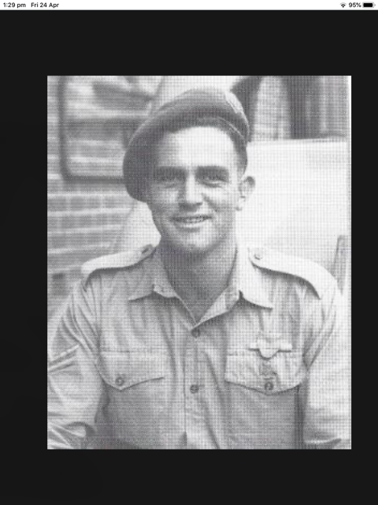
______________
Cleary, The men who came out of the ground:
…….
ON 19 FEBRUARY 1942 at 10 a.m., Japan’s advance through Asia arrived on Australia’s doorstep when 188 planes attacked Darwin, killing an estimated 250 people. The raid was designed to knock out Allied air power in Australia’s sleepy northern outpost so that Japan’s plan for simultaneous landings in east and west Timor could be carried out later in the evening.
…….
The battle-hardened 228 Regiment under the command of Colonel Sadashichi Doi, which had fought its way down through China and was fresh from conquering Allied troops in Ambon, was marching in three columns towards Dili. …. Two companies of the 228’s 2 Battalion were heading east into Dili, while 7 Company was moving south-east towards the mountains in order to block the retreat of the Allied troops in Dili town and at the airfield.
…….
Privates Joe Poynton, 19, and Herbert Thomas, 30, used their Tommy guns to good effect, while Private William Hudson, 22, used his rifle and Curran lobbed grenades.
…….
As dawn approached, McKenzie realised that his situation was hopeless. His men would be completely exposed by daylight and the section was likely to suffer more casualties, if not be wiped out completely. McKenzie decided that he could not follow his orders; he prepared to blow the runway with charges which had been set for some weeks and then make a run for the town. Just as McKenzie’s men prepared to depart the airfield, about a dozen Japanese troops charged their position, crossing the footbridge over the canal. The Australians returned fire and stopped the advance. Firing at a range of 50–100 metres, and despite having little protection other than the corner of a tin shed, Poynton, Thomas, Hudson, and Curran held off ‘streams of Japs who were trying to force their way across the little bridge’.
Of the four men, it was Poynton’s firing that proved to be the most accurate and prevented the position from being overrun. The men from the section saw Poynton ‘fill the ditch’ with Japanese as they pressed their attack over the footbridge. Poynton had fitted a 50-round drum magazine to his Tommy gun; so intense was his firing that the gun became too hot to handle and Poynton had to ask his mates to help him change the magazine. During a lull in the fighting, a single shot rang out from the middle of the airfield. Two engineers who were positioned in a slit trench had seen a figure trying to crawl out to cut the wires to the explosives. One of the engineers, Corporal Rex ‘Tex’ Richards, stopped the infiltrator. Just before dawn, McKenzie gave instructions to Corporal Curran to blow the airfield while McKenzie and a party of four would cover their retreat, all of them meeting at the south-east corner. To make their escape they would first have to cross 600 metres of the airfield’s open ground. As they prepared to leave, still more Japanese pressed the Australian position but they were held back by the party of just four men.
…….
The explosion created a huge diversion for McKenzie’s men, who were quickly making their way towards the corner of the runway. As Poynton, Thomas, and Hudson covered the withdrawal amid a crazy scene of smoke and dust and bullets, they found time for one last gesture for a brave and dying comrade. They saw that Private Gannon lay wounded next to his signal lamp and so they raced over towards him. Hudson, who like Gannon had enlisted in the outback mining town of Kalgoorlie, realised that Gannon was so badly wounded that he could not be moved. Hudson grabbed Poynton’s water bottle and left it with Gannon, bidding his dying mate a heartfelt farewell before moving off with the rest of the party.
…….
At 8.30 a.m. McKenzie’s party made haste towards the mountains, joining a convoy of Dutch soldiers in a car and a truck. After passing the governor’s residence McKenzie spotted a Japanese soldier on the road. He went to fire on him but his gun jammed. This was a lucky mishap because McKenzie soon realised that the Japanese soldier was a member of an ambush party that had been set up to wipe out the retreating soldiers. McKenzie looked for a better location to approach the Japanese position undetected. As they moved above it, they saw that it was manned by eight Japanese soldiers armed with two light machine guns and six automatic rifles.
Poynton and Private Fred Growns, 21, a tractor driver from Ballidu, WA, moved close to the ambush post and Growns shot one soldier with his rifle. Poynton took out a machine-gun crew with his Tommy gun and then, after a Dutch soldier handed him some grenades, darted towards a tree that was a near the enemy. Using his skill as a bowler on the cricket pitch, Poynton’s first grenade missed its mark, his second failed to explode, but his third landed next to the second machine-gun crew and took out four men.
…….
That night, Callinan slept in the hills before moving on to Aileu and then to Railaco, above the company’s former base at Three Spurs, which he reached after an exhausting two-day march on mountain tracks used by people, ponies, and goats. They marched up and down, across an endless series of ‘false crests’ that made up the mountain range. At Railaco he was reunited with more men from the brave section, including McKenzie and his party. McKenzie and Poynton were highly decorated for their actions at the airfield and at the ambush above Dili. Poynton was awarded the DCM, and McKenzie was awarded the third highest honour for an officer, the Military Cross.
Poynton had proved himself to be the perfect candidate for an ‘independent company’. While Poynton was physically tough—he boxed at middleweight and captained the Western Australian rugby union side—he was emotionally fragile. Like many others in the unit, Poynton had endured a difficult childhood that followed his father’s desertion of the family when he was 13. The experience had ‘left a hole in him’, said his younger sister, Ann Creswell-Beasley. Though he was a man’s man, women liked him because they sensed his vulnerability. By joining the 2/2 Company Poynton had gained a new family and perhaps the father figure he had sorely missed in his childhood. That night on the airfield, Poynton was holding up a family tradition from his mother’s side that spanned a millennium. His mother’s family, the de Creswells, could trace their lineage back to William the Conqueror, who led the Norman conquest of England in the Battle of Hastings of 1066. Poynton’s middle name was William. He had certainly served lived up to his lineage during his first brush with vastly superior enemy numbers at close quarters.
…….
It wasn’t only the men directly under Veale’s command who wanted to get off the island. Even Private Joe Poynton, the hero of the battle for the Dili airfield, found himself part of a group wandering aimlessly along the Timor coast looking for a boat to sail to Australia. A few days after the airfield encounter, Poynton had made it all the way over the Dutch border to Atamboea, where he met Lieutenant Colin Doig and three other 2/2 members. The six decided to attempt to sail to Australia.
…….
At this time, some of Veale’s senior officers, Majors Cape and Chisholm, attempted to sail back to Australia in two makeshift vessels which they acquired on the north coast of the island. The two boats soon lost sight of each other and after three days at sea Cape’s party gave up when their boat capsized, causing them to lose everything other than the clothes they were wearing. To survive they begged and scavenged for whatever they could find. … when the two parties were reunited they headed for Portuguese Timor. Along the way they met some Dutch soldiers and three Dutch Timorese boys who were very helpful to them and ‘settled with us’. After a harrowing journey taking almost two months, moving through ‘very heavy tropical rain each day’, Cape and Chisholm found Spence’s headquarters in Bobonaro.
…….
Dexter was not satisfied that the threat had passed and so he ordered Corporal Foster to mount a reconnaissance patrol. When Foster asked for volunteers, Privates Joe Poynton and John Darge stepped forward. Poynton, who had fought heroically in the 2/2’s first action against the Japanese in Timor, was to bookend his service by taking part in its very last mission. At around 6 p.m., just after sunset, the three-man party departed with orders to search for the enemy and return by midnight that evening in time for the evacuation. Following the coast for about 20 km, Foster’s party finally reached the Japanese force near Beco, where they could see that the enemy had dug in on the beach with artillery. They were anticipating an invasion, rather than an evacuation, perhaps as a result of the intelligence report received via the Italians on 10 November ….
…….
Gerry McKenzie was awarded the Military Cross (MC) for his leadership at the airfield, while Joe Poynton went one better, earning the DCM.
…….
Joe Poynton returned to a hero’s reception in 1945, with his deeds on the Dili airfield and in the mountains above having made their way into a wartime comic strip. The following year, he was invited to represent his unit in the Empire Victory celebrations. In May 1946, he left for England on HMAS Shropshire. While on the ship, Poynton won a boxing tournament, but on his return he got into an altercation while stopping in the Suez. Poynton was left with a scar above one eye to show for it. He eventually settled down, worked as a builder, and remained a fit and powerful man in his later years, playing club rugby union until he was in his early 40s. He died a two weeks before his 83rd birthday.
____________
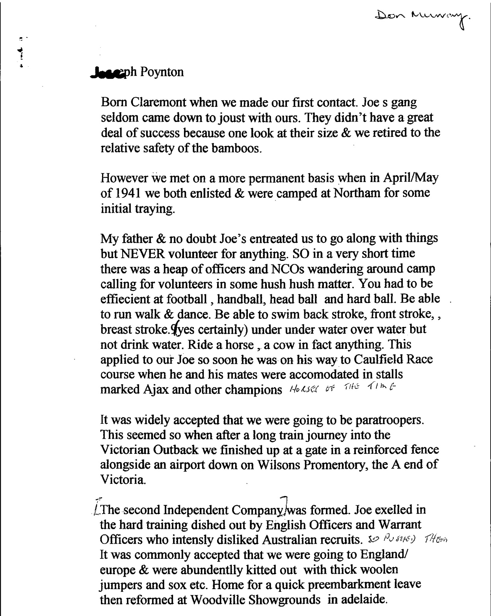
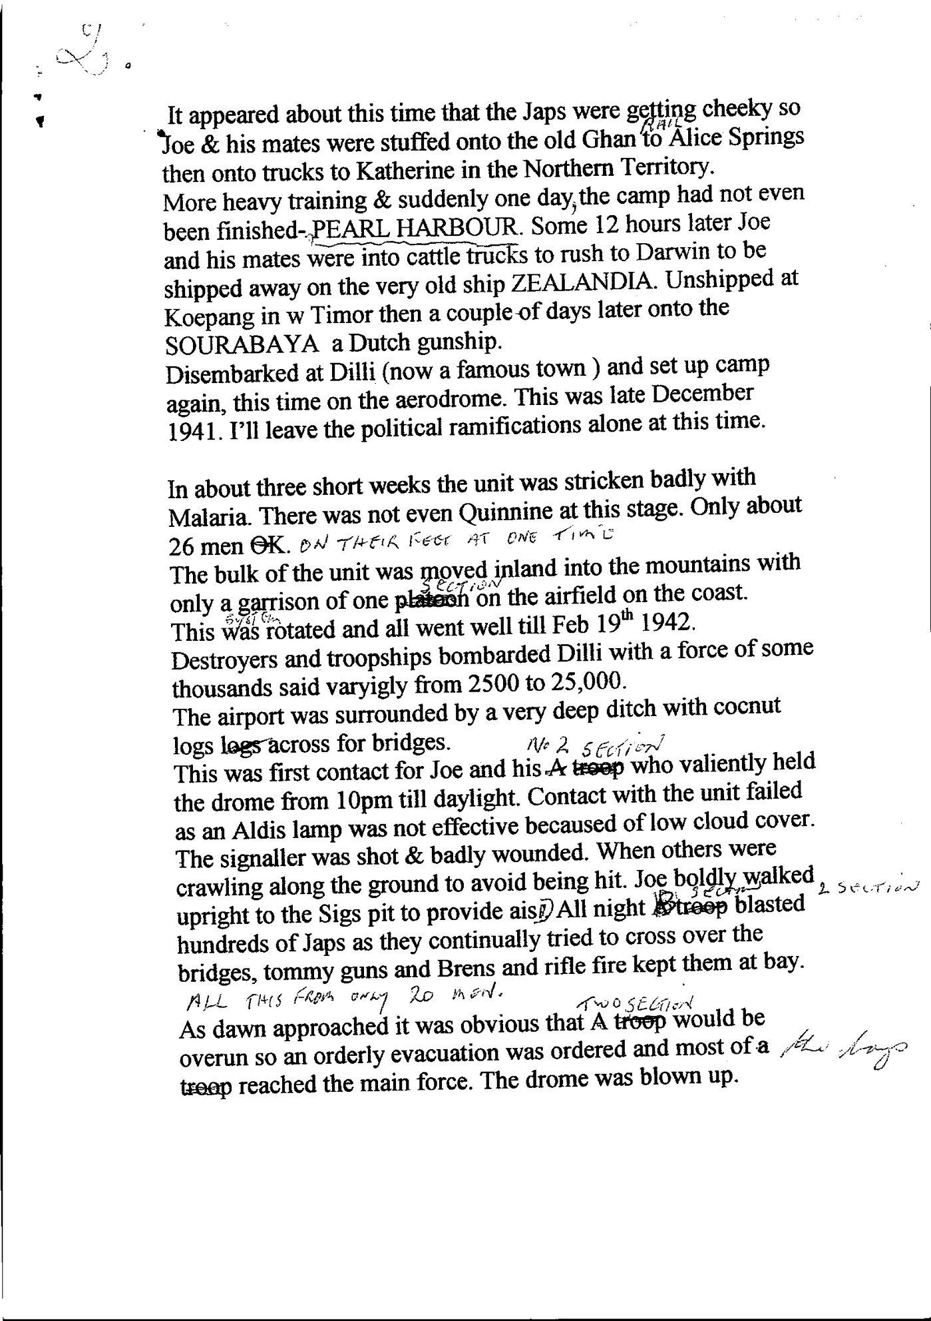
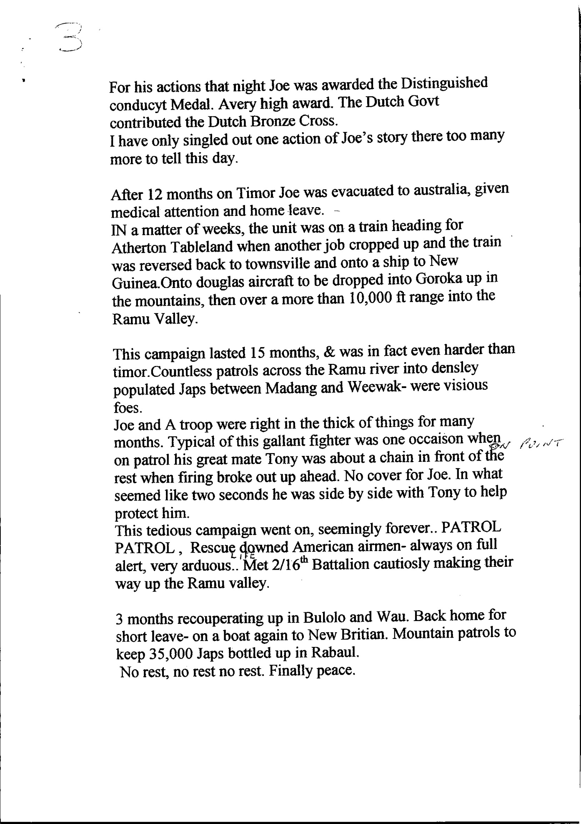
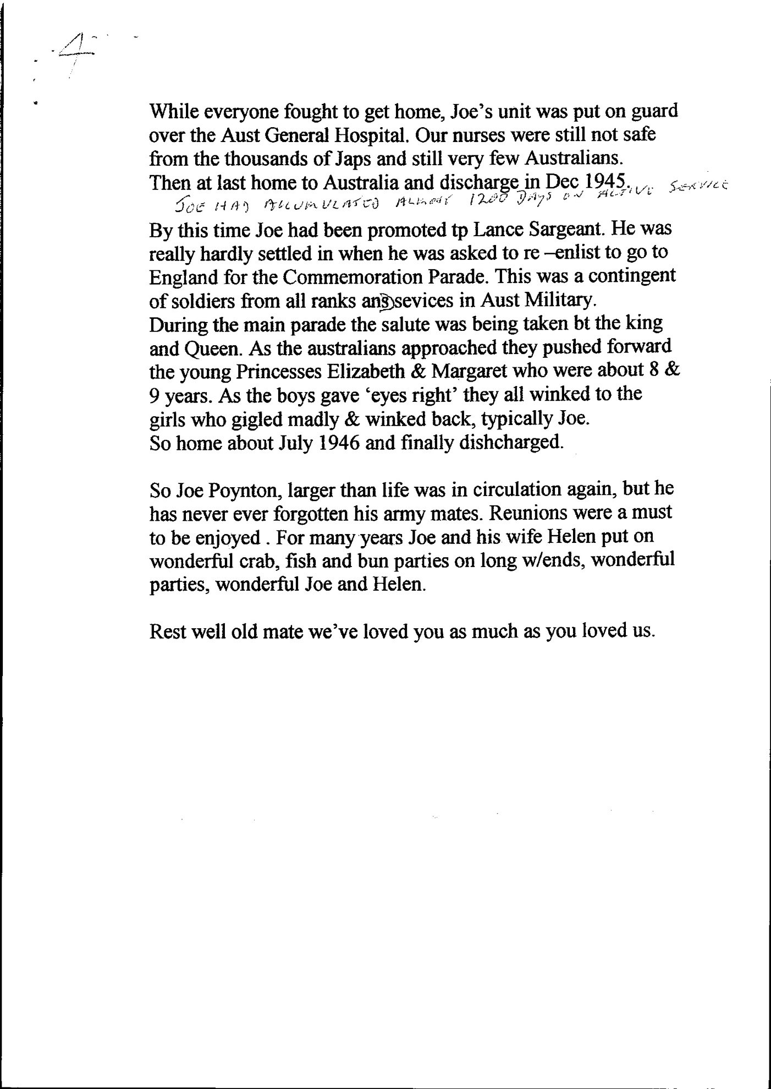
Poynton, Joseph William
Private
WX12552
Distinguished Conduct Medal
“During the operations at Dili Aerodrome on the night of 19/20 February 1942, Pte POYNTON, together with three others, fiercely attacked Japanese troops crossing a small bridge leading to “DILI” aerodrome, and by his example, coolness and daring, and total disregard of the danger he very materially prevented two attempts to take the aerodrome hangers.
He fought the Japanese at close quarters with his tommy gun, inflicting several casualties.
In subsequent action on the following day when Privates POYNTON and GROWNS took up an ambush position, GROWNS very quickly inflicted one Japanese casualty. POYNTON, with great determination and daring went into action and silenced a Lewis gun nearest him with the Thompson machine gun. He then obtained some hand grenades from a Dutch soldier, rushed forward to a nearby tree, threw three grenades, the third of which blew up the gun and four of the crew. This resolute and daring action enabled Lt McKenzie to continue the manoeuvre.“
Note 1. The third soldier was Fowler, John Frederick, WX11366. Mentioned in Despatches for this and other actions.
Note 2. Growns, Frederick William, WX13530
Poynton, Joseph William
Private
WX12552
Dutch Bronze Cross
“During the operations at Dilli Aerodrome on the night of 19/20 February 1942, Pte POYNTON, together with three others, fiercely attacked Japanese troops crossing a small bridge leading to “DILLI” aerodrome, and by his example, coolness and daring, and total disregard of the danger he very materially prevented two attempts to take the aerodrome hangers.
He fought the Japanese at close quarters with his tommy gun, inflicting several casualties.
In subsequent action on the following day when Pte POYNTON and another soldier took up an ambush position, the other soldier very quickly inflicted one Japanese casualty. POYNTON, with great determination and daring went into action and silenced a Lewis gun nearest him with the Thompson machine gun. He then obtained some hand grenades from a Dutch soldier, rushed forward to a nearby tree, threw three grenades, the third of which blew up the gun and four of the crew. This resolute and daring action enabled Lt McKenzie to continue the manoeuvre. ”
Note: The other two soldiers were
Fowler, John Frederick, WX11366
Growns, Frederick William, WX13530
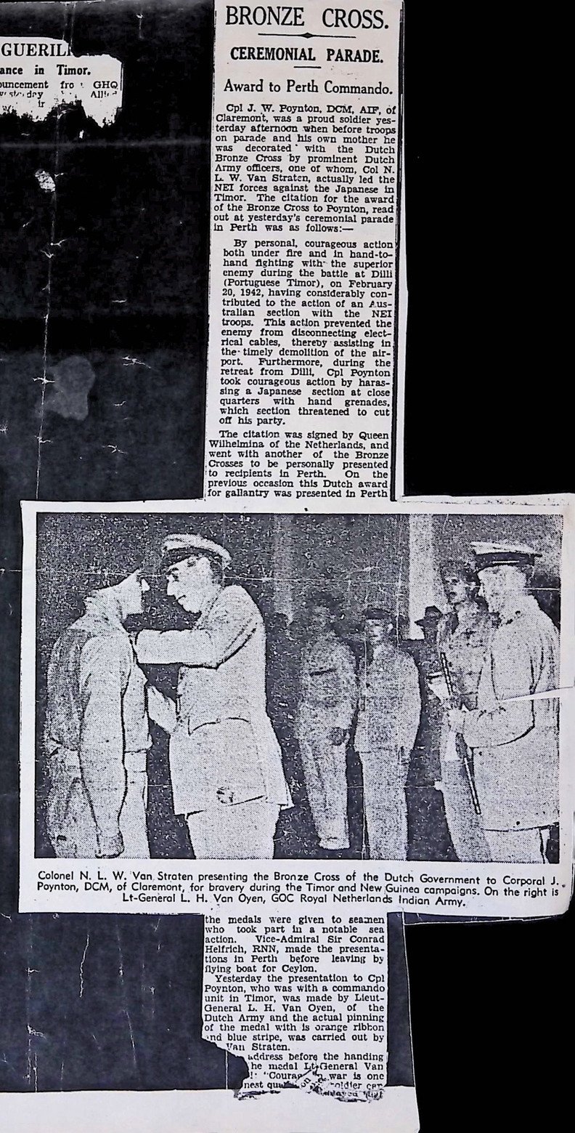

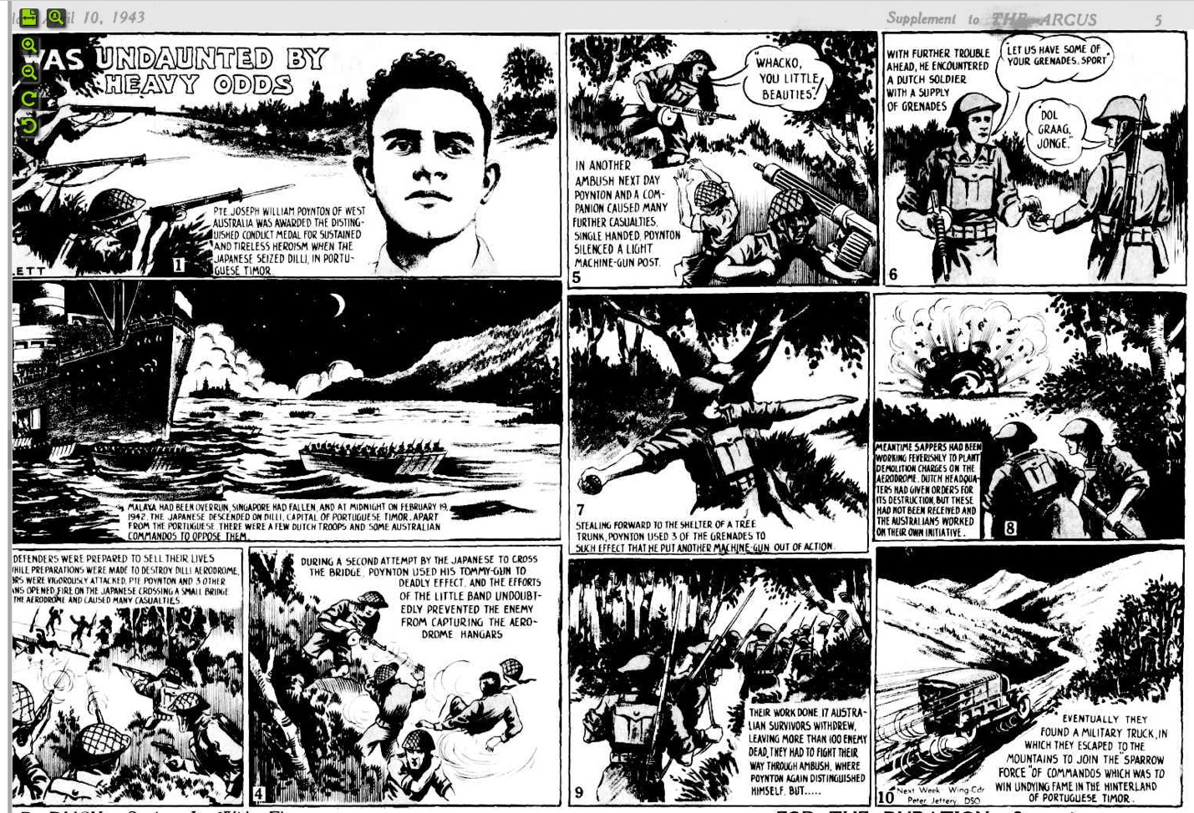

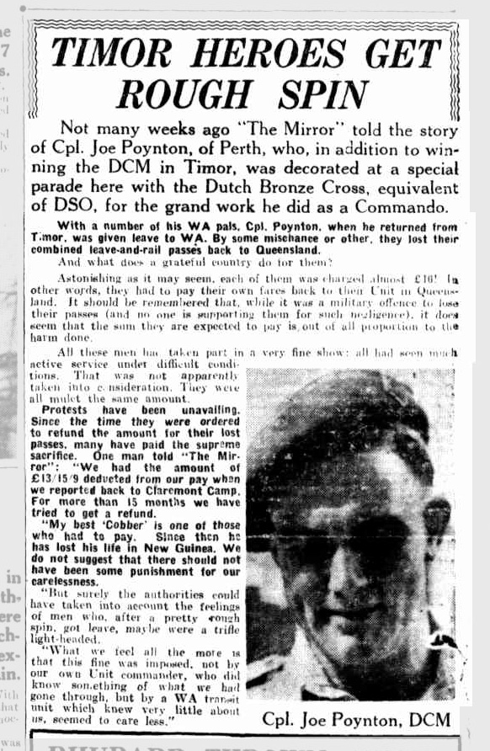

SOURCE: ‘The West obituaries’ / edited by Patrick Cornish West Australian Monday, June 14,2004
Victories in war and peace
JOSEPH WILLIAM POYNTON
Born: Ballarat, Victoria, April 1922
Died: Mandurah, March 2004
Battles on the rugby field were on Joe Poynton's mind as he helped Nedlands become premiers in the winter of 1940. The final whistle blew and the cup was brought towards the pack of champions. A camera was produced; film was not that easy to come by in wartime but this was a special occasion.
Joe, then 18, was not going to hang around and wallow in triumph. He had another occasion, another duty, another battle to head for. That year — a northern-hemisphere summer of battering and bruising from the Luftwaffe - had been bare of triumph for Australia's allies.
He joined the army and became part of the Second Independent Company, which heard that "special missions" were on the cards. The kitting-out procedure included thick jumpers and socks. They must be assigned to Europe, surely? In fact, Joe and his mates went to Timor, soon after Japan's attack on Pearl Harbor had made the conflict truly global.
"Stealing forward to the shelter of a tree trunk, Private Poynton used three of his grenades to put another machine gun out of action," said a comic-strip caption in the Argus newspaper in April 1943, when something of the true heroics of the Timor commandoes could be trumpeted in public. "Their work done, 17 Australian survivors withdrew, leaving more than 100 enemy dead. They had to fight their way through ambush, where Poynton again distinguished himself."
For his 80th birthday two years ago, his wife, Helen - known to their family and many friends as "Nen" - had rounded up forwards, backs, shovers and shakers.
Over a few beers at home in Mandurah on the day, the courageous old soldier preferred to talk about Nedlands rugby heroics and his pride at representing WA over many seasons. In 1957, by then a carpenter and builder, his forward play had helped Neddies to another championship.
However reticent Joe Poynton was about war days, the facts are hard to bury under a rugby scrum. He won a Distinguished Conduct Medal for bravery that, had he been an officer, would have garnered a Military Cross. Another newspaper feature on the Timor commando action, published in Melbourne in 1962, mentioned Lance-Corporal Poynton as "among the bravest of the brave . . . a demon with a tommy-gun".
He won the Dutch Bronze Cross, presented by Queen Juliana of the Netherlands, which then owned the western half of the island as part of the Dutch East Indies.
Joe's first battle had been with the track running alongside the Trans-Australia railway line. In 1928, when he was six, his parents brought their five children from Victoria to settle in WA. The terrain and heat were terrible, he remembered, though the tasty meat pie bought in Kalgoorlie partly made up for the ordeal.
His father's departure from the family shortly afterwards brought further struggles for Joe's mother Amy. Somehow she stayed afloat, emotionally and parentally, and Joe was to feel protective towards her for the rest of her life.
His carpentry apprenticeship at Midland railway workshops was interrupted by war but he was eventually able to forge a strong building career.
Having met Helen O'Brien, a trainee nurse, in January 1946 he said goodbye for a while after being selected to sail to Britain on the Shropshire for the Victory Parades.
Carpentry at the Woomera rocket range in South Australia allowed him to save money for their marriage in 1953. Those construction skills were to last a lifetime. His daughters' homes have plenty of evidence of his practical creativity.
The naming in 2001 of Poynton Way, in the Silver Sands district of Mandurah, was testament to his handiwork.
When the Mandurah Offshore Fishing Club got into development mode, he was the first man chosen for the building committee.
Some mates wondered what he meant by his common turn of phrase, "It's a moral". A sure thing, is what he was referring to.
"Great man, great commando, great friend, great loss" was among the comments in newspaper tributes after Mr Poynton died in March.
He is survived by Helen, their daughters, Julie-Ann Jackman and Rhiann Gosper, and six grandchildren; and by his sister, Ann Beasley-Prior.
Among the music at his memorial service was the Skye Boat Song, a favourite with him. As a rugby forward there were sleeker team mates who sped "like a bird on the wing". Poynton power, however, encompassed determination, strength and— for a man who played his last game for WA as a 39-year-old — lasting the distance, on the fields of war and of peace.
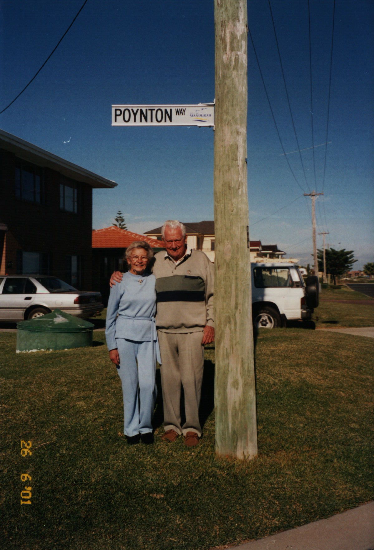
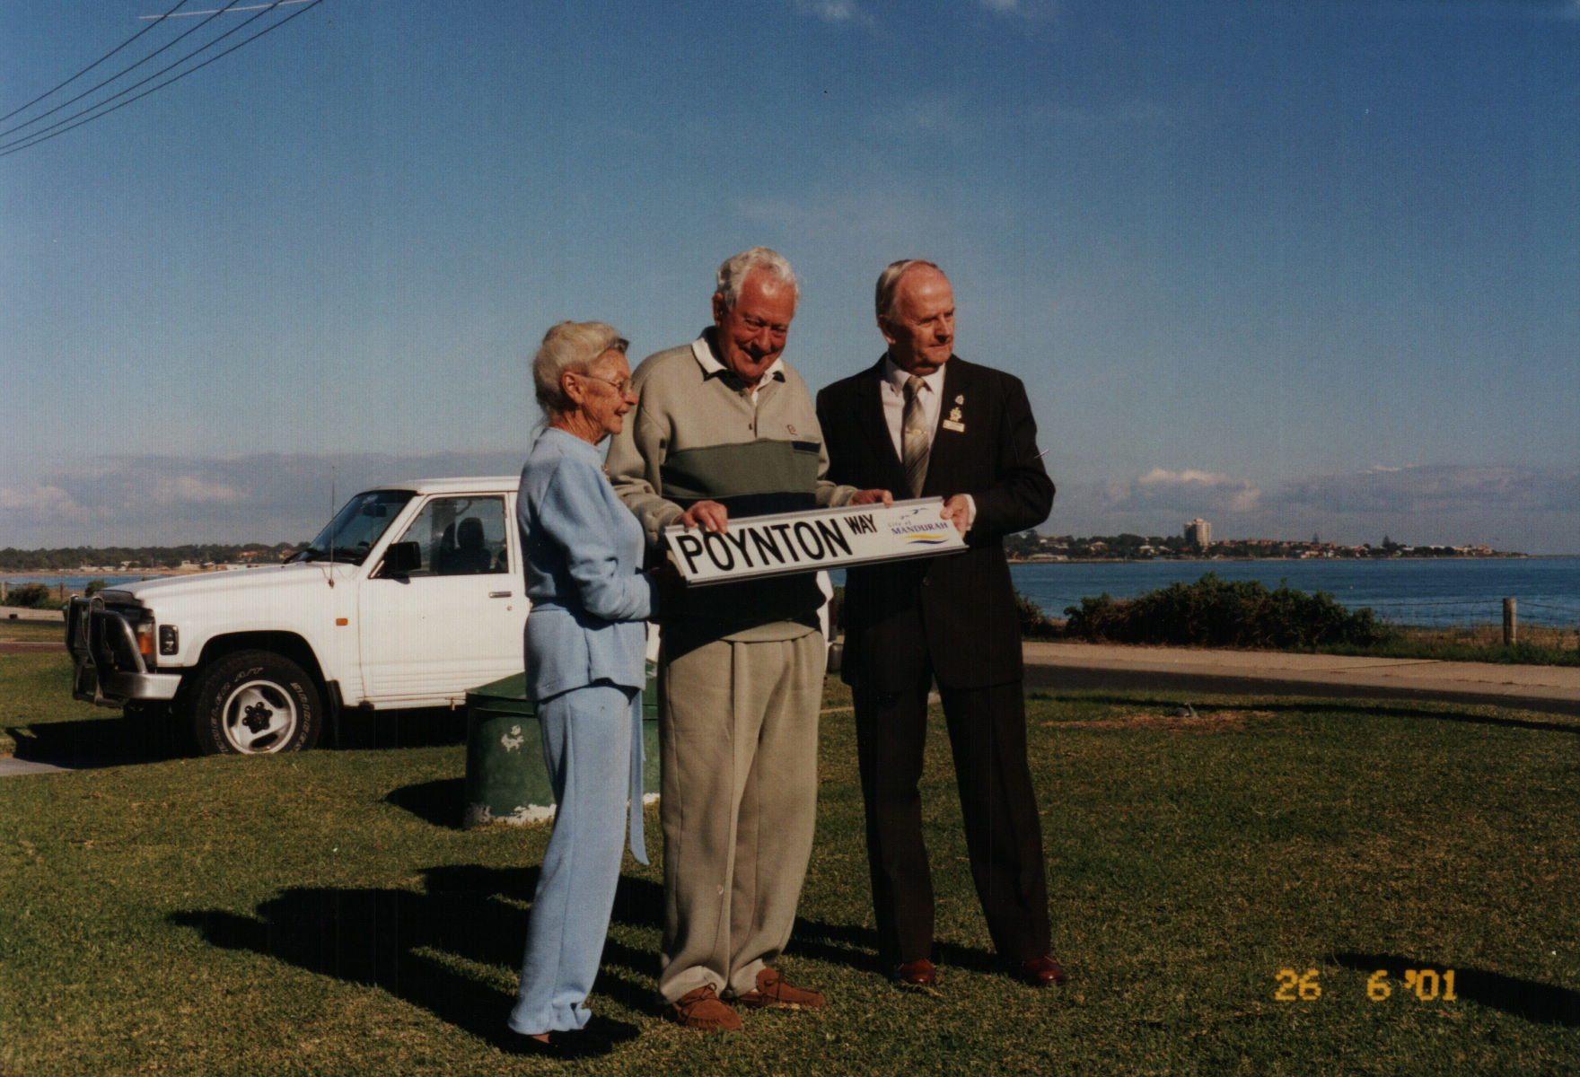
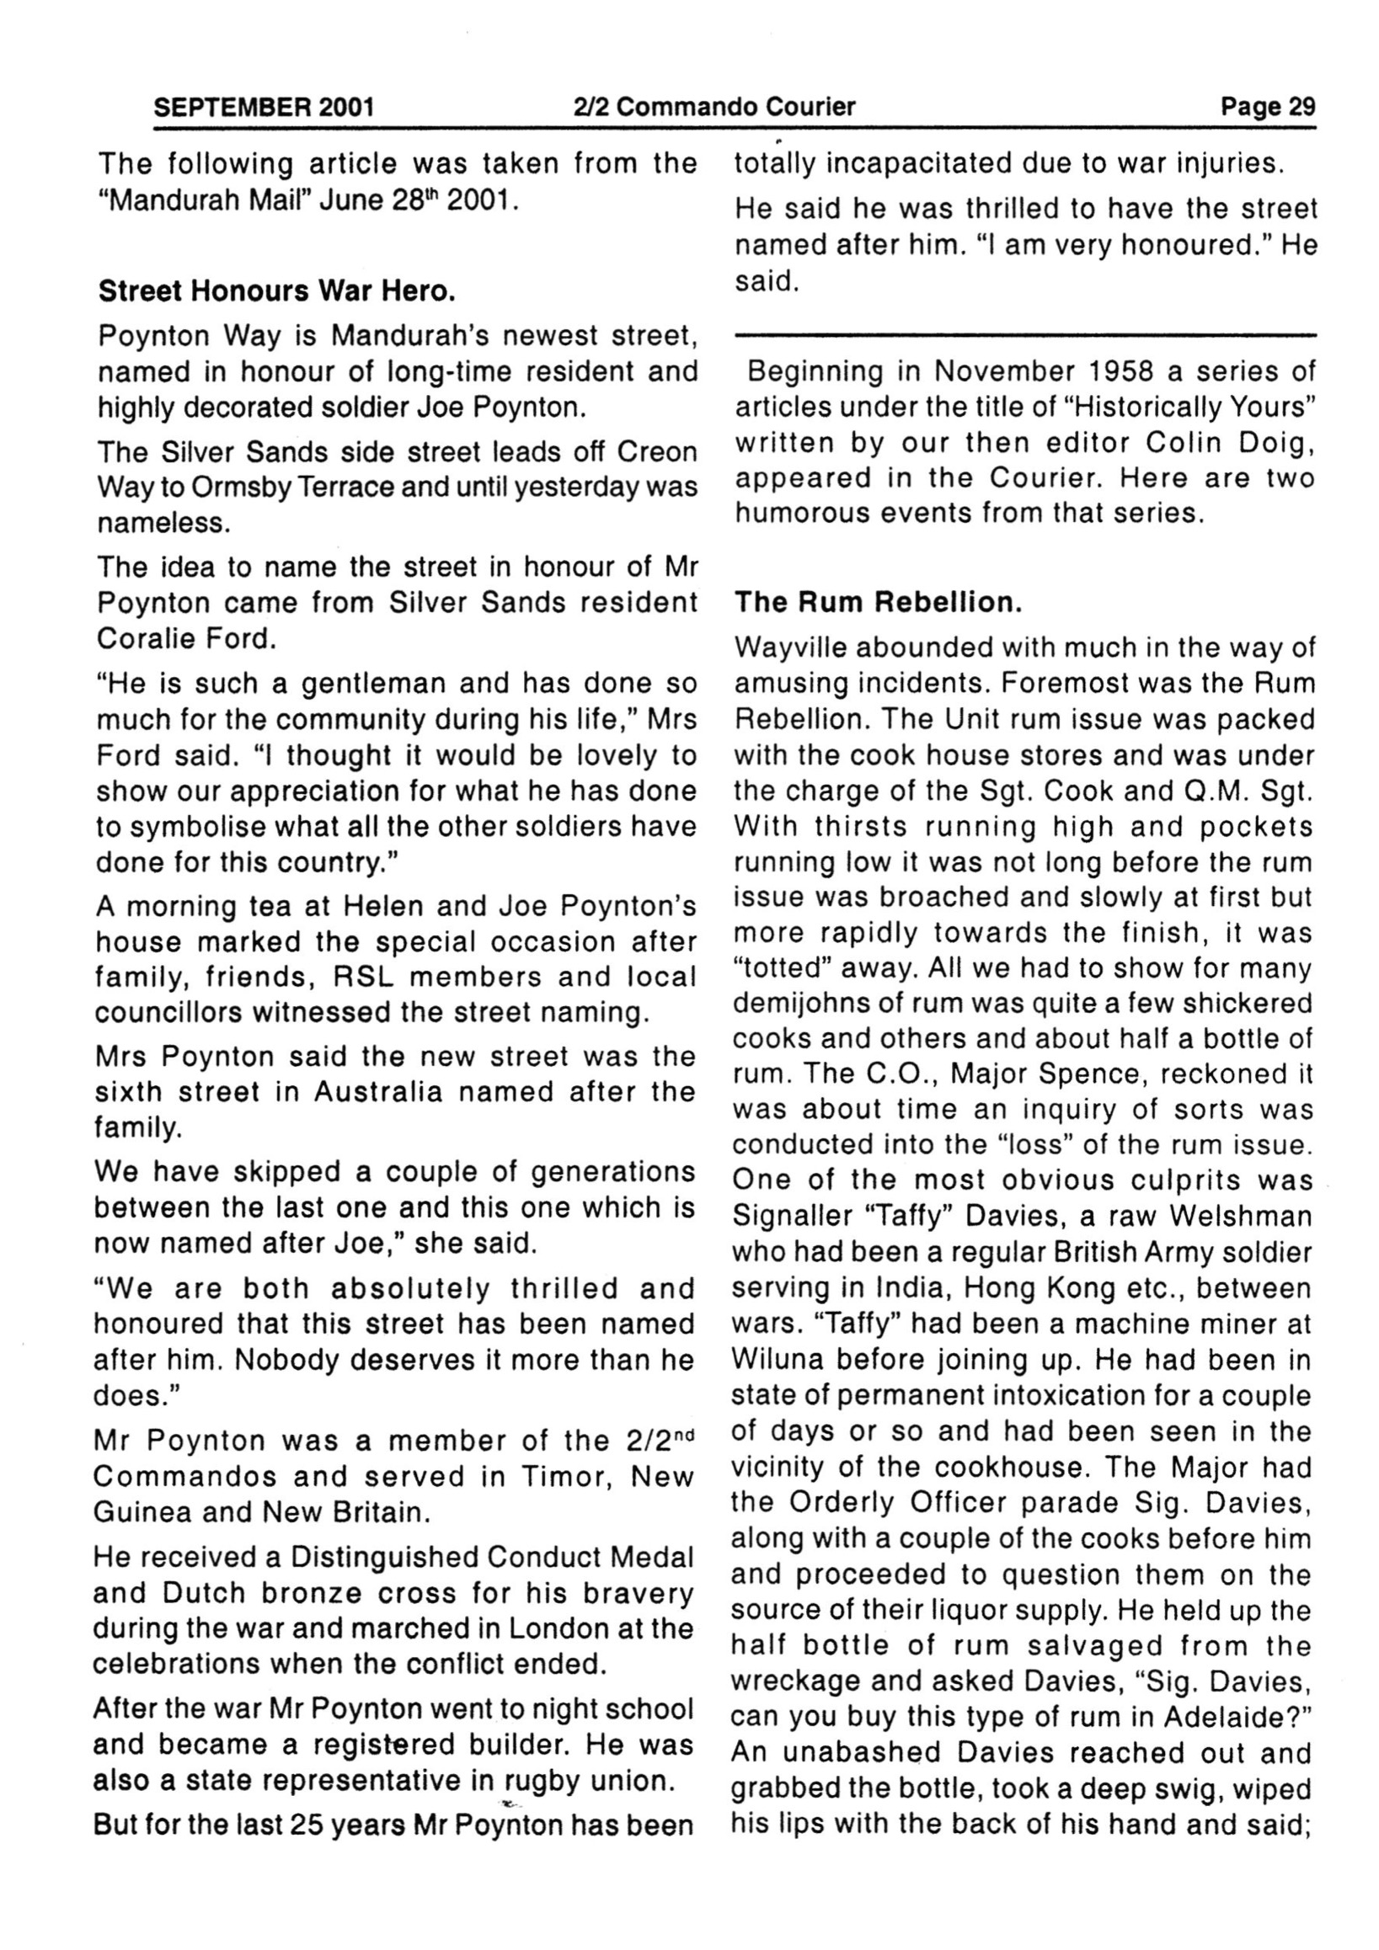
Vale Joseph William POYNTON DCM WX 12552
Joe passed away peacefully at the 'Greenfields Nursing Home', Mandurah on the 17th March last, three weeks short of his 82nd birthday. So died one of the greats of the Unit.
Joe was born at Ballarat on the 4th April 1922 being one of 5 children. In 1928 when he was six, the family moved by car to the West. The drive over the Nullarbor with its rough roads was a great adventure for Joe. A big meat pie on reaching Kalgoorlie topped off an exciting trip and from that time on a meat pie was always a favourite of Joes.
The family settled in Claremont. Joe was a bright student and did well at school. A well-built youngster there was never a dull moment in his boyhood days. On leaving school in 1937 he obtained an apprenticeship as a carpenter at the Midland Railway Company which he completed before enlisting in the AIF in early 1941. Joe became an original member of the 2/2nd and served in the Unit from go to whoa. He took part in No. 2 Sections gallant stand at the Dili Drome on 19/20th February 1942 when the Japs invaded East Timor and was awarded a DCM and Dutch Bronze Cross for bravery in that action. Strong, tough and fearless, his courage became a byword among members of the 2/2nd. Joe was a member of the Unit's boxing team and knew how to look after himself. He attained the rank of Lance Sergeant and retired from the army early in 1946. He was selected in the AIF's London Victory March Contingent in mid 1946, an honour well deserved for a man with such a fine war record.
A handsome man, Joe saw Helen O'Brice on a bus early in 1946 and kept on winking at her every time he caught her eye. A few days later he ran into her again at North Cottesloe Beach and asked for a date. So began a loving partnership which lasted 58 years. A young journalist (female of course) described Joe as " An answer to a maiden's prayer" in an article in the local paper when Joe was awarded his DCM in Feb. 1943. Few of the girls around in those days would disagree with her!
Joe was a good sportsman becoming involved in snorkelling, waterpolo and horseriding. He excelled at Rugby Union and played for the Nedlands Club for many years including in their grand final won in 1940. After the war he resumed with his old club, played in several WA sides, and was Captain and Vice-captain on a number of times. A tough but fair player, he played with Nedlands in 1957 in their grand final win with a nose guard having sustained a broken nose in a game a week earlier. He was 35 at the time and retired four years later in 1961. A loyal clubman was Joe.
In 1949 he worked as a carpenter at the Woomera Rocket Range for 2 years and built up a bank running a two-up and dice game with his mate Max Tomilson. Returning to Perth in 1951 he and another mate Bert Kelly, became partners building homes in Innaloo, White Gum Valley, Hyden and Merredin. He attended night school and got his builders ticket, building his own first home in Claremont prior to marrying Helen in 1953. In 1959 Joe and Helen moved to Fremantle and established the Skye Hospital. Under Helen, a capable matron, the hospital flourished while Joe built extensions to cope for the demand for more beds. Joe and Helen were blessed with their much-loved girls Julie-Ann in 1958 and Rhiann in 1964. Joe was a devoted dad and thought the world of his young daughters. After 12 years at the Skye they moved to their holiday home at Ormsby terrace, Mandurah which Joe had built. It was a big comfortable home with lovely ocean views. Here the family spent their next 31 years. 2/2nd members have many happy memories of those wonderful outings on the Sunday of the Australia Day weekend. Helen's catering was really something while Joe, an expert fisherman, made sure there were plenty of crabs on hand, topped off with a barbecued sheep provided by the Campbells. They were good times.
A side street was named Poynton Way by the Council in their honour in 2001, a fine tribute indeed.
Joe and Helen were great travellers heading up North in the winter months and did trips around Australia with their great friends Peter & Pat Campbell. Joe was always willing to help out and was on the building committee of the original Mandurah Offshore Fishing Club. He loved fishing and always brought home good catches. He enjoyed nothing better than having a few drinks with his old mates, Wattie, Huddy, Tiger and Tony. They would reminisce on old times. Joe being an ardent Eagle supporter, footy was a popular topic.
In 2002 with their old home now too big for the two of them and Joe beginning to suffer from memory loss, they moved to a smaller but comfortable home in Cuvier Place, Mandurah. Joe's condition gradually worsened and with Helen not enjoying the best of health, Joe went into "Greenfields" where he died peacefully on the 17th March. Helen and the family were always first in Joe's life. He loved his six grandchildren and delighted in watching them grow and was proud of their accomplishments. His fighting spirit never waned and remained strong until the very end.
A large crowd attended his funeral service held at Bowra & O'Dea's Chapel at Mandurah. Present from the Association were Clarrie & Joy Turner, Dot & Rodney Maley, Eric & Twy Smythe, Bart & Loris Mavrick, Bernie & Babs Langridge, Keith & Val Hayes, Doc Wheatley, Ray Parry, Bob Smyth, John Burridge, Vince Swann, Jack Carey, Peter & Pat Campbell, Dick Darrington, Tony Bowers, Don & Ida Murray, Len & Betty Bagley, Jim Lines, Laurie & Sheryle Harrington, Pip Dunkley, Elvie Howell, Mary & Paddy King, Vera, Leonie, Coralie, Lexie & Graham Watson.
Don Murray, George Horsham and Aaron Gosper all paid fine tributes to Joe in what was a very moving celebration of the life of a very special person.
Joe's ashes were scattered in the ocean off his former Ormsby Terrace home.
The Association extends its deepest sympathy to Helen, Julie-Ann and Rhiann and their families.
Lest We Forget.
Jack Carey.
Mr dear friends of old, thank you sincerely for your messages of love and sympathy and those who attended the service for the celebration of his life. Joe would have been so honoured at the love and respects extended to him and the caring love you have shown to my family and me.
Please accept this as our personal thanks.
"It is hard to walk the road that two have trod,
But the way becomes easier with the care of special angels, better known as friends."
Thank you all, Helen.
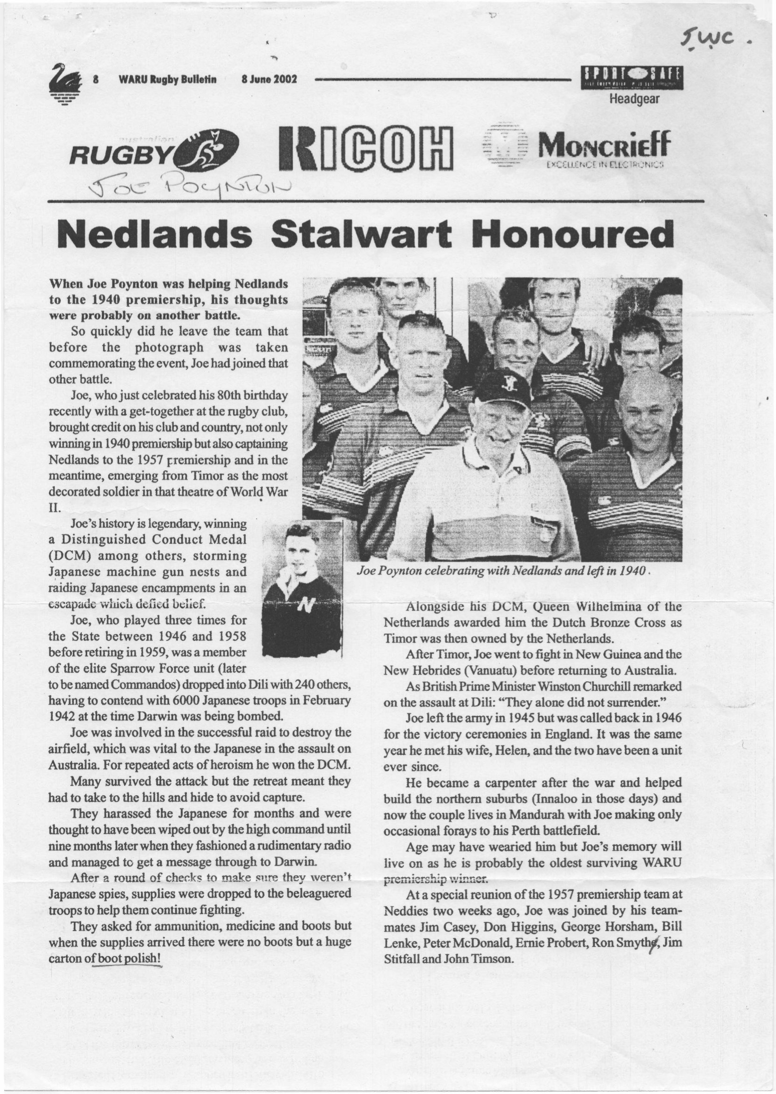

__________
Prepared by Ed Willis
Revised 23 May 2026

