PRIVATE MAX LYNDON LOVELESS (TX4745) – 1914-1971
SIGNALLER, SIGNALS SECTION
https://doublereds.org.au/history/men-of-the-22/tx/max-lyndon-loveless-r419/
BIOGRAPHICAL SOURCES
MAX LOVELESS AND ‘WINNIE THE WAR WINNER’
After resistance by the main part of Sparrow Force had ceased in Dutch Timor on the 23rd February 1942, the forces commander began to reorganise and redeploy his troops in the southern half of Portuguese Timor about the middle of March.
Fighting as guerrillas against overwhelming odds, deficient in supplies and out of touch with Australia, it was imperative for the small force to re-establish communications with the mainland. It was for this purpose that men of the 2nd Independent Company, the fortress signals section on the island, and members of Signals, 8th Division, pooled their resources to build a set capable of raising Darwin. The most expert and tireless of these was Signalman ‘Joe’ Loveless. His technical ingenuity and skill was assisted by the professional electrical engineering expertise of Captain G.E. Parker from Dutch Timor.
After many trials and much revision, Australia was contacted on the APRIL 20 1942, and Darwin was made aware that the Australians in Timor were alive and well.
The set was affectionately named "Winnie the War Winner".
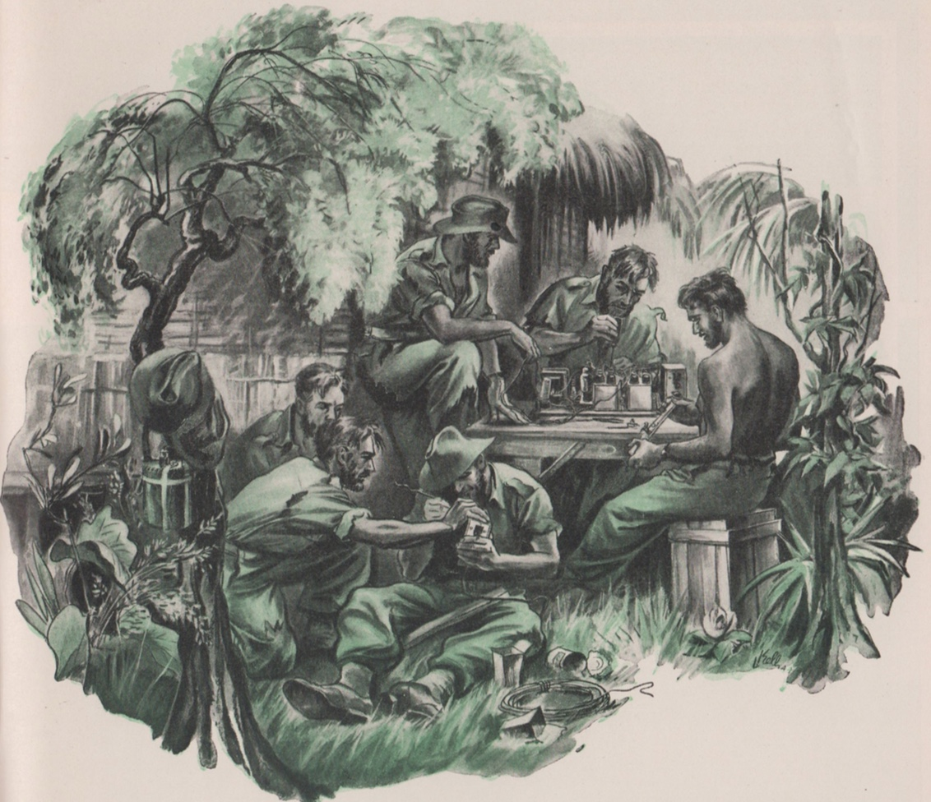
Constructing “Winnie the War Winner”. Source: Signals – the story of the Australian Corps of Signals, 1949
The story of ‘Winnie the war winner’ has been told many times. The most recent and authoritative recounting is by Paul Cleary in his book ‘The men who came out of the ground’ which is included in the following extract:
‘[It was] the most important single happening in the life of this fighting force on Timor, as continued resistance would have been impossible for any length of time without it.’
Filmmaker Damien Parer on the remarkable ‘Joe’ Loveless and his building a radio out of ‘odds and ends’ to contact Australia

THE 2/2 COMPANY’S enormous logistical reorganisation in March and April had given it a fighting chance. Vital supplies were safely stashed in mountain hideouts, the Timorese were supplying food on credit and some semblance of order prevailed for a company stretched out along mountain tops over a front of more than 100 km. Yet the company’s life expectancy was clearly limited without resupply from Australia, and this would not be forthcoming without radio contact.
The company had never had its own radio link with Australia and Sparrow Force’s last radio had been smashed to pieces under orders from Brigadier Veale. Back in Australia, no-one thought to send a search plane to discover the fate of the 270 men who had been left behind in Portuguese Timor. In the chaotic months that followed the fall of Singapore and the Dutch East Indies, most likely no-one gave the 2/2 Company a second thought, let alone bothered to send supplies.
‘The boot position is fast becoming critical …’
While ammunition reserves were significant, they would run out with prolonged fighting, and medical stores were in even shorter supply; ‘supplies are being depleted rapidly despite rigid economy,’ reported the senior officers in the war diary on 28 March. But what inhibited the company’s offensive action more than anything else was not the limited supply of ammunition or the short rations of food or even medical supplies. It was boots. The craggy surface of Portuguese Timor was quickly taking its toll on the leather-soled boots issued by the Australian Army. The company reported in its diary on 27 March: ‘The boot position is fast becoming critical.’ But by the end of April, the situation was extreme. A pair of leather-soled boots had a life of about one month when soldiers were patrolling in the forward positions, while those in the rear could expect a little more wear, about two months. Without supplies of new boots the company would lack mobility and would soon be rendered an ineffective fighting force. The company introduced a routine of taking off boots at times when an attack was unlikely so that the men’s feet would harden, preparing them for a time when they had no boots whatsoever. Senior officers considered the local manufacture of clogs, but this was not found to be feasible.
Money was also going to be very important if the 2/2 was to be able to continue to buy supplies of food and to pay for services like the pony trains. The value given by the Timorese to their surats was certain to wane over time if they could not be paid with currency that had an intrinsic value. They could not live on credit forever.
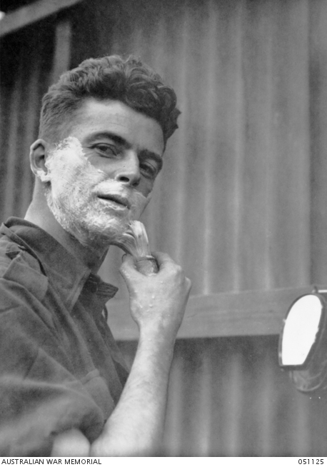
TX4745, Signaller M. L. Loveless of Tasmania
‘… the senior command turned their attention to re-establishing radio contact with Australia’
As the company reorganised in March, the senior command turned their attention to re-establishing radio contact with Australia. On 7 March, Major Spence gave responsibility for directing this task to a senior signals officer from Sparrow Force, Captain George Parker, 37, an electrical engineer from the Sydney suburb of Earlwood who had survived the Japanese landing in Dutch Timor before arriving at the Sparrow Force HQ in early March. While Parker had overall responsibility, one of the lowly ranked privates, Signaller Max Loveless, already had the task in hand.
Max Lyndon Loveless, 37, a radio technician from the Australian Broadcasting Corporation’s Hobart radio station, was an edgy man who suffered from anxiety and lacked the physical prowess of the bushmen in the 2/2 Company. Had selection been based on his physique alone, Loveless would never have got a guernsey, but he was selected because the skills of a radio technician were in high demand at the time. In Timor, Loveless would face a challenge that he could never have imagined, and he would be called on to contribute more than anyone else to the survival of the company. Loveless, who was known to most people as ‘Joe’, was starting from way behind because the 2/2 Company was badly equipped when it came to radio communication. They had been sent to Timor with unwieldy ‘109’ sets which were used by the platoons to contact Company HQ. When platoons got, their radios working again, each was assigned a time on the quarter hour to contact Company HQ, but the ‘109’ sets used by the platoons weren’t effective beyond a range of about 30 km. The radio set in Dili that had been previously used to contact Kupang was now in enemy hands.
‘… acquiring as much radio equipment as he could lay his hands on’
Immediately after Captain Parker gained his new assignment, he set about acquiring as much radio equipment as he could lay his hands on. One of the first targets was a Japanese-owned SAPT plantation at Fatu-Bessi, in the mountains south-west of Dili, which was believed to have a powerful radio. A party from C Platoon crossed swollen streams to reach the plantation where they seized the radio and interrogated the owner, Jaime Carvhalo, for suspected ‘pro-Japanese activities’. They piled the radio into the owner’s car, a late 1920s Chevrolet Tourer with running boards and a canvas top, and then drove it to Hato-Lia, before the set was eventually sent to Mapé. The set was only a receiver, not a transmitter, but even so Parker’s team kept it for spare parts. The plantation owner was later released. [1]
On 20 March, Parker dispatched Corporal Alan Donovan to lead a three-man patrol to Atambua to recover parts from the set that had been destroyed by Brigadier Veale, but all that he could find were some crystals from the smashed set. Donovan, who had also joined the 2/2 from Dutch Timor and worked on the radio project, was sent on a second mission into Dutch Timor where he obtained a power pack from a Dutch transmitter, two aerial tuning condensers and 20 metres of heavy aerial wire. Parker also recovered a ‘109’ radio set that had been buried by Signaller Don Murray after leaving the Three Spurs camp shortly after the invasion. Murray went back to retrieve the set and while struggling to move it he came upon two Timorese boys who offered to help. The boys, one named Roberto, helped Murray carry the set all the way to Mapé, on the other side of the island, and then they stayed by Murray’s side for the rest of his time on Timor. Loveless used the set for spare parts.
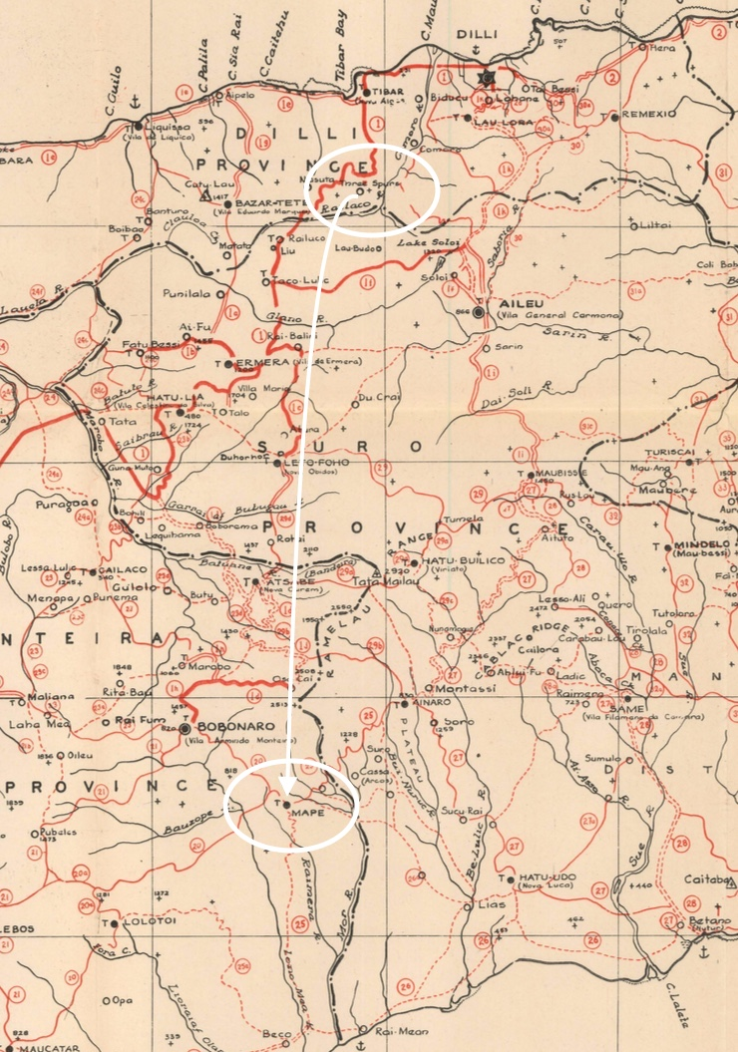
The probable route taken by Sig Don Murray and the Timorese boys between Three Spurs and Mapé through Taco Lulic, Lete-Foho, Atsabe and Bobonaro can be traced on this road and tracks map. Source: Area study of Portuguese Timor (1943)
‘Loveless and his team were given premises in which to work …’ - Mape
On 1 April, Loveless and his team were given premises in which to work—a small windowless shed that had been used to store rice at the local school in Mapé, a sparsely populated and very marginal town in the south-west corner of Portuguese Timor. The signallers worked day and night, burning pig fat to provide illumination. Loveless was supported by a fellow signaller Keith Richards, who proved adept at recycling solder from the spare parts. With the crystals from the Atambua transmitter Loveless constructed an oscillator, which produced a frequency, and he extracted two valves from the Portuguese receiver. Parts from the Portuguese receiver were also used to construct a power supply for the unit. By early April, Loveless had started work on the amplifier using valves from Murray’s ‘109’ set. Ten days later he completed work on the amplifier, and then he turned his attention to the power supply, which was produced with spare parts. All the bits and pieces were housed in the two halves of a kerosene tin. Loveless was almost ready to go, except that he had to devise a system for charging batteries.
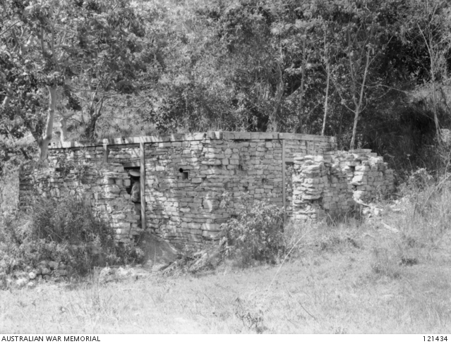
The hut at Mapé, Portuguese Timor, used by the Signals Section, Force Headquarters, 2/2 Independent Company. It was here that the famous transmitter Winnie the war-winner, a masterpiece of improvisation, the wireless set was constructed by TX4745Signalman Max Lyndon Loveless.
‘… charge the batteries …’
Using a 6-volt generator donated by plantation owner and former army officer Tenente Lopes, they constructed what Parker called a ‘boong charger’. Occupying a room of about 3 square metres, the generator was driven by a rope that went around a wheel of 45 cm in diameter, and then attached to this was the much larger wheel which had handles on it so that it could be turned by manpower. Four Timorese were enlisted to turn this wheel as fast as they could to charge the batteries. After going to these great lengths, the ‘boong charger’ was a dismal failure. Parker then dispatched a patrol led by Lieutenant Harold Garnett, which brought back a 6-volt, and 100-watt battery charger salvaged from a car near Dili. But there was no petrol to run it; this also had to be obtained by another 2/2 patrol. Petrol was in short supply in the colony, so patrols brought back kerosene and diesel, which was mixed together to produce a substitute fuel for the petrol engine.
By 15 April, Loveless had charged his batteries and could listen into the radio traffic in Darwin. This feat alone bore great significance; Sparrow Force learned for the first time that
‘What is the Christian name of Jack Sergeant’s wife?’
Australia had not been invaded, contrary to the propaganda leaflets distributed by the Japanese. By 17 April, Loveless had the radio set ready for signalling to Australia. The signallers identified themselves as YCF, the calling sign for Sparrow Force, without knowing that it had been made redundant by the Japanese invasion of Timor, and without knowing that the faint signal could be barely heard in Darwin. Again, on the night of 18 April, they signalled ‘LOA—LOF— LOW from YCF’. In Darwin, a senior signals officer, Captain Joseph Honeysett, was on duty that night when the weak and outdated signal came through. The next evening Honeysett ordered that all radio communication in the region be shut down so that the signal could be heard clearly. Honeysett thought that the signal could have come from the enemy, given that YCF was no longer in use. One of the signallers in Darwin knew that Signaller Jack Sargeant was with Sparrow Force in Timor, and he asked if he was with them. Indeed, he was. Jack Sargeant was one of the men crouched beside the radio praying like hell that it would reach Australia. The Darwin signaller asked: ‘What is the Christian name of Jack Sergeant’s wife?’ Sergeant answered that it was Kath. Then the Darwin signaller asked a second question—what was Sargeant’s street address. Sergeant gave the details, followed by a stunning message that said: ‘Force intact and still fighting. Stop. Badly need boots, quinine, money, and Tommy gun ammunition.’ [2]
‘… Sparrow Force was still a fighting unit’
The message proved conclusively that Sparrow Force was still a fighting unit. The news that the 2/2 was still waging guerrilla warfare against the Japanese was simply stunning for Australia, as it arrived at the country’s darkest hour. With the capture of more than 22,000 men in Asia from Japanese victories in the Malayan Peninsula, the Philippines, Rabaul, and in the Dutch East Indies, the news that one band of men was still fighting proved to be tremendously valuable both in strategic terms and in terms of morale. After this successful transmission, Loveless’s men named the set after Winston Churchill. They called it ‘Winnie the War Winner’.
The chief of the Australian Army, General Sir Thomas Blamey, failed to grasp the significance of this news and he proposed withdrawing the company or using it as part of a much bigger operation to recapture the island. Blamey outlined these options in a letter to General Douglas MacArthur. But MacArthur could see the value of keeping things just as they were, and in his reply to Blamey on 11 June 1942 he stated firmly that ‘these forces should not be withdrawn’. The company should simply continue its campaign of ‘harassment and sabotage’ against the Japanese, as MacArthur put it. While knowing very little about what the company was doing, MacArthur seemed to perfectly grasp their role.
While Captain Parker had overall responsibility for re-establishing radio contact, he gave full credit to Loveless for showing the ‘greatest initiative’ which ‘undoubtedly led to our success’. Other men in the unit thought that Loveless’s radio was the work of a genius, or, as his fellow signaller Don Murray put it, ‘pure arse’. …. The stress and strain of working day and night on the assignment took its toll on Loveless, who appeared to have suffered a nervous breakdown and was sent back to Australia a few months later after completing the assignment of a lifetime. His illness continued after returning to Australia and he was discharged from the army in November 1943.
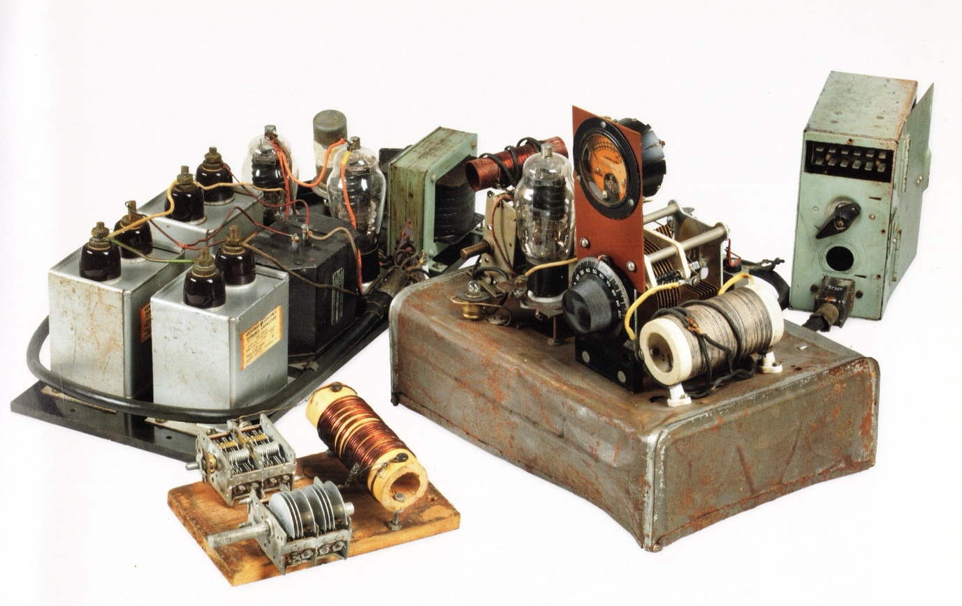
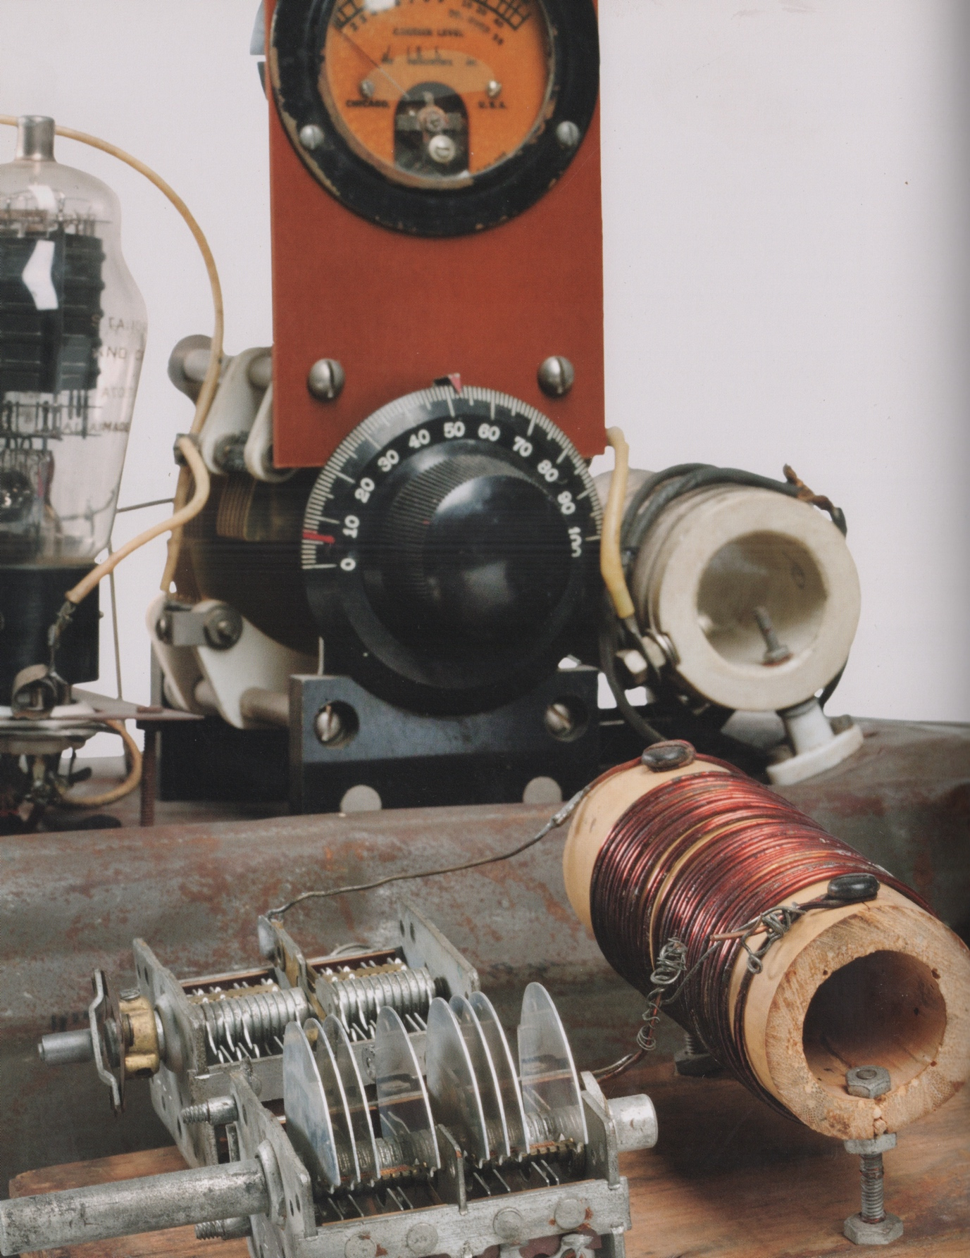
‘Winnie the war winner’ on display at the Australian War Memorial, Canberra, in the Second World War Galleries
NOTES
[1] ‘Report on activities of Special W/T section 2 March–19 April 1942’, Captain George Parker, AWM PR00249. Parker’s account is by far the most authoritative of what took place in rebuilding the radio, though other details have been taken from the accounts by Callinan and Doig. One major factual error in other accounts is the claim that a Qantas radio was used by Parker and Loveless to build the radio. This was not brought to Mapé until 29 April, after radio contact had been established. The company’s war diary for that day says, ‘Several Portuguese cooperated in bringing from Dili an AS Transmitter, property of Qantas airways. This they handed to Lieutenant Garnett, who has been operating in the Remexio area. He arranged for it to be delivered to Force signals. It proved suitable for their work.’
[2] Some accounts say it was Parker whose details were checked, but this could not have been the case. Parker was not married at the time. The reconstruction of the events in November that year by Damien Parer put Sargeant as the person whose family details and address were checked. There are several versions of the ‘force intact’ message. This one is taken from D. Parer, ‘Dope Sheet’, AWM FO1814.
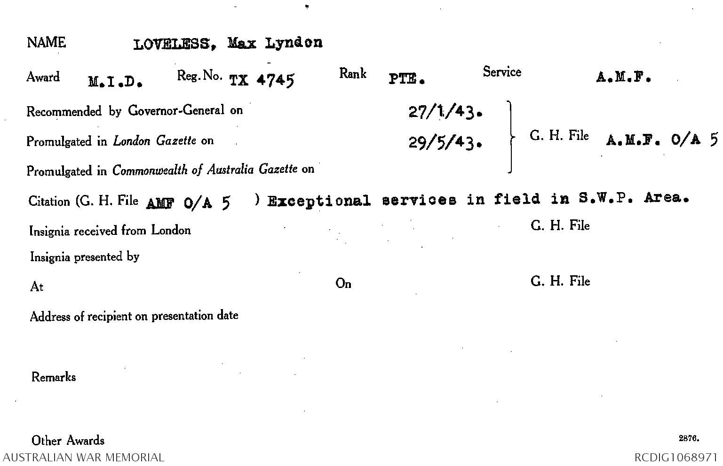
Joe Loveless was rewarded for his work on ‘Winnie the war winner’ with a ‘Mention in Despatches’
ADDITIONAL READING
Cyril Ayris. - All the Bull's men: no. 2 Australian Independent Company (2/2nd Commando Squadron). – Perth: 2/2nd Commando Association, c2006: 223-230. [Available for purchase from https://doublereds.org.au/store/product/9-cyril-ayris-all-the-bulls-men-pdf/]
Bernard Callinan. - Independent Company: the Australian Army in Portuguese Timor 1941-43. – Melbourne: Heinemann, 1953 (repr. 1994): 121.
Paul Cleary. - The men who came out of the ground: a gripping account of Australia's first commando campaign: Timor 1942. – Sydney: Hachette Australia, 2010: 105-110.
J. D. Honeysett ‘Chance takes a hand’ Signalman vol. 1, no. 2 1978: 7-8. [Informative article by then Brigadier J.D. Honeysett who relates the fortunate set of circumstances in which he was directly involved that allowed the first signals from ‘Winnie’ to be intercepted, responded to and verified]
http://www.signaller.com.au/past-editions/Signalman%20Vol%201%20No2%201978/Signalman%20Vol%201%20No2%201978.pdf
Karl James ‘Winnie the war winner’ in Australian War Memorial: treasures from a century of collecting / [edited by] Nola Anderson. – Millers Point, N.S.W.: Murdoch Books Australia for the Australian War Memorial, 2012: 394-397.
Peter R. Jensen. – Wireless at war: developments in military and clandestine radio 1895-2012. – Kenthurst, N.S.W.: Rosenberg Publishing, 2013. [See ‘Sparrow Force and Winnie the war winner’: 189-193 for a technical assessment of the radio and its construction]
Signals – the story of the Australian Corps of Signals / written and prepared by members of the Australian Corps of Signals. – Sydney: Halstead Press, 1949: 128-132.
Susan Turner ‘An interview with the inventor of “Winnie the War Winner”’ Signalman vol. 29 1995: 36-37. [Interview with Captain – later Lieutenant Colonel - George Parker]
http://www.signaller.com.au/past-editions/Signalman%20Vol%2029%201995/Signalman%20Vol%2029%201995.pdf
‘[Vale Max Lyndon (Joe) Loveless]’ 2/2nd Commando Courier vol. 25, no. 231 June 1971: 4-5.
https://doublereds.org.au/couriers/1971/Courier%20June%201971.pdf
‘Winnie's role in war effort remembered’ Commando Courier vol. 60 April 1986: 3.
[Opening of the Max Loveless Pioneer Memorial Collection attended by Sir Bernard Callinan]
https://doublereds.org.au/couriers/1986/Courier%20April%201986.pdf
Christopher C.H. Wray. - Timor 1942: Australian commandos at war with the Japanese. – Hawthorn, Vic.: Hutchison Australia, 1987: 96-99.

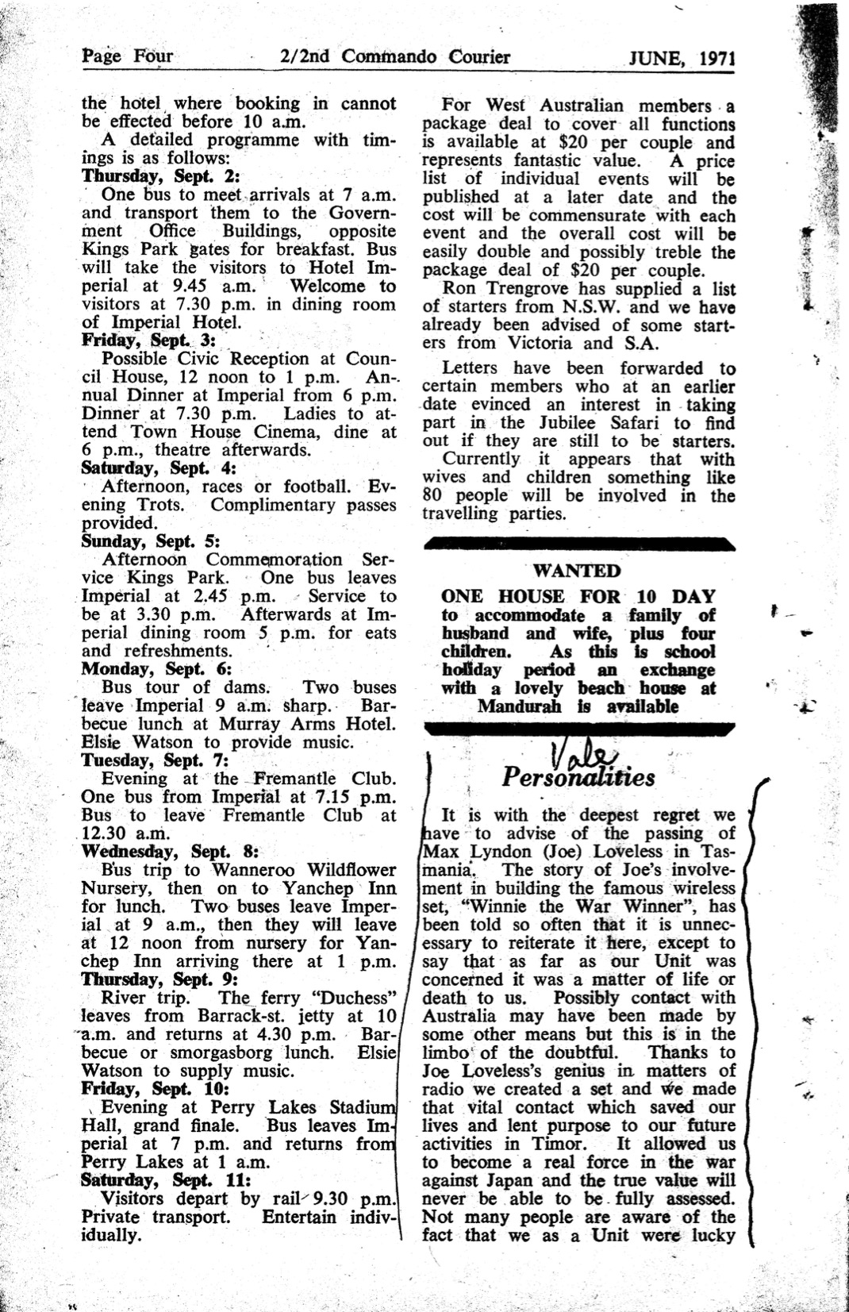

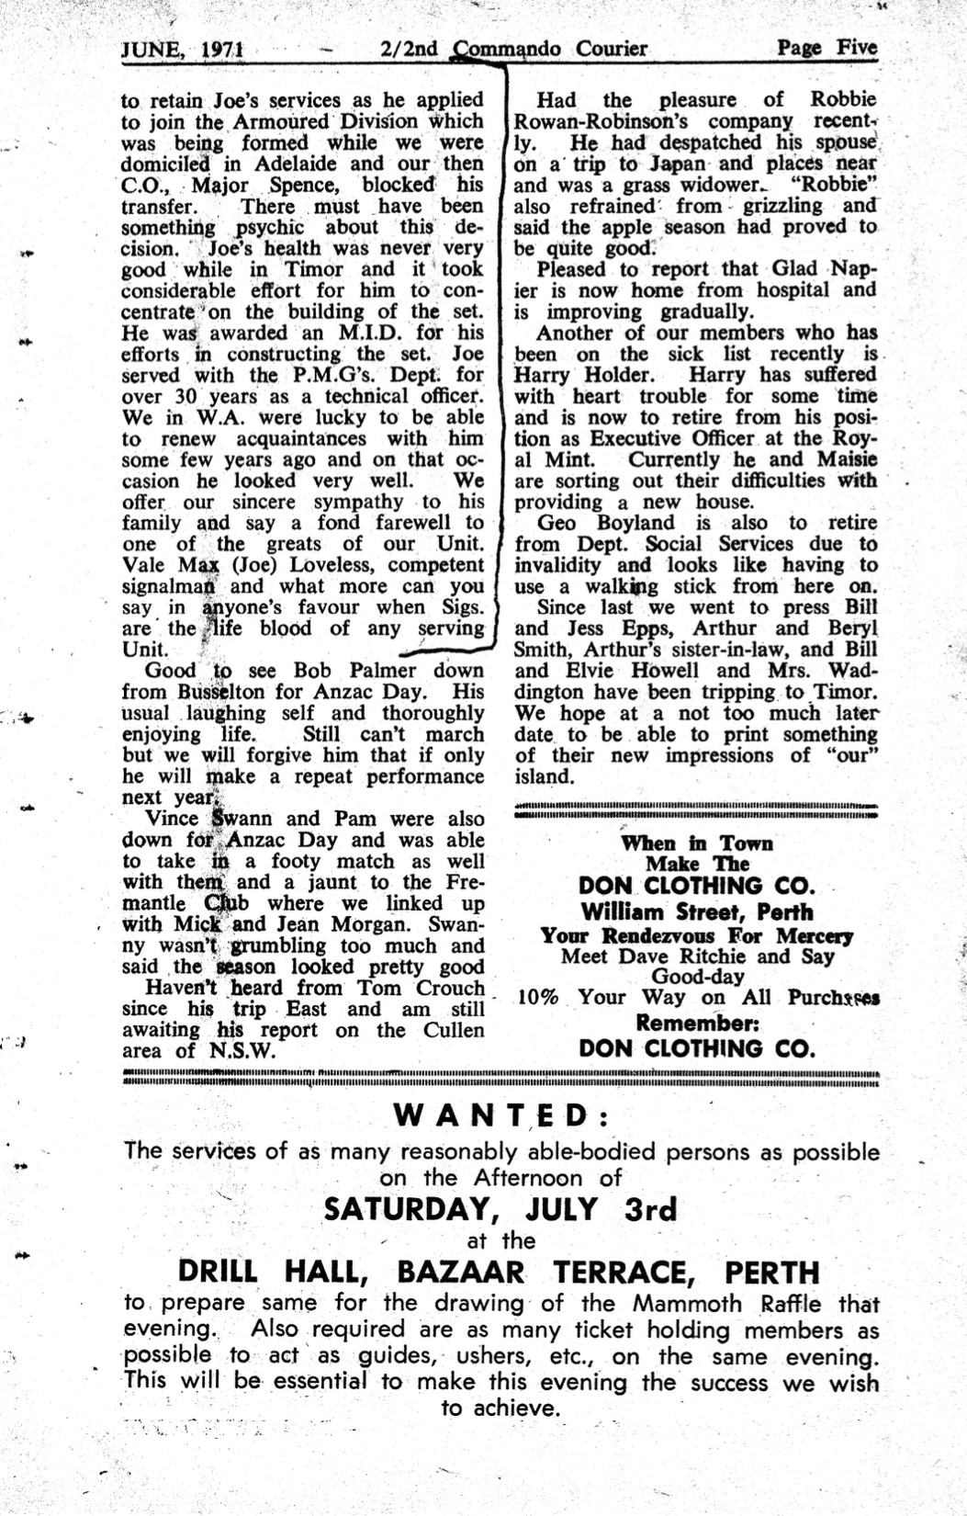
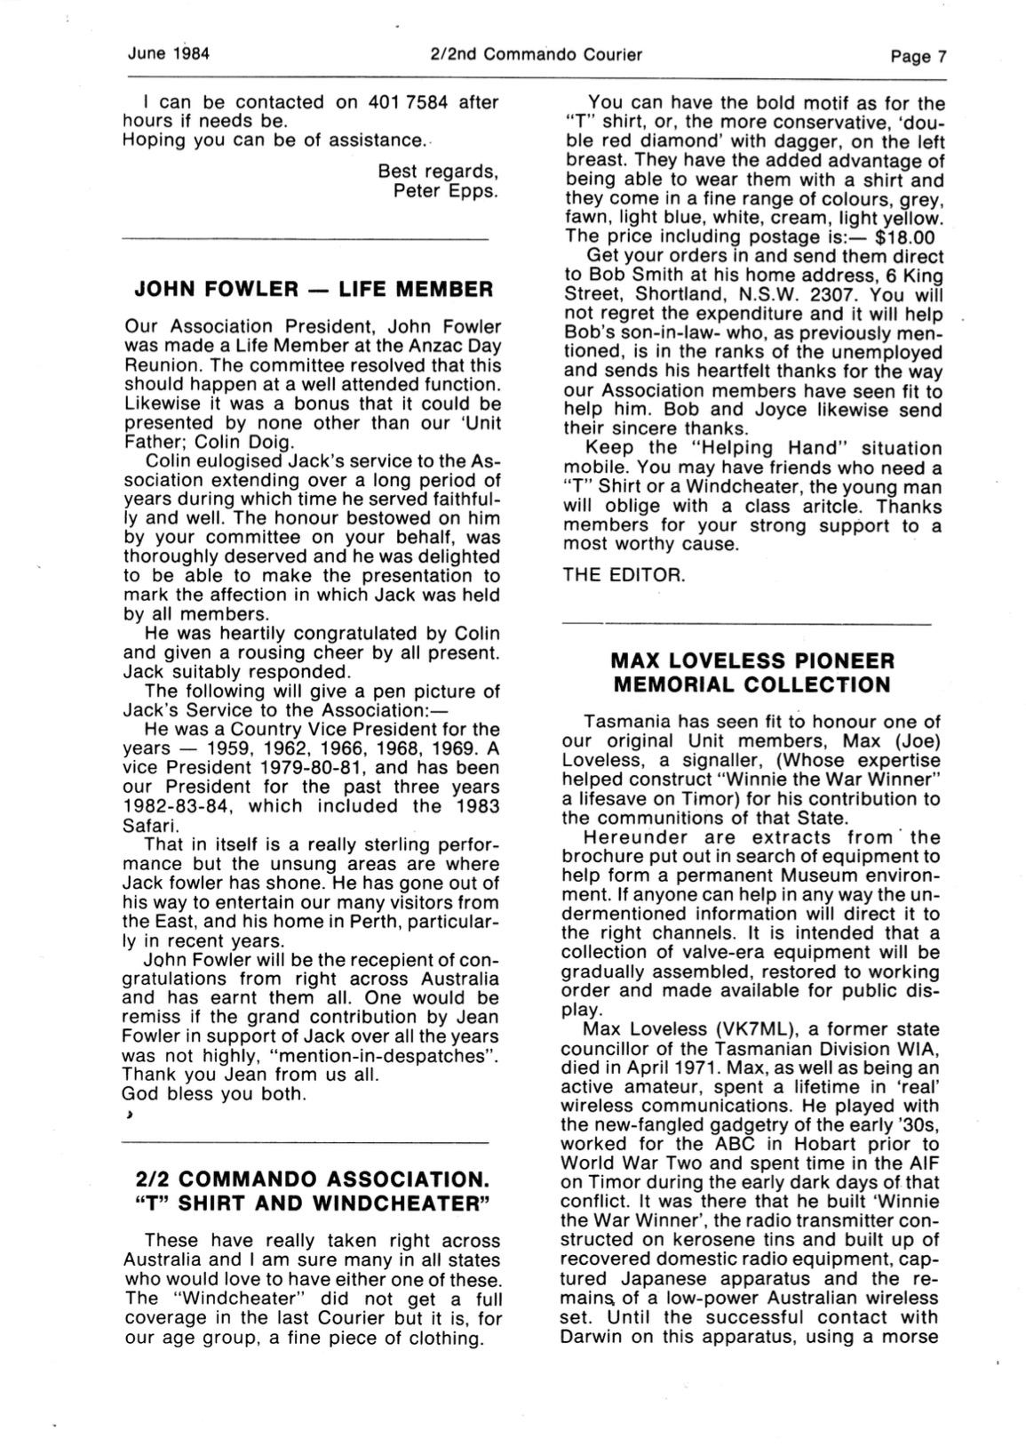
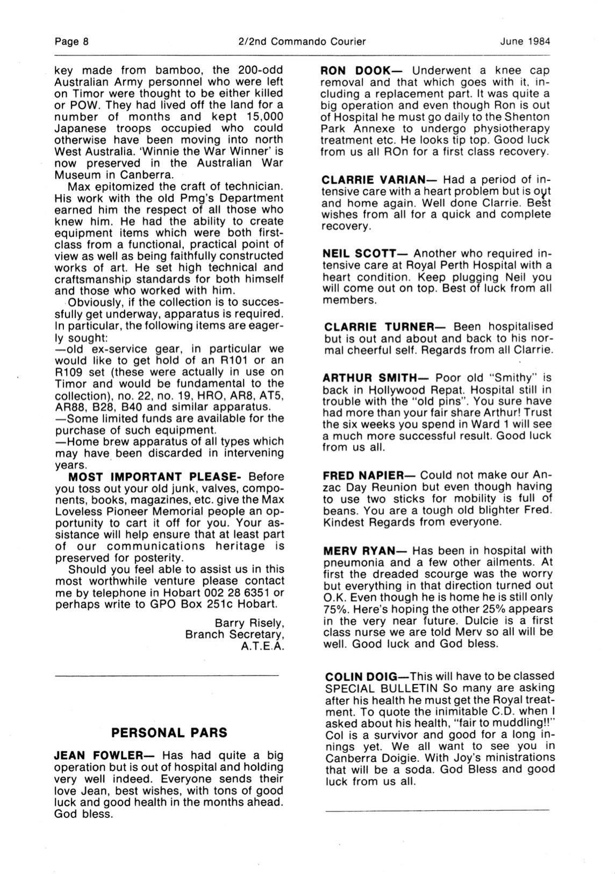
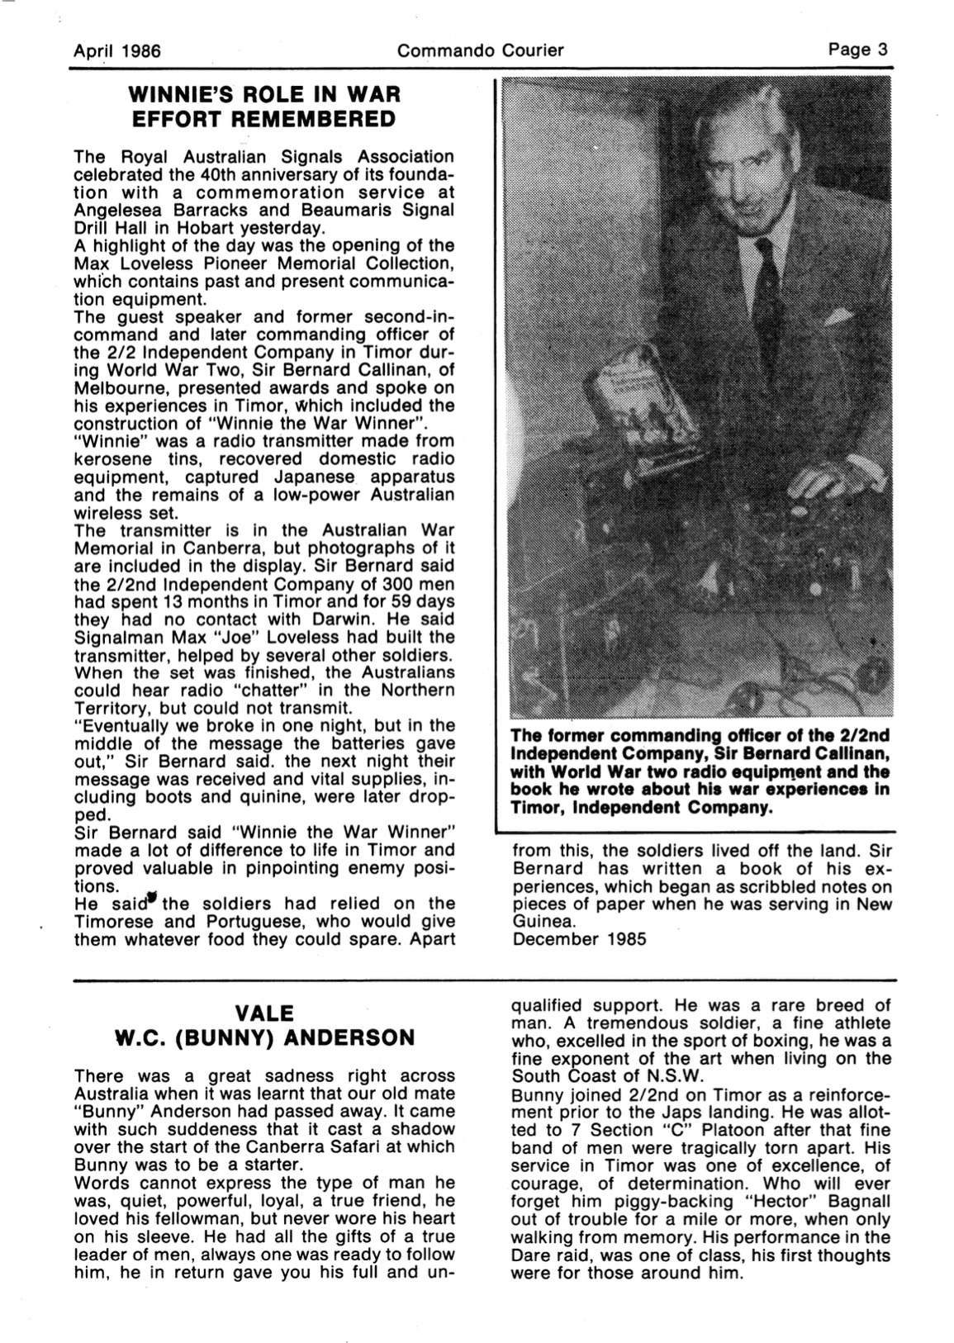
____________
Prepared by Ed Willis
Revised 21 May 2026

