PRIVATE VINCENT PATRICK (PADDY) WILBY (VX60836) – 1920-2010
SAPPER, ENGINEERS SECTION
https://doublereds.org.au/history/men-of-the-22/vx/vincent-patrick-wilby-r737/
BIOGRAPHICAL SOURCES
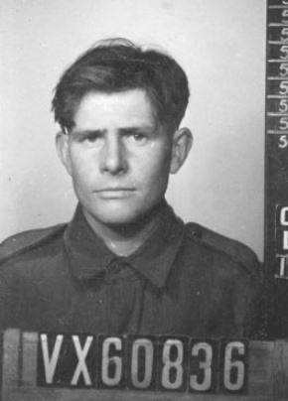
PADDY WILBY AND THE TIMOR PONY STORY
INTRODUCTION
Its readily evident that the motorbike rules as the dominant form of personal transport for Timorese now, both in Dili and rural areas. Motorbikes have become increasingly affordable for many families and are used for work, shopping and social interaction. As the motorbike and vehicle based public and goods transport has become dominant, the Timor Pony is rarely seen in Dili now but out in the districts it still has an important role to play, particularly in transporting heavier loads from remote hamlets to market days in the villages and towns.
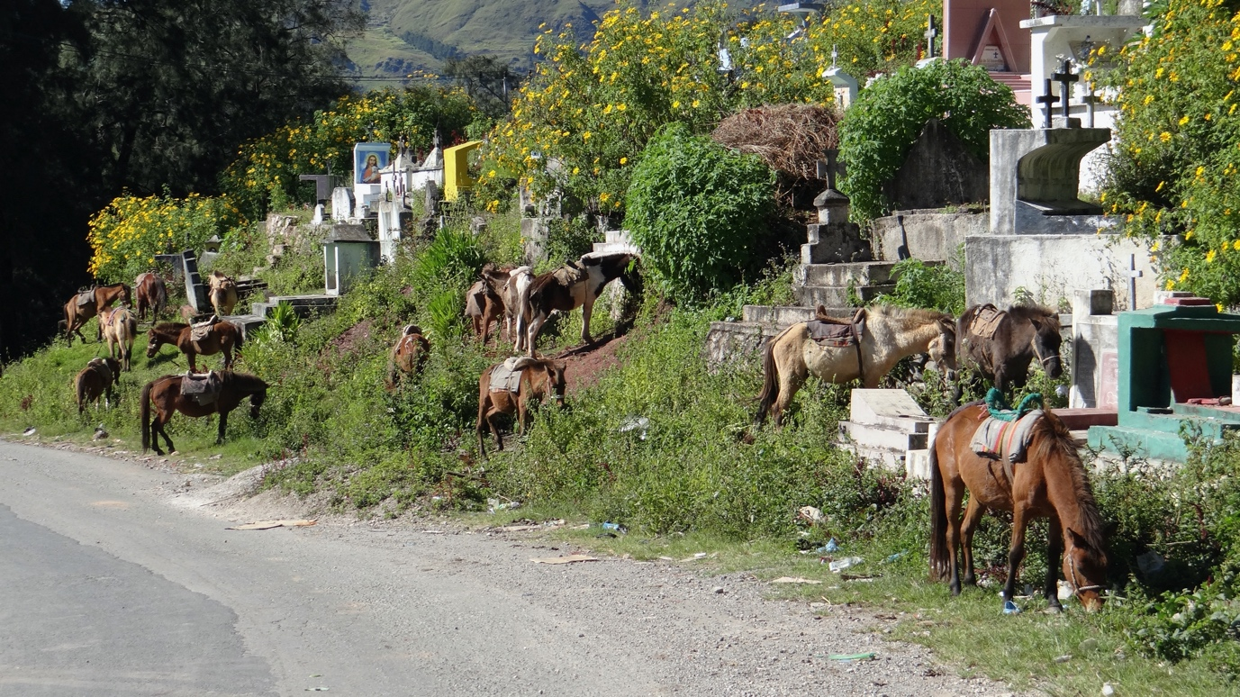
Timor ponies tethered at the cemetery – market day, Maubisse, 27 April 2014
Today’s circumstances are vastly different from those prevailing during the commando campaign on Timor during 1942 where the Timor ponies played an essential logistical support role. Sapper Paddy Wilby, an experienced bush horseman, is credited with getting the Timor pony trains into effective operation early in the campaign by using them to relocate ammunition and other stores from their vulnerable situation in Hatu-Lia to Atsabe and other platoon HQ locations further south. Once communication was re-established with Australia and regular supplies were provided by ship, Timor pony trains were used to transport weapons, ammunition, food, clothing, currency and other goods inland from the southern landing places at Suai, Beco and Betano to where the fighting men were located. The signallers were particularly reliant on the ponies to carry their heavy radio equipment and became very adept at loading them up in a timely fashion when having to move at short notice.
To read a fuller account of the Timor ponies contribution to the commando campaign go to the post on Doublereds: https://doublereds.org.au/forums/topic/236-the-timor-pony-story/
THE TIMOR PONY DESCRIBED
The ‘Area Study of Portuguese Timor’ (1943) provides the following description of this unique and interesting animal:
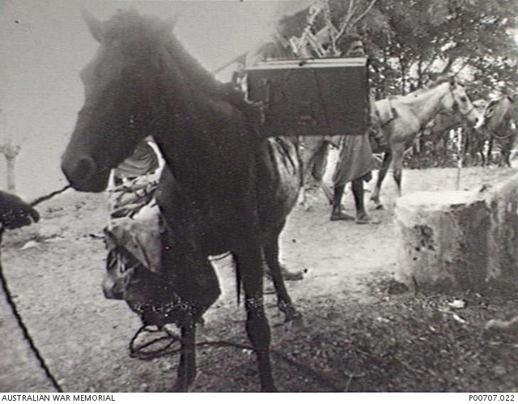
PORTUGUESE TIMOR. 1942. HORSES (TIMOR PONIES) BEING LOADED WITH GEAR, PART OF A PACK TRAIN USED BY MEMBERS OF THE 2/2ND INDEPENDENT COMPANY
The Timor pony will take a load of 100lbs., and it should not be overloaded. It has a speed of about 2 ½ miles an hour on an average, and it can maintain this for long periods. Normally, only males are used for transport, and these are always stallions, the mares being kept for breeding. Mares were used by our troops for transport. The loading of a Timor pony, which stands from 8-10 hands high, is either by pannier or packed on to a wooden saddle. Saddle sores are a constant source of trouble. There are no statistics as to the number of the animals, but it is known to be very considerable. In many districts it is estimated that there would be more than one pony for each family in the area. Timor ponies are extremely hardy and live off the country. They are tethered for grazing when not turned out to run in the hills. If grass is not plentiful, they are fed with maize or grain. This is particularly necessary when engaged in heavy work.
Note: The Japanese brought to Timor some Australian type horses which they had taken out of Singapore. Some of these horses died shortly after being put to work in the hills. They were probably mismanaged and not fed, but even so this illustrates the well-known fact that the local ponies will stand up to the arduous conditions and non-nutritious pasture much better than imported animals. Mules also have been tried on several occasions, but reports on the results are conflicting. [1]
[1] Allied Geographical Section, South West Pacific Area. - Area study of Portuguese Timor [cartographic material] / Allied Geographical Section, South West Pacific Area. - [Brisbane] : The Section, 1943: 56. https://repository.monash.edu/items/show/26455#?c=0&m=0&s=0&cv=0
DOIG’S ASSESSMENT OF THE TIMOR PONY
Col Doig also wrote perceptively about the Timor pony:
Magnificent Little Animals ….
Everything else seemed to grow small and be in miniature. We will deal with the Timor pony first. These were magnificent little animals, real thoroughbreds in miniature - beautiful hoofs and lovely carriage and came in every equine colour imaginable. The best were real beauties. They did not go in for castration on the Island - everything was an entire either stallion or a mare. The stallions were the riding stock and the mares used for carrying things. As they broke down, they were turned out and these were the ones most likely to breed and the breed was inclined to go backwards because the worst stock was doing most of the breeding.
Luckily the Portos and others had gone to the trouble to establish studs to upgrade the stock. It is said that normal horses taken to Timor will pygmyise in passing generations, the reason being given the lack of iodine in the mountainous areas. Much the same as happens in the Alps in Europe.
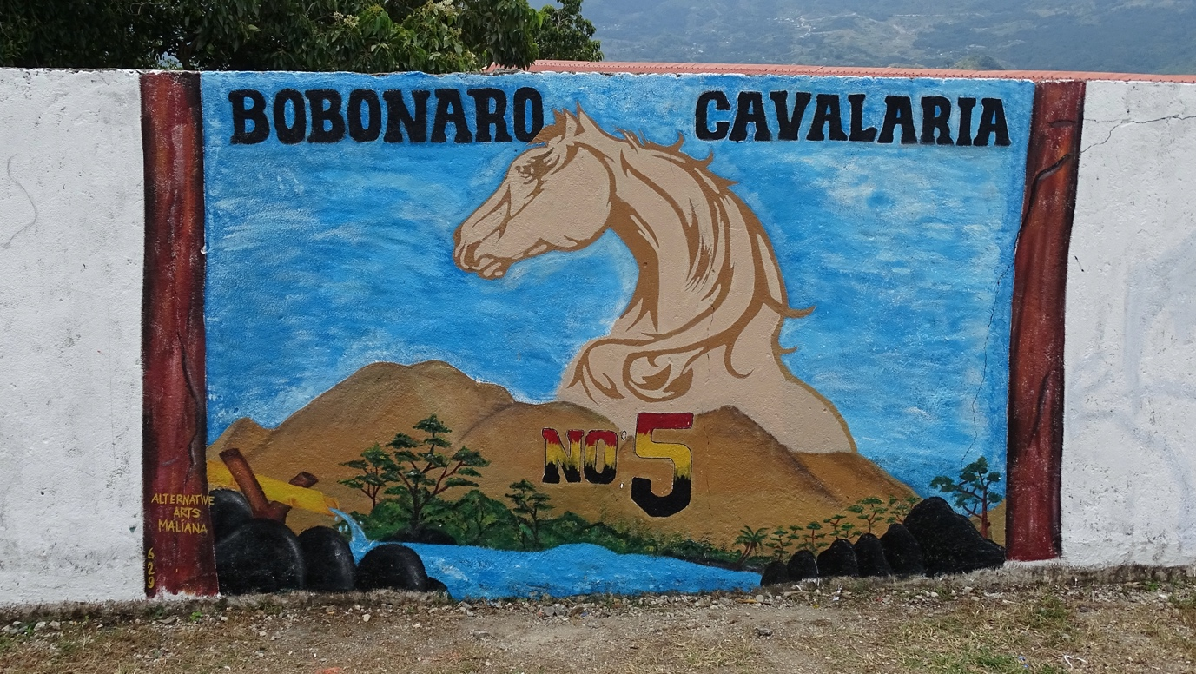
Mural on wall outside the old Portuguese stables, Bobonaro – 30 April 2019
Sousa Santos’s Stable at Bobonaro
As said the best had to be seen to be believed; there was one establishment at Bobanaro where the native cavalry was ensconced. This was a huge circular stable with all the mounts graded for colour. The piebalds together, and then skewbalds, blacks, greys, bays, chestnuts, roans and what have you. They were well looked after as Sousa Santos the Administrator was a very keen disciplinarian and kept everyone upon the collar. As an old cockie from way back I don't remember a sight in my life to quite outdo his contingent of at least 100 horses. They used to be fed on the local grass and it was a great sight to see a string of young boys come in daily with a sheaf of grass on their heads and carriers all dressed in the "Bari Pole".
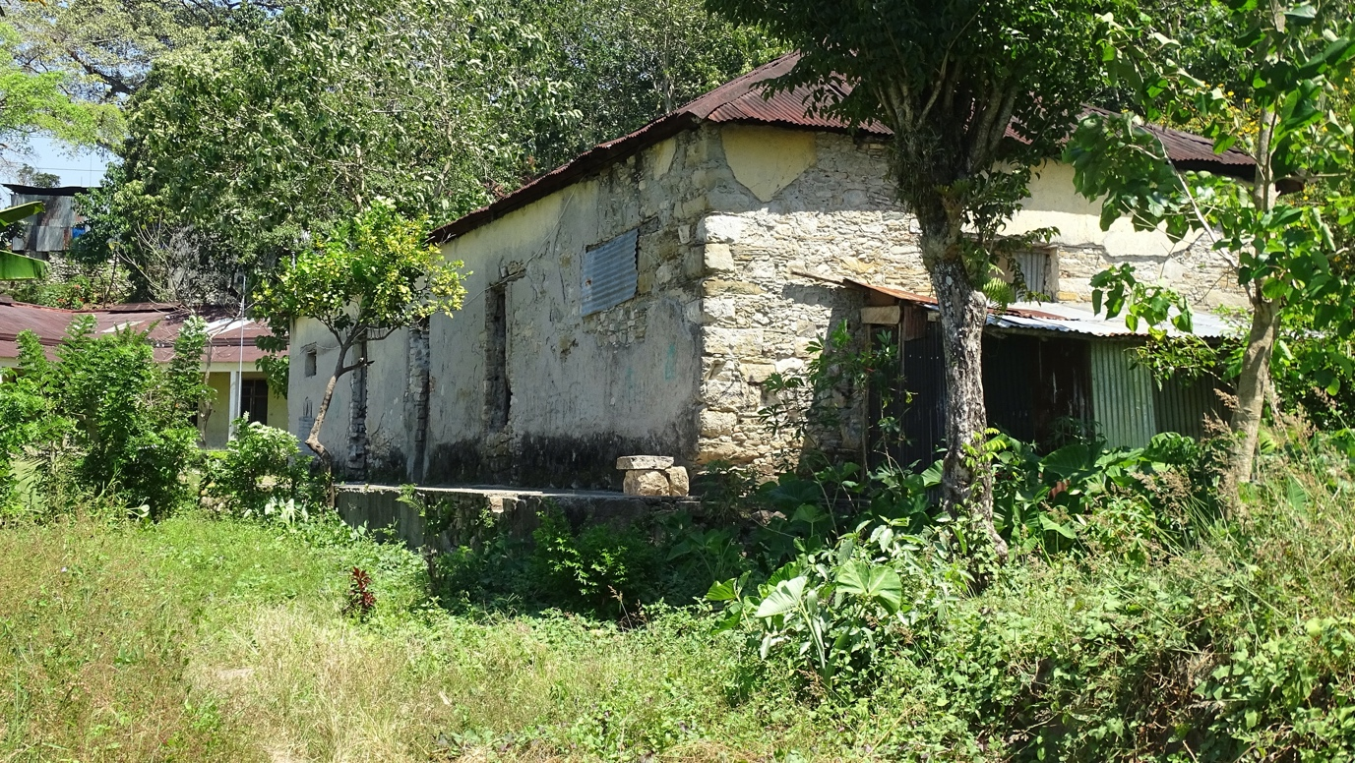
Old Portuguese stables, Bobonaro
Sousa Santos' personal mount was a magnificent piebald stallion as frisky as they come and named "Whisky" after the famous brand of Scotch. The horse would come out of his stable with his ostler practically walking on his hind legs and as soon as Sousa mounted him would prance about and take off at a solid canter. Generally speaking their gait was an amble meaning that the legs on the off side moved together as did the other side in the same manner as a modern pacer.
Loading and Riding the Ponies
Unfortunately, the saddles both riding and pack were abominable, made of raffia and cane tied on with rope or "tarley" and these didn't take long to give a horse a sore back and some of them were a hideous sight after a short while.
The ability of these ponies to carry loads over terrible tracks was truly amazing. Your author had quite a bit to do with packing horses in the Kimberly in WA and these little beauties would out carry Australian packhorses any day. It was not uncommon for these ponies to be loaded with a 90 to 100 lb. box of ammunition on either side of the saddle or a peco of rice or tobacco on either side - a peco is 62 lbs. An Aussie horse would be lucky to carry 25 lbs either side. I really think these animals were grossly overworked, especially on this impossible terrain. The riding saddles were much the same except a primitive bridle of rope. The horses were not mouthed in any way and of course with the narrow tracks this was not really needed. [2]
[2] A history of the 2nd Independent Company and 2/2 Commando Squadron / compiled by C.D. Doig. - Carlisle, W.A. : Hesperian Press, 2009: 100-101.
PADDY WILBY AND THE TIMOR PONY TRAINS
Paul Cleary has told the story of Paddy Wilby and the Timor pony trains in his book ‘The men who came out of the ground’ [3]:
[3] Paul Cleary. - The men who came out of the ground : a gripping account of Australia's first commando campaign : Timor 1942. - Sydney : Hachette Australia, 2010: Ch. 9 ‘People and Pony Power’, esp. pp.116-119. https://www.hachette.com.au/paul-cleary/the-men-who-came-out-of-the-ground-a-gripping-account-of-australias-first-commando-campaign-timor-1942
Beginnings
The ammunition left near Hatu-Lia was still within striking distance of the enemy, and had not been safely hidden, so Callinan told a small party of men to pay the Timorese to help move the stores to a safer place. One of the men whom Callinan relied on to carry out this crucial task was not a senior officer or even an NCO; it was a lowly ranked sapper, or private, in the engineers corps. Vincent Wilby, 20, from Bendigo, Victoria, had met Callinan years before when he worked for a short time as an assistant in Callinan’s drafting office, and Wilby had joined Callinan on his journey into Dutch Timor. While returning to Portuguese Timor, Wilby had acquired a team of Timor ponies that he had stolen along the way. Callinan later admonished Wilby for taking the ponies, insisting that he should pay or at least promise to pay for any property that he acquired. These first few ponies proved to be very useful, forming the nucleus of the transport corps used by the 2/2 Company. [4]
[4] Vincent Patrick (Paddy) Wilby, VX60836 https://doublereds.org.au/history/men-of-the-22/vx/vincent-patrick-wilby-r737/
Wilby’s Background
Wilby was one of the more worldly men in the 2/2 Company whose horizons in his teenage years had been unlimited. After the death of his father when Wilby was four, he was raised in a strict Christian Brothers’ orphanage in Melbourne until the age of 14. Wilby then travelled around Australia with his swag, hitching rides on freight trains, before working his way to the United States as a merchant seaman. By the time he enlisted in the army, Wilby had been to every state in Australia, working odd jobs during the tough Depression years, relying on the charity of people in the bush. During those bleak years, Wilby avoided cities because he found them full of despair, whereas people in rural Australia would give him a meal and other help when he needed it. Wilby found that all he had to do was ask for help.
Bere Mau
Again, in Timor Wilby found himself in a desperate situation with no money, but the resourceful sapper knew instinctively how to get help. After two months in Timor, Wilby possessed a good ability in Tetum and an exemplary rapport with the Timorese people. He had settled into life in the mountains of Timor better than most, and he was enthralled with the place. He had gone on patrols up into the mountains and seen forests populated by monkeys and postos on the hilltops ringed by terraces, flowers, and creepers. He had seen rainbows straddling the island after the afternoon dump of rain. For Wilby it was a fascinating place of endless ‘hills and hollows’. He was one of the first to gain the support of a Timorese offsider, whom the men came to call criados, meaning servant. Just after the Japanese invasion, Wilby met a Timorese boy who was fleeing Dili and heading back to his village at Atsabe. The boy was hungry and when he met Wilby he said makan, the Malay world for food. Wilby thought the boy, Bere Mau, had a commanding presence and might be a useful aide, so the two teamed up.
The Timor Pony
When Wilby got his assignment from Callinan, he and Bere Mau went off in search of more of the Timor ponies, a hardy animal that is believed to have been bred in the colony from ponies brought from Flores Island and India. The Timor pony had a strong connection with Australia, as the horse ridden in Banjo Paterson’s ‘Man from Snowy River’ had a ‘touch of Timor pony’. The Timor ponies formed the backbone of the transportation system on the island; as many as 100,000 were believed to be hauling goods and produce up and down the mountains. Standing at 1–1.2 metres tall, the ponies could carry as much as 60 kg. Wilby and Bere Mau garnered as many as 39 ponies, together with 59 Timorese who handled the ponies or carried goods themselves, with the aim of moving all the supplies left at Hatu-Lia to Atsabe. Each pony was capable of moving 500 rounds of ammunition, which Wilby thought was ‘a bit too much’, but they got through. The extra load meant that the pony train could move about 30,000 rounds of ammunition on each round trip.
While the Timor ponies held up, an old man keeled over and died during one journey. The Timorese rushed him back to his village for burial, and then returned to the pony train. [5]
[5] Paul Cleary interview with Vincent ‘Paddy’ Wilby.
To Atsabe
Wilby personally took part in six return trips to Atsabe, each leg taking about a day, traversing the rugged terrain on narrow walking tracks, until they reached a hiding place just outside Bere Mau’s home village. Some of the journeys started early in the morning and took until late in the evening; others went through the night. The hiding place was located about 200 metres from the town in a cave. The cave could only be entered by going through a ravine, and then up a steep slope. Over the course of six weeks, the pony train hauled a steady stream of ammunition - over 100,000 rounds of .303 bullets for rifles and Bren guns, 45,000 .45 inch bullets for the Tommy guns, and 2,000 grenades. [6]
[6] Wilby interview with Paul Cleary; B. Callinan, Independent Company: 50.
Frank ‘Grandpa’ Browne
As the ammunition was being put into safe hiding, the soldiers realised that some of it had become wet after being stored outside at Three Spurs. It had to be dried quickly before the brass casing corroded and made the bullets unserviceable. One of the older men in the unit, Frank Browne, knew of a practice of using pig fat to grease ammunition and suggested it to his senior officer. Before working in the outback mining town of Big Bell, WA, Bristol-born Browne had served with the British army in Afghanistan after the First World War, among other places, where animal fat had been used on ammunition. Browne was officially 39 when he enlisted, but he was undoubtedly much older; the men in the company called him Grandpa Browne. [7] The men asked the Timorese to find as much pig fat as they could obtain. Fortuitously, the 2/2’s hospital had been set up in Atsabe, so able-bodied patients were sent down to the cave to grease the ammunition day and night.
[7] Francis (Frank) Ernest Browne, WX8263 https://doublereds.org.au/history/men-of-the-22/wx/francis-ernest-browne-r35/
Surats
Wilby succeeded in pulling off this Herculean logistical effort without actually having any money. Callinan had told him that the Timorese should be paid to move the stores, but given that the company had no money of any value, he could only write a promissory note—known in Malay as a surat - in order to get the job done. Wilby wrote out numerous surats in the local currency; a rate of 1 pataca per day for a handler and pony, and half a pataca for porters. The pataca converted into 1 shilling and 8 pence, about a third of the daily salary for an Australian soldier. The Timorese accepted these surats even though Wilby’s company had no conceivable way of honouring them, given that it had no radio contact with Australia. Still, the Timorese accepted Wilby’s word that one day they would be repaid.
The ‘Hide-Out’ Principle Put into Effect
Over time, the Australians spread out their reserves of ammunition and weapons in bases held by each of the four platoons. They put into place the ‘hide-out’ principle conceived of by Callinan and Baldwin a week after the invasion - bases for operation that contained reserves of ammunition, weapons and food. But they quickly realised that they could hide nothing from the Timorese. They were entirely dependent on their ‘goodwill’ as it was impossible to conceal anything whatsoever from their ‘ever-watching eyes’. Instead of hiding their reserves, they placed them in the hut of the village chief, ‘and we lost nothing’, wrote Callinan. In mid-March, just days after Wilby had hauled the last remaining cases of ammunition from Hatu-Lia, the Japanese arrived in force. Callinan later wrote of Wilby’s incredible effort: ‘The situation is fabled to produce the man, and Sapper Wilby certainly came into prominence’. [8]
The pony train demonstrated that the Australians were innovative and adaptable and had established a very good relationship with the Timorese people.
[8] Bernard Callinan. - Independent Company : the Australian Army in Portuguese Timor 1941-43. - Richmond, Vic. : Heinemann, 1984: 50. See also (a) ‘Vale - Paddy Wilby - VX60836’ Courier September 2010: 7-11 https://doublereds.org.au/couriers/2010-09%20-%20Courier%20September%202010.pdf. Paddy’s vale includes the reprint of one of his reminiscences of working with the pony train ‘Shades of Caruso’ and (b) Paddy Wilby ‘Timor Memories - Series 10 “Dutch Courage”’ Courier June 2001: 19-21. https://doublereds.org.au/couriers/2001-06%20-%20Courier%20June%202001/
NOT THE END OF THE ROAD FOR THE TIMOR PONY’S MILITARY ROLE?
Taking on the point made in the last comment by Cleary, Captain James Barrett has made some interesting observations about Timor ponies in an article in the ‘Australian Army Journal’ primarily devoted to the Army’s experience with camels in recent desert environment peacekeeping operations [9]:
[9] James Barrett ‘In their steps: the ADF and camels’ Australian Army Journal Autumn 2019, Volume XV, No 1: 117-132. https://www.army.gov.au/sites/default/files/publications/australian_army_journal_-_autumn_edition_2019_volume_xv_number_1.pdf
Since then, conflicts have continued to demand resourcefulness from the Australian soldier, and there is a need for a non-motorised support platform. Despite the effects of mechanisation, the precarious early battles of the World War II in New Guinea may not have ended in our favour if we did not have the support of both local human porterage and our own pack animals along the Kokoda Track.
At the same time, our commandos in Portuguese Timor had guidance from their faithful ‘criados’, food and shelter from the local population and the trusted Timor pony to do the heavy lifting in the mountains and valleys. Over 50 years later, when Australian forces returned to East Timor with INTERFET, it was again the Timor pony that offered occasional support, along the high border tracks beyond vehicle range, taking vital supplies to observation posts and re-trans sites. [10]
[10] See Robert Garran ‘Timor pony patrols restock spirit of Sparrow Force’ The Australian, 1999 Dec 31, p.7. and Doug Macdonald ‘East Timor RAAF Caribou operations - Wallaby Airlines reborn’ National Emergency Response, Vol. 15, No. 1, 2000 Mar: 26-7.
Barrett concludes by making the following recommendation:
Regional Engagement Options
Animal transportation could be seen as an alternative engagement opportunity. Regionally, our important military association with Timor Leste, as documented, goes back to World War I. The Timor pony helped our commandos at a critical time in our national history. If the ADF wished to further engage with the Timor Leste Defence Force (F-FDTL), a combined animal transportation activity could provide a practical opportunity. This would allow ADF members to formally understand the use of small ponies in mountainous environments and share with the Timorese our knowledge of camels in the desert. The activity could help to maintain our valued historical links to the Timorese people and nation, allow the Timorese to display their own military heritage with the pony, and further develop our professional relationship as defence forces.
Beyond our engagement, there would be opportunity for the United States, New Zealand and Timor Leste to share common learning in common terrain: joint participation at respective military exercises employing animal transportation.
_________
Prepared by Ed Willis
Revised 20 May 2026
