LIEUTENANT JOHN ROSE (NX65630) – 1920-1972
OC NO. SIGNALS SECTION
https://doublereds.org.au/history/men-of-the-22/nx/john-albert-rose-r579/
BIOGRAPHICAL SOURCES
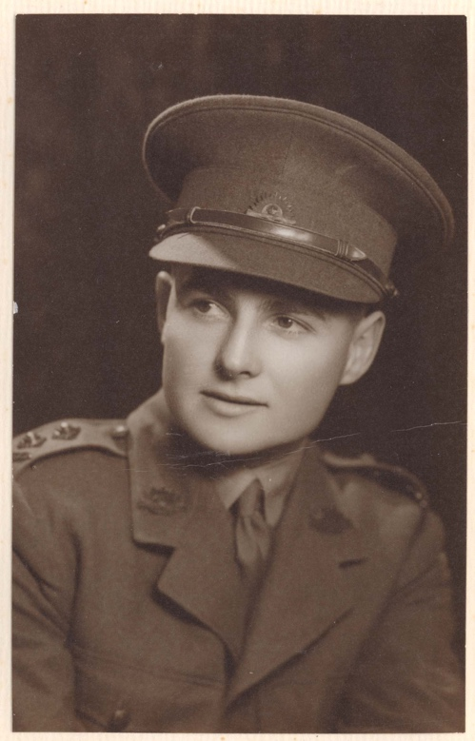

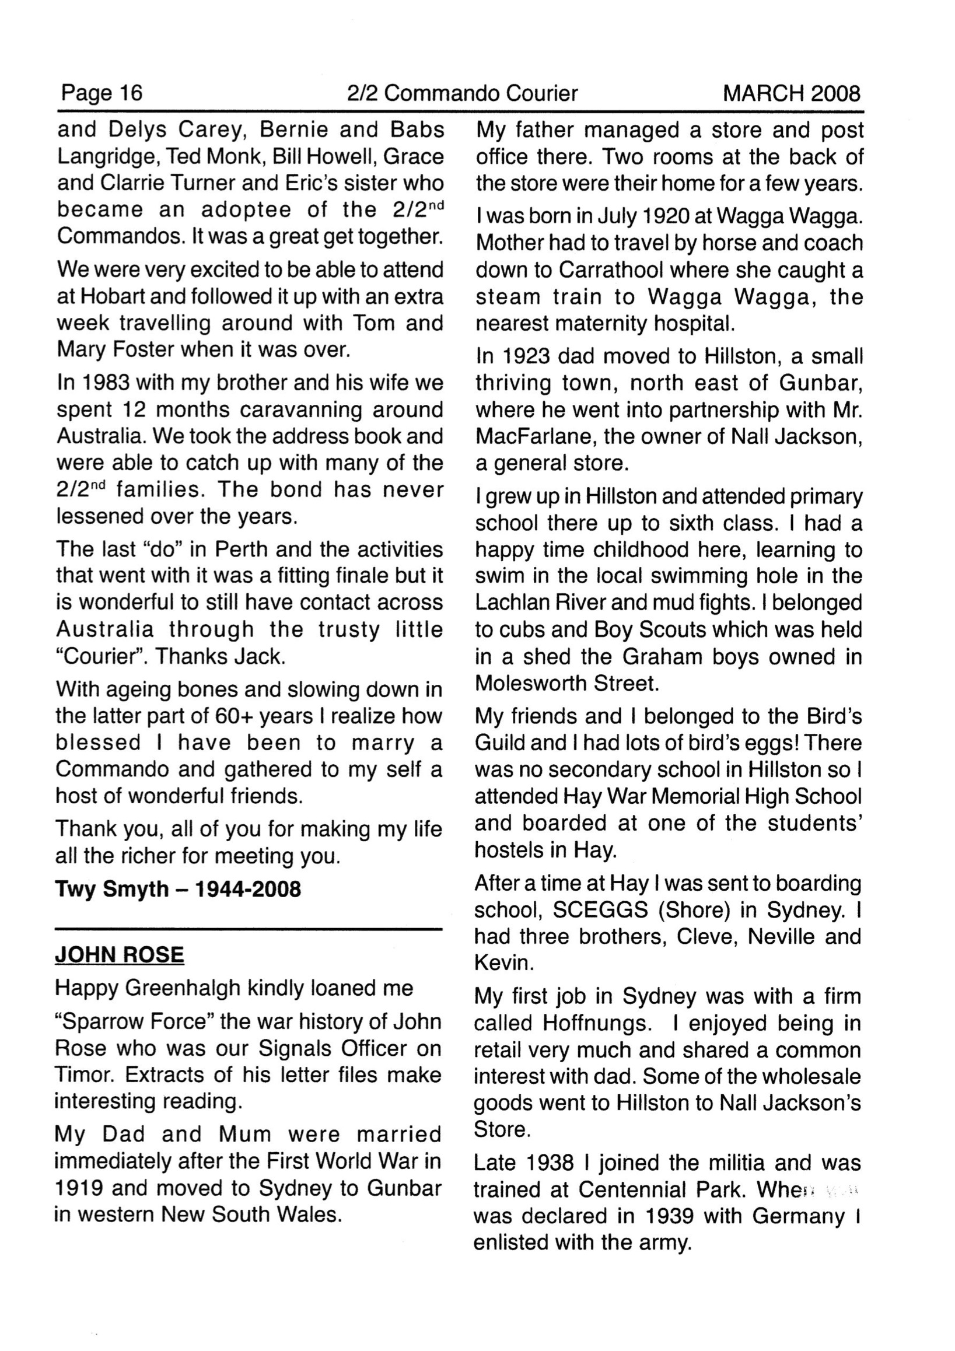
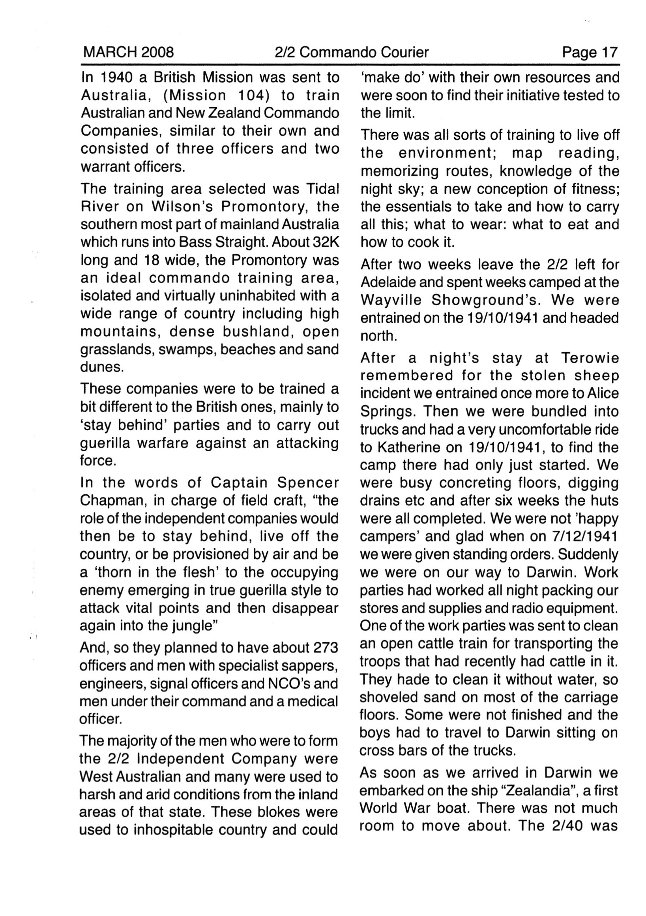
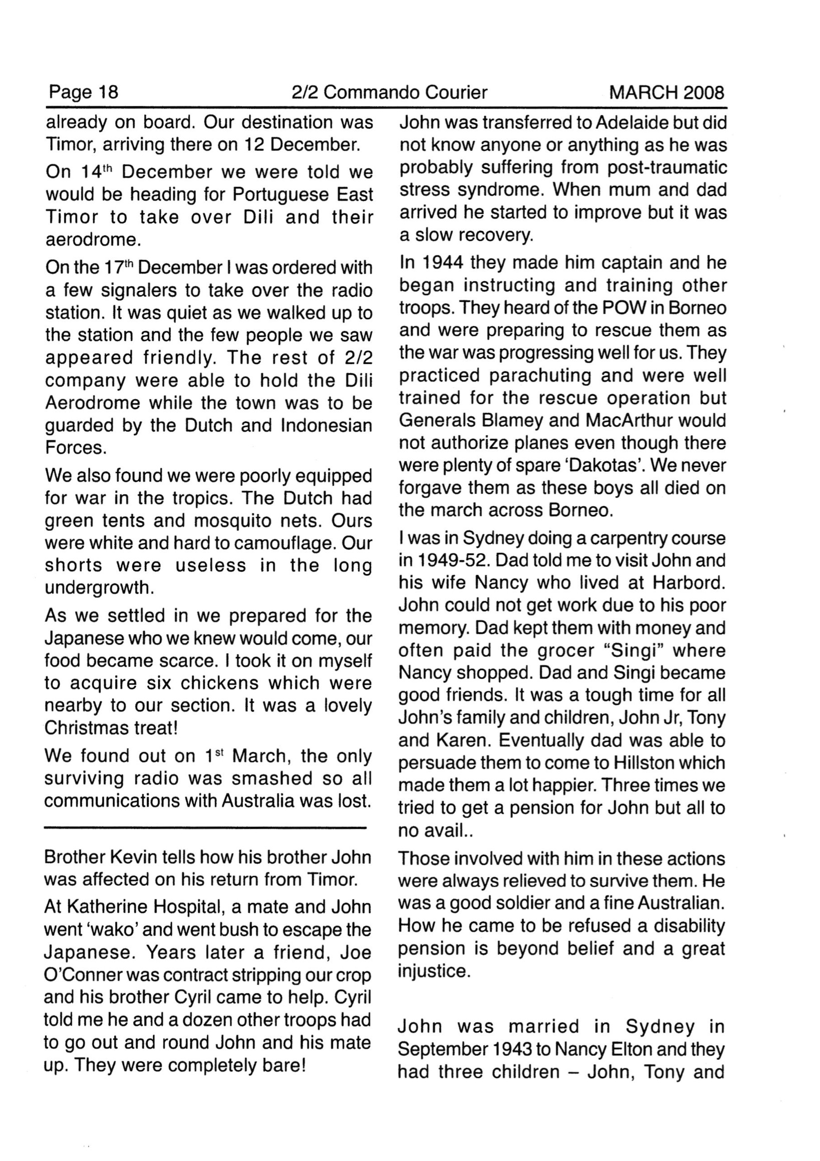
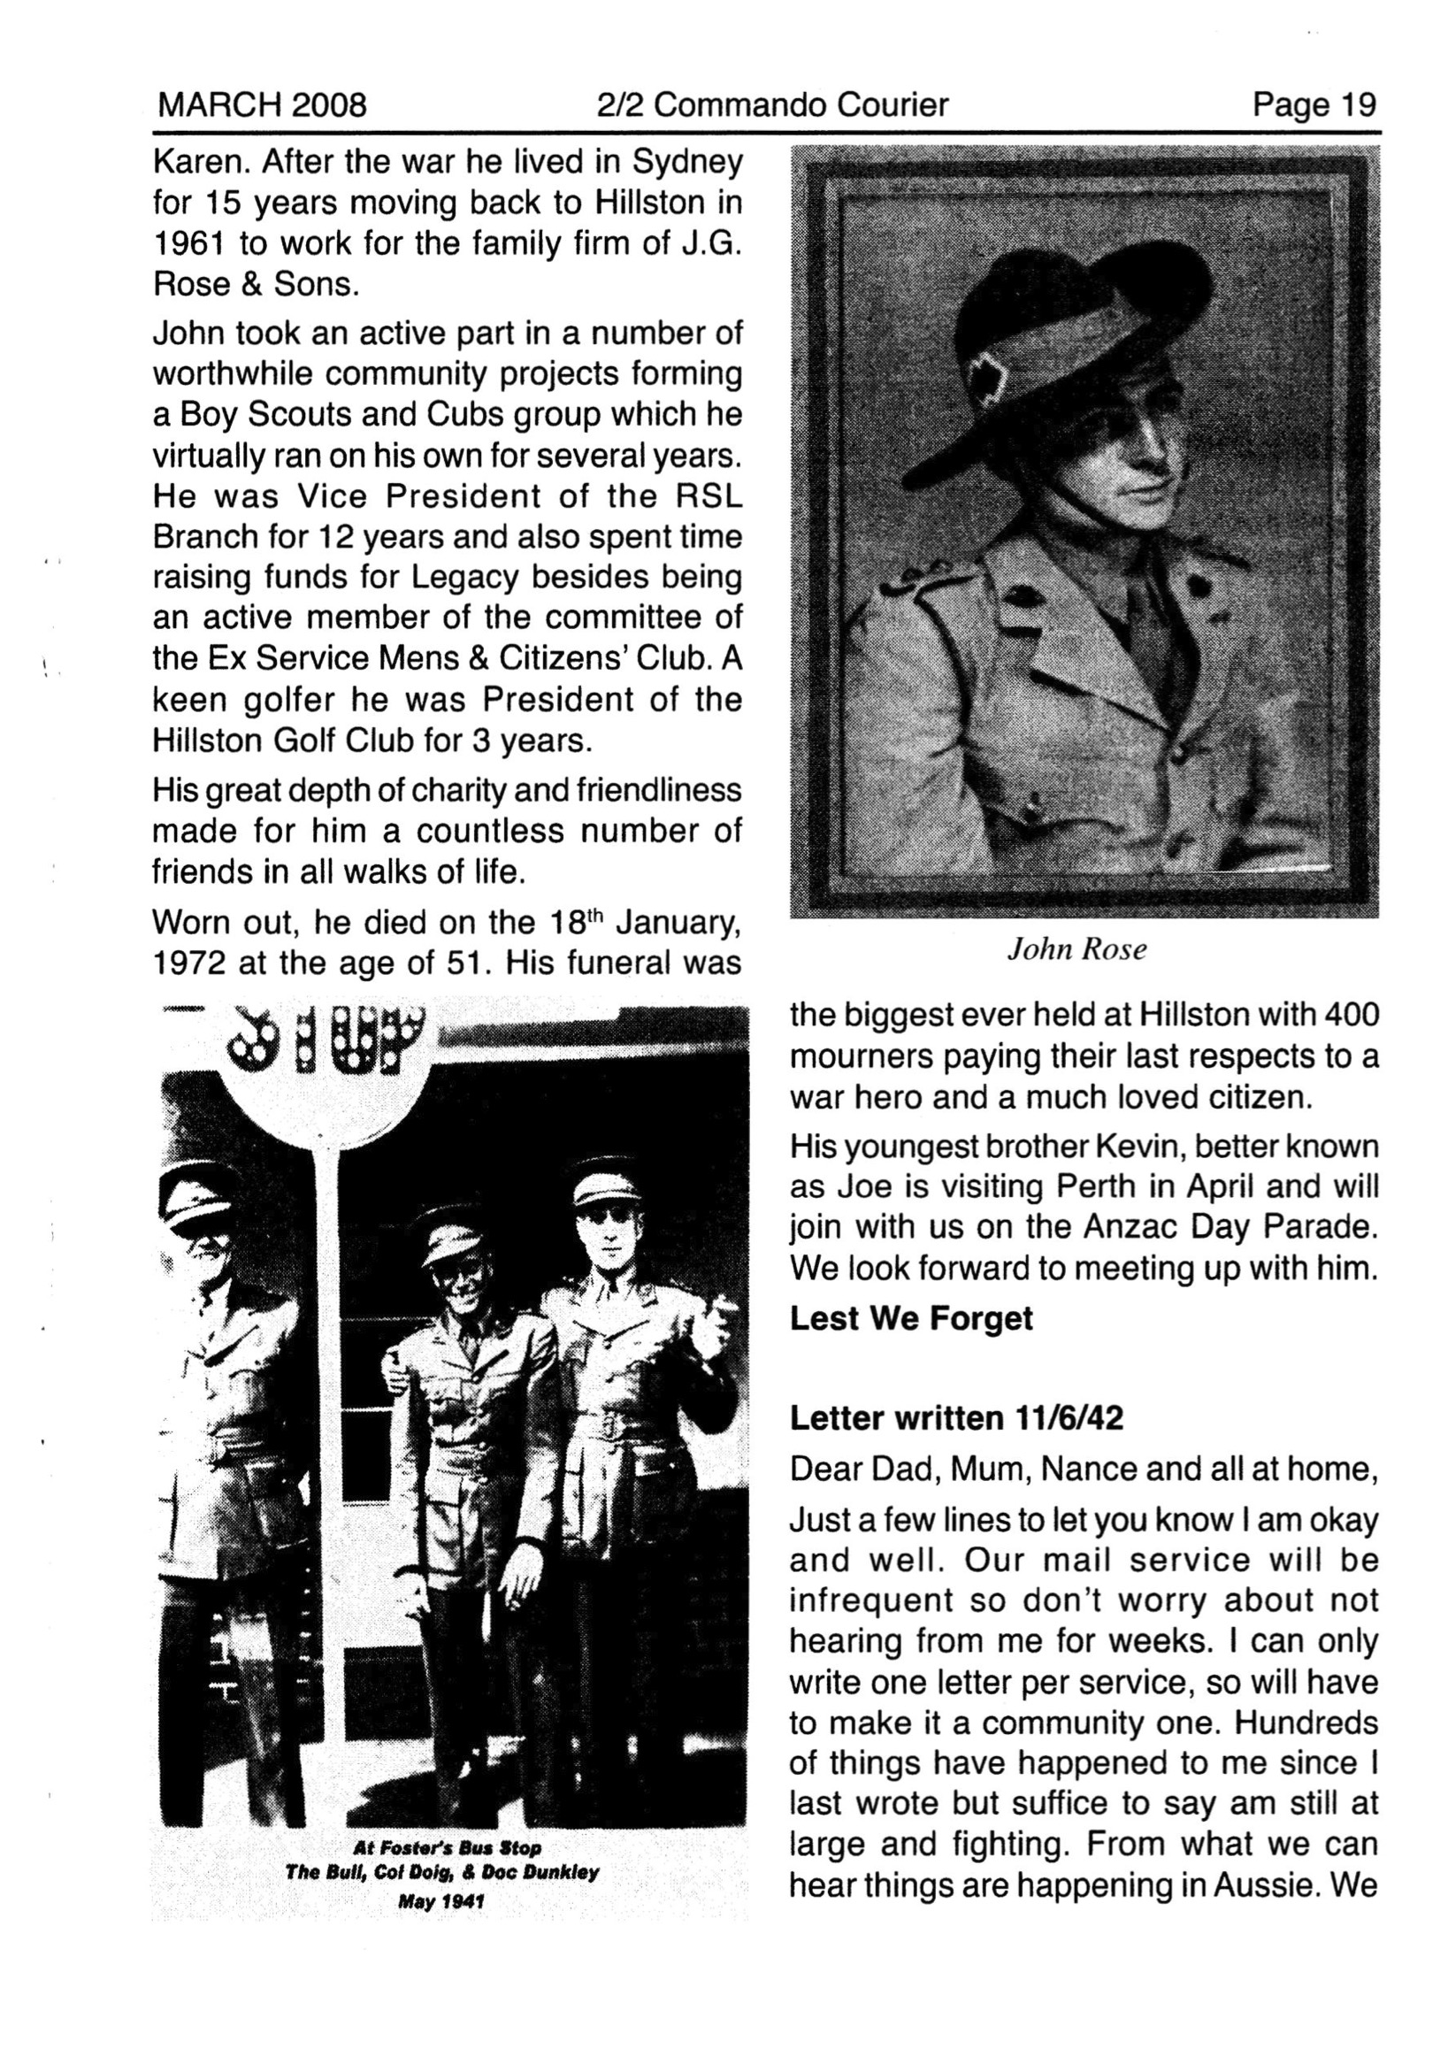
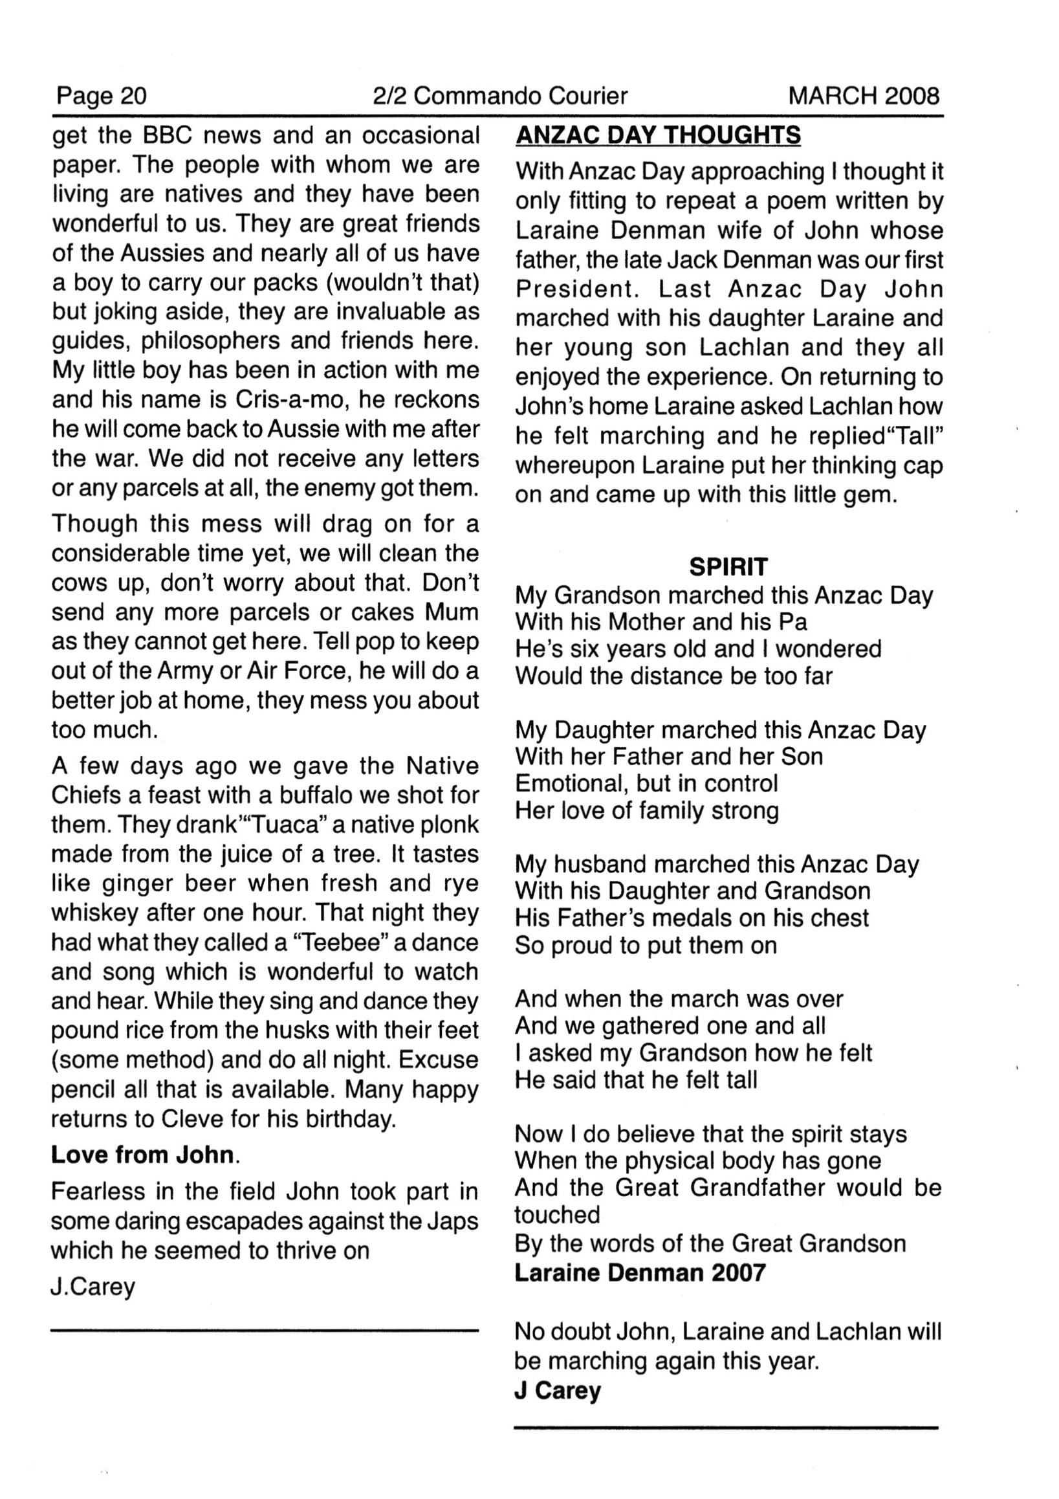
________________
Cleary, The men who came out of the ground :
…………
They set off with the aid of Timorese guides towards the Japanese, passing the plantation centre of Vila Maria, which struck Wheatley as a ‘pretty place’. There they met the head of the company’s signals section, Lieutenant John Rose, 22, from Mudgee, NSW, who was living in a colonial house surrounded by rose gardens. From this vantage point, Rose and two other signallers, Don Murray and Ron Sprigg, watched the Japanese trucks go past every day. When Wheatley suggested that Rose join him, he and his men agreed, even though as signallers they had undergone even less training in how to fight guerilla war than other men in the company. Rose’s men thought he was a little crazy, but still they followed this officer armed only with a pistol close to the clutches of the enemy.
The party of five headed for an expected truck movement along a windy, hairpin-bend road linking the centres of Ermera and Hato-Lia, leaving behind their Timorese aides who were to wait with their heavy gear. Upon reaching the road, Rose showed that he had little idea of how to stage a roadside ambush. He chose a location that the men feared would get them all killed because they would have to cross the road to make their getaway. Sadler told the senior officer bluntly that it was a ‘suicide spot’. Wheatley agreed, so Rose told him to choose another position. Wheatley moved them to the other side of the road and then climbed up to a position with a commanding view. Wheatley thought it was a nice spot as he was able to rest his rifle’s 66 cm barrel on a log and get clear shots of the road. The position also enabled Wheatley to cover the retreat of his four mates below, who hid themselves in scrub and 2 metre tall coffee trees.
And so this gang of five previously untested soldiers began a nervous wait before their first enemy encounter. Signaller Murray, 20, a radio technician from Perth, was so nervous that after about an hour his bowels began to rumble, so he walked some distance away to relieve himself. Just as he was in the throes, a truck loaded with about 15 Japanese troops arrived on the scene. Murray just managed to re-join his mates before the first shots were fired. The riflemen opened up, stopping the truck and prompting the Japanese soldiers on the back to leap off. Sadler couldn’t get a clear aim with his Tommy gun so he stepped out onto the road and fired a long burst at the soldiers who were jumping off the truck and had begun to return fire. Sadler’s powerful gun kicked to the right as he fired the long burst but it silenced the enemy fire momentarily. Sadler was ‘terrified’ as he met the enemy at a range of just 5–6 metres. The Japanese, with their ‘hands covering their faces, were more terrified’. When Sadler went to continue firing, he discovered that he only had one bullet left in his magazine; so frightened was he that he had fired 19 bullets in that long burst, instead of the 3–4 round bursts he had been trained to fire.
Moments later, a second truck laden with more troops approached. Rose waved his arm in the air, signalling the retreat, even though the job was only half done. Rose’s men fired some shots at the second truck and then bolted down a track towards a small stream before ascending a steep slope to make their getaway. One of the men fell over as he splashed through the water, and in his panic to escape Sadler dropped a magazine and then lost the track. He tried to climb straight up but the steep slope made his exit impossible. The surviving Japanese returned a burst of fire from a light machine gun as Sadler found the track and he ran up the slope, crouched low, and came upon Wheatley, who was still firing. The surviving enemy soldiers ran around wildly as they tried to find cover. Some continued to return fire; at this moment it seemed that some might survive their terrifying encounter with an unseen enemy.
………
Worse still, the men on the airfield could not even radio the Three Spurs camp, located 13 km away, from late afternoon onwards. As it was the wet season, heavy clouds descended over the town, leaving the small force at the Dili airfield one of the most isolated groups of soldiers in the Asia–Pacific region at the time. The cloud cover also prevented a ‘Lucas’ signalling lamp from being used to reach the Three Spurs camp. One of the signallers, Gordon Stanley, who had worked for the PMG in Melbourne before joining up, had warned the officer in charge of the signals unit, Lieutenant John Rose, that the lack of communications put the small force in a perilous position in the event of an attack. ‘They will come in the middle of the night and there will be nothing we can do to warn the force in the hills,’ Stanley said. [13] Rose, a salesman in civilian life, was in command of the signals section despite having no previous experience in communications. The Australian Government had deployed forces to the neutral territory without providing adequate clothing, medicine, or means of communication.
……..
THE WHEATLEY ambushes gave the small unit an enormous lift and encouraged others to be equally bold. From the end of April onwards, the scattered and largely unorganised patrols of the company began hitting the enemy every two or three days. Like the Wheatley ambushes, most of these attacks were carried out by just a few men. In May, they began striking the Japanese in the camps and outposts, taking advantage of the poor security at their perimeters. In early May, the ‘brave but foolhardy’ Rose was ready to have another go after his epic encounter at Vila Maria. He teamed up with another soldier and the two prepared for the attack by stripping to their boots and shorts and covering themselves in charcoal grease from the cooking pots at a Timorese village. Rose had heard that a nearby village called Atoora in the Ermera area had been occupied by the Japanese, so they set off, guided by two Timorese boys. After watching the Japanese eat their evening meals and settle in for the night, they crept up close to the huts and lobbed grenades and raked them with Tommy guns. Rose reported that the attack had left behind a body count of 20 men. After going on the raid with Wheatley, it seemed that Rose was now much more interested in practising hit-and-run warfare than running the Signals Section. A few days later, Sergeant Harvey James, 23, mounted a solo raid on an outpost. After observing it for two days, he killed all 12 enemy soldiers.
……..
The support from the Timorese that had saved the 2/2 Company men featured in the letters. Lieutenant John Rose told his parents in June 1942:
‘The people we are living with are natives and they have been wonderful to us. They are great friends to the Aussies and nearly all of us have a boy to carry our packs (wouldn’t that) but joking aside, they are invaluable guides, philosophers and friends here. My little boy has been in action with me and his name is Cris-a-mo, he reckons he will come back to Aussie with me after the war’.
……..
The head of the 2/2 Signals unit, John Rose, showed signs of post-traumatic stress disorder immediately after returning from Timor. While recovering in hospital in Katherine he escaped the grounds and a search party found him in the bush completely naked. Rose had taken part in some of the most daring actions of the campaign, but as head of signals he bore a heavy conscience for the failures that led to the massacre of 15 men. He did not remain with the company after returning to Australia and died at the age of 51.
………….
________________
Callinan, Independent Company:
I was not observed in my movements and eventually reached our outpost at Rotai that had been the object of the morning's shelling. There I had some food and then pushed on to Atsabe, where I saw Turton. He thought I had been captured, and was relieved to see me. We arranged a quick reorganization of all troops in that area, and sent them up to Rotai under Rose, who once again took over a difficult post.
………….
I arrived back at Atsabe, and Turton went off to Mape to train his platoon in three days. The next day I went up to see Rose, who was doing a good job; he had his posts well arranged, with a regular system of reports, and a well-organized food supply.
………….
Rose, sitting up in his hut looking over the valley to Lete-Foho and beyond towards "Sappers O.P.", was receiving continuous native reports of a Japanese outpost of twenty men in a village midst the high country above Vila Maria. Each day the natives confirmed the report. One evening he called for all the dirty cooking pots of the village, and he and a soldier stripped off except for their shorts, boots and socks, and blacked themselves, much to the amusement of the natives. Then, with a "Tommy" gun and plenty of grenades, they set off for the Japanese village. They took two native guides. Arriving at the village he found there were five huts, but the Japanese occupied only two. He sent the natives in to examine the huts, and they reported which ones were occupied by the Japanese. The Japanese either had no sentry or he was asleep, so Rose and his "Tommy" gunner treated both huts with grenades and the "Tommy" gun fire. By dawn he was back in his hut, watching for undue movements. Later reports credited him with having either killed or wounded the lot, and there was no further Japanese outpost in that area.
………….
Company headquarters at that stage consisted of myself and Sergeant Press, who was the signals sergeant, but as we were using Rose for other work he was acting as officer in charge of signals.
………….
From these. charming headquarters I set about some further reorganization. From Doig, who had become very ill with combined malaria, diarrhoea and pleurisy, Rose took over the command of what I named "Section Thirteen". This was actually more than a section and a half in strength, being over thirty strong, and it was in effect the reserve for the company. Rose went down to Cailaco to take command, and then moved back to Maliana as from there he could better watch the frontier and report by telephone to me at Bobonaro. As usual he did well, and soon had patrols pushing along the frontier. By this time the Japanese had occupied the whole of Dutch Timor, and were in all the main towns on that side of the frontier. They would occasionally send a convoy around by road into Portuguese Timor to Balibo. We could not extend our line further by garrisoning Balibo, but Rose instituted a system of regular patrols to there in the hope of catching enemy convoys, but he had no success. Hearing on one occasion that some Japanese had moved in, he set off in the middle of the night to catch them, but when he arrived there the following morning they had gone. So he waited for two days, hoping that they would return, but as there was no sign of them he came back. That night he rang me to say there were no Japanese in Balibo. I asked him what time he had left there and he said eight o'clock, so I told him that I had just heard through Sousa Santos that the enemy had entered the town at nine o'clock. He was most disappointed, especially as he felt the Chinese at Balibo had knowledge of the Japanese coming, and had deliberately misled him to avoid a fight in the town. He had told them to prepare breakfast for him at six o'clock that morning, and was annoyed to find it ready for him shortly after four o'clock; but he had taken it then and, after a final look around the area, he had departed.
………….
Plans were being made to bring McKenzie's and Turner's sections over to the Cailaco-Maliana area and to place the platoon under the command of Dexter, and then to move Rose to Ainaro, where his section could receive some medical attention and some of the benefits of the training areas there. These men had acquitted themselves very well in the withdrawal from Koepang, and had since been covering a large area that was highly malarious; they were badly in need of a rest.
………….
________________
Doig, Ramblings of ratbag:
There were quite a few officers on the camp staff, we were quick to make some friendships, especially as it was bandied around that most of them had a few bottles of beer cached under their tent boards. Lt. Johnny Rose and I promptly helped them to get rid of this surplus grog and it was then I discovered that dear Johnny was well and truly over the hill mentally.
Somehow, he acquired a motorbike and was blurting around the lines laughing in a maniacal way, and to cap it all off, he was at the hospital one day and took a liking to a silver rising sun badge a nurse was wearing on her dress, and snatched it dress and all, and the poor lass was yelling blue murder. After that episode Dr. Dunkley and another medico put him in a strait jacket and sent him south for urgent treatment. I later found out that Johnny had contracted cerebral malaria quite early in Timor and when he later came good his memory had failed him about halfway through the Timor campaign. [?]
