Reviewed and Assessed by Tom Hoyer and Mario de Jesus – 20th Oct, 2025
Project location: Los Palos - Escola Secundário Técnico Vocational No 1.
Vocational Tools Project, with Principal Jose dos Santos.
As with all trips to Timor Leste, it is easy to be inundated with requests for assistance. From tanks, pipes, submersibles, equipment and building materials.
Our 1st world expertise and financial resources are seen to be an avenue to support more projects and opportunities.
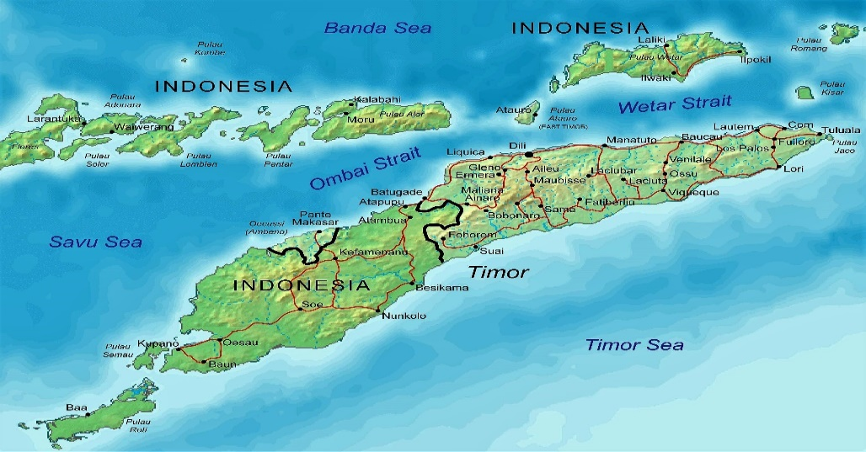
A new project at the same Technical School site in Los Palos focusses on the supply of tools and equipment.
The school has teachers, students, new classrooms and associated workshops, but limited teaching tools and equipment.
As with all Rotary projects, a needs assessment is performed, at site, with the benefits identified and verified prior to commencement. This is a model that is already tried and tested, sustainable, mature and successful.
The assessment includes:
Forming a partnership with the local administrators, local padres, school principals, or community leaders (X(j)efe) as is appropriate.
- The site is selected where need is established and human resources are available.
- Labour is supplied for free. This is achieved via a strong communications model explaining the benefits that support the whole of the school and wider community.
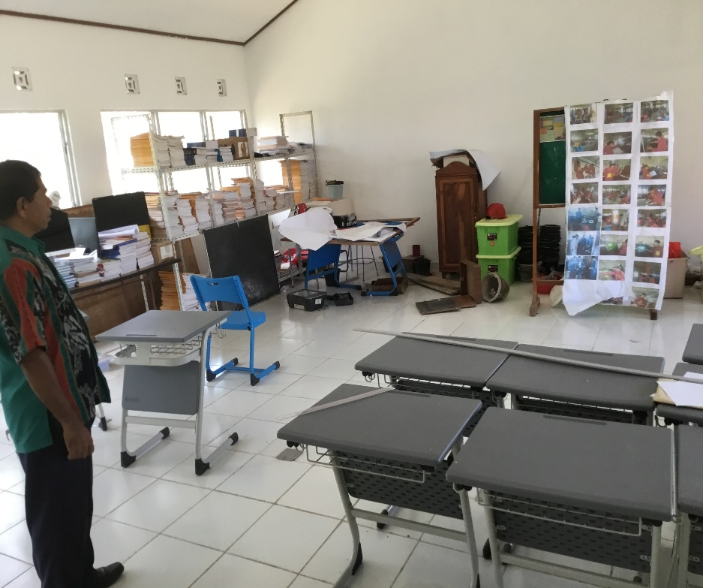
- Maintenance issues are identified and recognised as needing on going support.
- Training is an essential component, and the school has an array of skilled staff to perform this.
- Further, the donors expect that the school encourages the community and parents to contribute a small amount, say 1 Dollar per quarter, to pay for maintenance and repairs when they arise. This is a sustainability measure for ongoing success.
- I have observed that racking, shelving and secure lockers are required. I am assured this will be ready when the tools arrive.
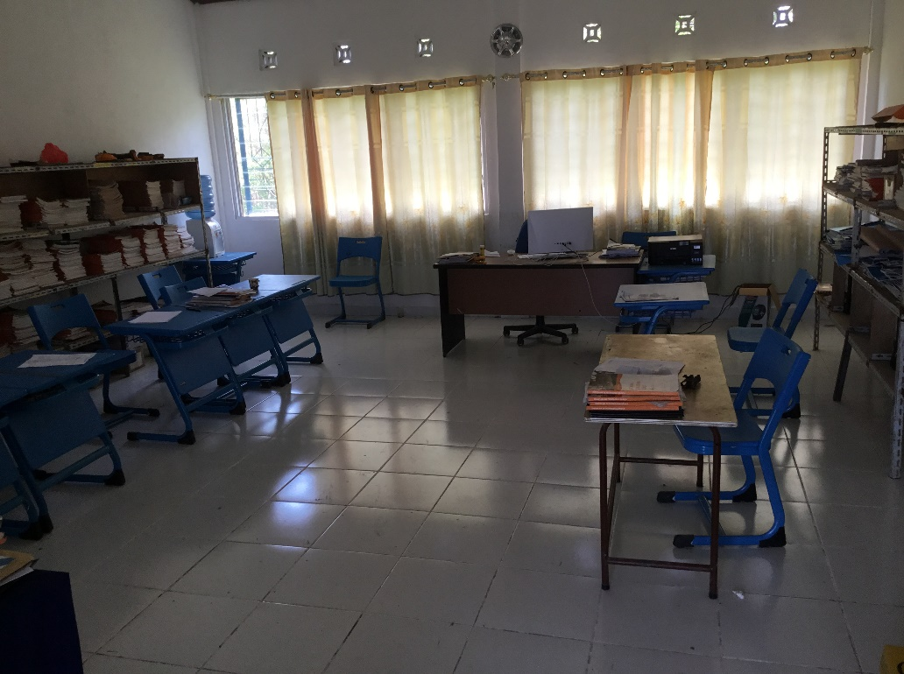
- Will be run and managed by trained and responsible local school or community leaders with oversight from the school principal.

This project is valued at $22,000.00, with multiple funding partners required.
Lists of Tools and Equipment is available.

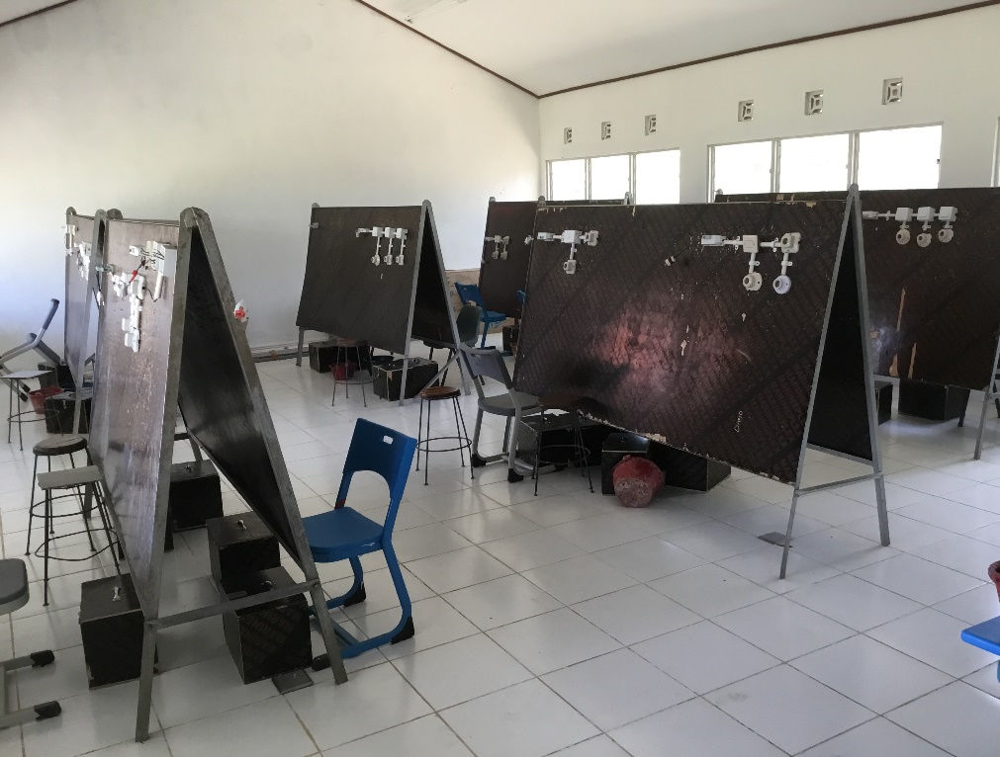

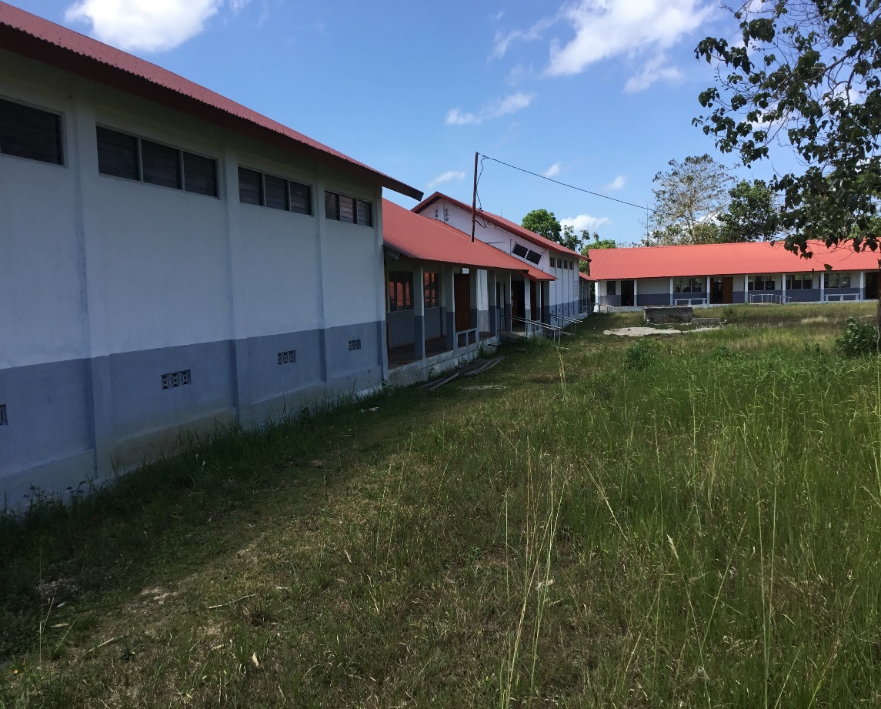

Tools List and Cost
4 Hand Planers $185.00 each = $740.00
6 Electric Drills = $580.00
2 Routers = $530.00
2 Zig Zag Saw = $200.00
6 Zig Saws (Blades) = $20.00
4 Extention Cords = $340.00
3 Circular Saws = $375.00
3 Circular Saws (Blades) = $45.00
2 Radial Arm Saws (Blades) = $550.00
4 Cordless Hammer Drills (with Batteries and Chargers) = $1100.00
4 Electric Grinders (Plus wheels) = $320.00
2 Single phase welder = $600.00
20 Welding hoods, goggles, gloves = $80.00
3 X 20 Brick Laying and Plastering Tools = $240.00
10 Shovels – various = $60.00
20 Hammers-various types = $200.00
10 Hand Saws = $70.00
4 Chisel Sets = $ 60.00
4 Hand planes = $60.00
10 Levels = $70.00
Total US$6240.00

